Can you write one Functional Interface ?
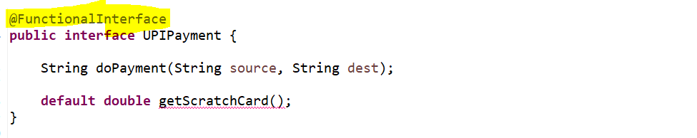
  - We need to provide the implementation for the method getScratchCard() otherwise it will treat as an abstract method, and we can’t write 2 abstract methods in our functional interface.
  - Public and abstract keyword is by default will be there in an Interface.
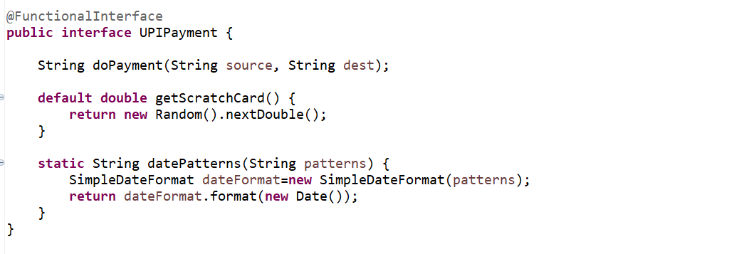
- So, as per the Functional Interface we define the abstract method, static method, and default method.
- We can define default and static method n number of times.

Purpose of default and static methods in Interface:-
- Since this doPayment() is an abstract method, it will force to all my implementation class to override this.
- But if you define a method as a default, it won’t force your implementation class to override it. If someone want scratch card feature then they can override it, if someone don’t want, they can ignore it there is no restriction.
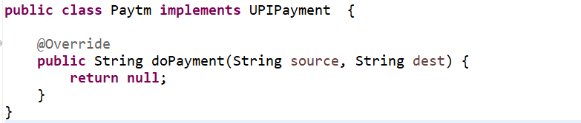
So, there are no compilation error its up to us either we want to implement this or not.
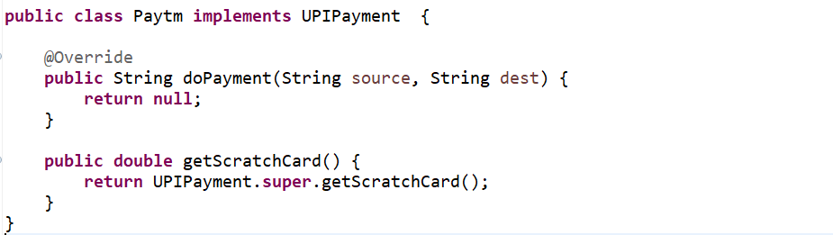
It’s up to me either I can provide the parent or super class feature or if u want to customize it you can add.

- This static method will be act as a Utility class. Let’s say I am creating a project and I can define a Utility class and I can add few of the methods which is widely used in my project or repeatedly I am using that piece of code so I can keep them as a static method in my utility class.
- But rather than doing that you can keep inside a same interface which is being used as part of your implementation.
Let’s simplify this…
So, when a user is doing a payment, I want to return a payment Id or the transaction Id as well as the date, at what date you did the transaction.
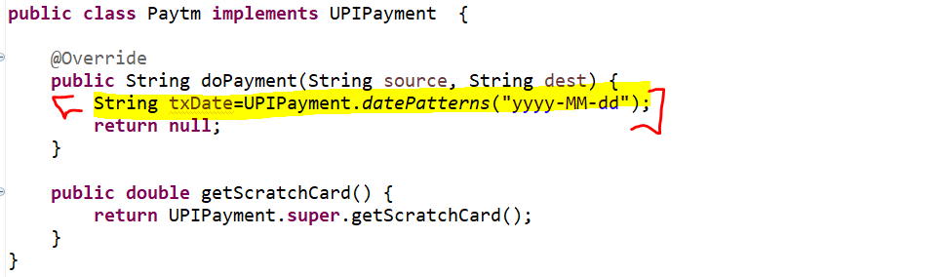
Since all the Implementation class wants to use this datePattern() methods rather than creating a separate utility class I added in the same interface which is being implemented in the multiple classes.

5. Can we extends functional interface from another functional interface.
Yes, we can extend but if you extend that your functional interface will not act as a functional interface. Bcz it will find multiple abstract methods inside that.
We already created a functional interface called UPIPayment.
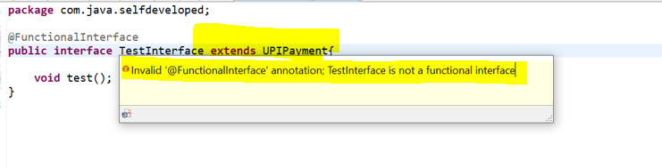
Actually, java have no restrictions to do that you can do that but if you do that your functional interface will not act as a functional interface. Now you can see there will be 2 abstract methods. So, if u remove @FunctionalInterface it will act as a normal interface. So, if u are extending your functional interface will behave as a normal interface.

Q. Java 8 Stream Intermediate and Terminal Operations?
Java 8 Stream has many operations which can be pipelined together to get desired result. Some operations produce another stream as a result and some operations produce non-stream values as a result. The operations which return another stream as a result are called intermediate operations and the operations which return non-stream values like primitive or object or collection or return nothing are called terminal operations.
1) The main difference between intermediate and terminal operations is that intermediate operations return a stream as a result and terminal operations return non-stream values like primitive or object or collection or may not return anything.
2) As intermediate operations return another stream as a result, they can be chained together to form a pipeline of operations. Terminal operations cannot be chained together.
3) Pipeline of operations may contain any number of intermediate operations, but there has to be only one terminal operation, that too at the end of pipeline.
4) Intermediate operations are lazily loaded. When you call intermediate operations, they are actually not executed. They are just stored in the memory and executed when the terminal operation is called on the stream.
5) As the names suggest, intermediate operations doesn’t give end result. They just transform one stream to another stream. On the other hand, terminal operations give end result.
6) Intermediate Operations :
map(), filter(), distinct(), sorted(), limit(), skip()
Terminal Operations :
forEach(), toArray(), reduce(), collect(), min(), max(), count(), anyMatch(), allMatch(), noneMatch(), findFirst(), findAny()
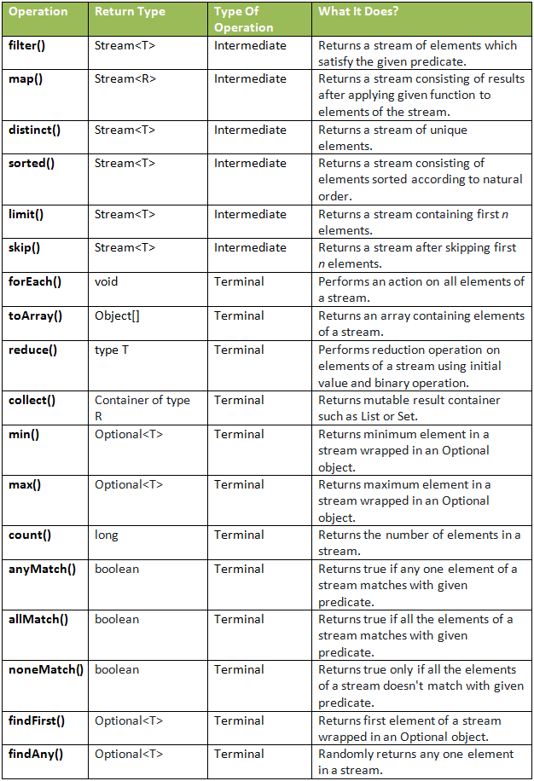

- Functional Interface & Lambda Expression
Lambda Expression -> The Expression through which we can represent an Anonymous function.
Anonymous : Nameless / Unknown
Anonymous function : A method who don’t have any name or modifier.
Syntax:- parameter Expression Body
() -> System.out.println(“Lambda Syntax”);
So, here m1() is our normal function and marked one is an Anonymous Function. So, we do have a question like if this method doesn’t have a method name or prefix then how we will call this method using object.
Note: For Every method we can’t write the Lambda Expression, Lambda Expression only can be applicable for Functional Interface. So, the Method which is present into a Functional Interface for that only we can write the Lambda Expression.
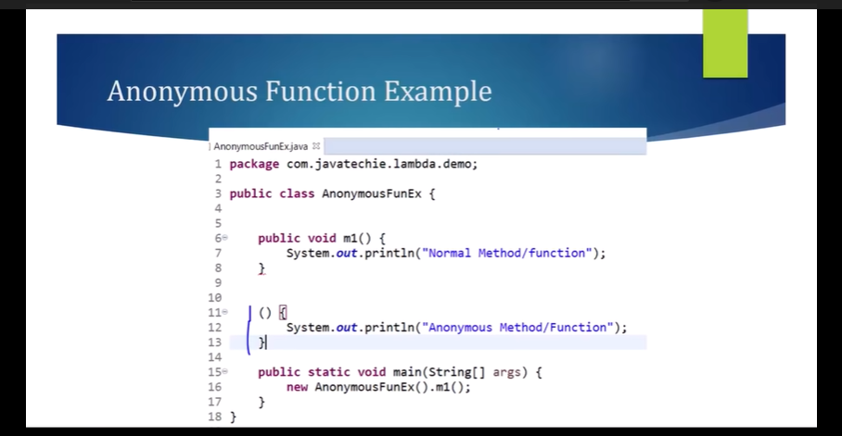
What is Functional Interface????
As we all know like In Java 8 Inside an Interface we can write a Default Method as well as the static method, But If the Interface contains only one Abstract Method, then only, we can say that Interface is a Functional Interface. So, as you observed that Runnable, Callable, Comparable and Comparator are Functional Interface because these all Interface contains only one abstract Method.
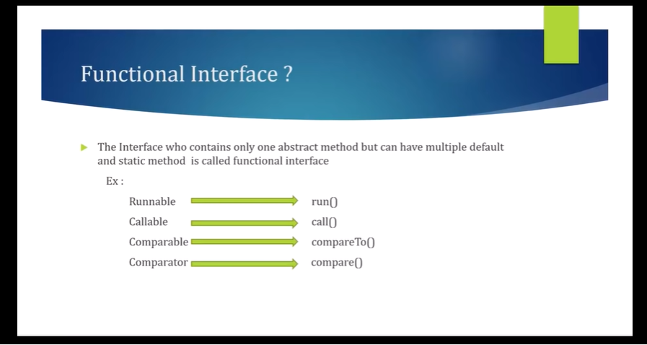

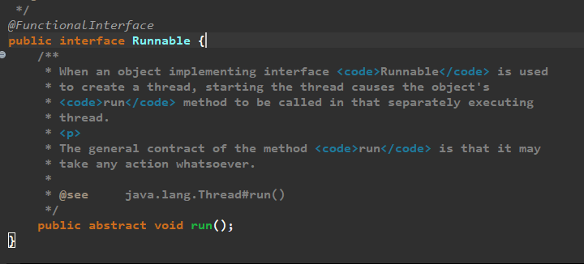
Like this we can write our own Functional Interface. So, it doesn’t matter for the static and default method If the Interface contains only one Abstract method, then we can say that Interface is a Functional Interface.
Note: For Functional Interface the Method which is Abstract for that one only we can write Lambda Expression. So, we can convert this m1() method to Anonymous Function using Lambda Expression.
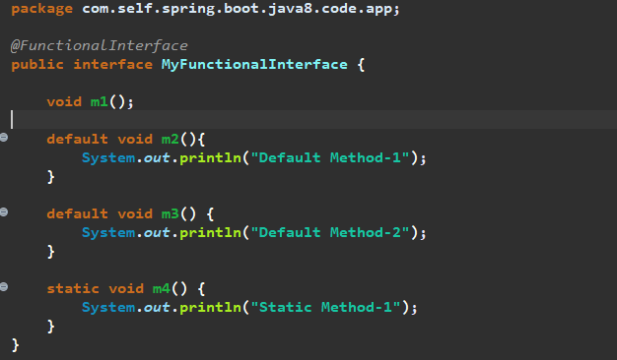
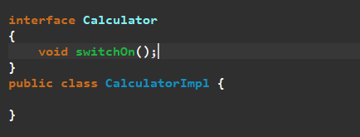
We are going to write the lambda expression for the switchOn() method. So. Lambda Expression is nothing we just need to convert this Traditional method into Anonymous Method Using Lambda Expression. So, let’s write a lambda expression for this switchOn Method.
If we will create 2 Abstract Method, then it won’t be a Functional Interface and lambda Expression will throw an Error….
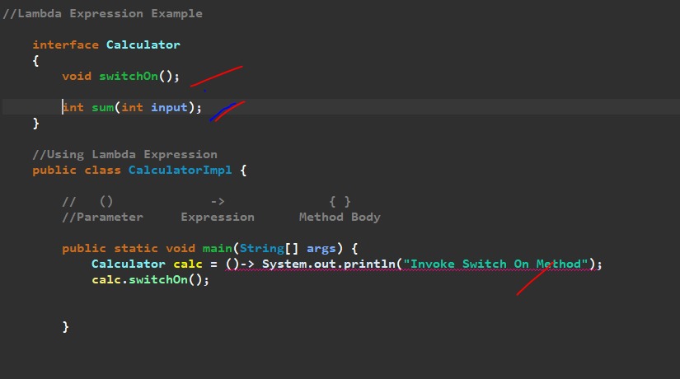

//Lambda Expression Example
interface Calculator
{
//void switchOn();
//void sum(int input);
int substract(int i1,int i2);
}

//Using Lambda Expression
public class CalculatorImpl {

// () -> { }
//Parameter Expression Method Body

public static void main(String[] args) {
// Calculator calc = ()-> System.out.println("Invoke Switch On Method");
// calc.switchOn();

// Calculator calculator =(input)->System.out.println("Sum = "+input);
// calculator.sum(135);

Calculator calculator=(i1,i2)->{
if(i2>i1)
return (i2-i1);
else
throw new RuntimeException(i2+" is Less than "+i1);
};

System.out.println(calculator.substract(12, 9));

}
}

//In Our Traditional Approach
// public class CalculatorImpl implements Calculator
// {
// @Override
// public void switchOn() {
// System.out.println("Invoke Switch On Method");
// }
//
// public static void main(String[] args) {
// new CalculatorImpl().switchOn();
// }
//}

Real Time Example for Functional Interface & Lambda Expression
We will take a Book Example and then we will sort Using Comparator using Lambda Expression Java 8…
Traditional way of Sorting…..
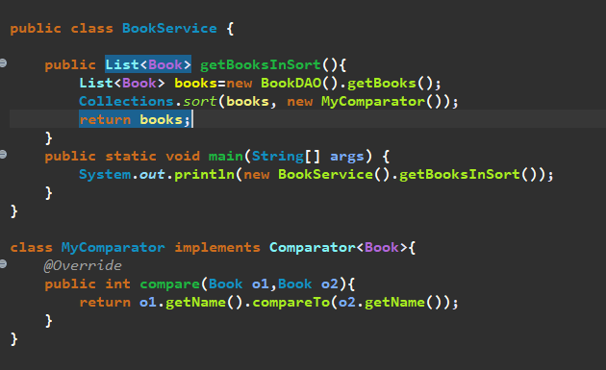
We can write this in another way using Anonymous Function for Functional Interface….Since Comparator is a Functional Interface so we can write Lambda Expression also for the method compare…
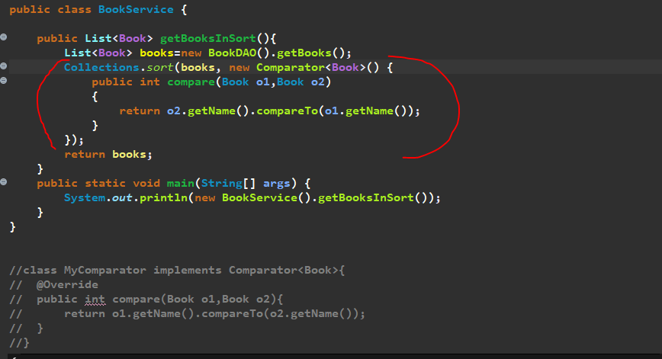
Using Lambda Expression…So we need to write the Lambda Expression for the Anonymous Function method compare()…so we don’t want any method name and Prefix…and no need to pass the data type of arguments so just remove…we just need the Expression and the body…since we are passing only one line so no need to give the bracket as well…so we can pass below instead of comparator…
(o1, o2)-> o2.getName().compareTo(o1.getName())
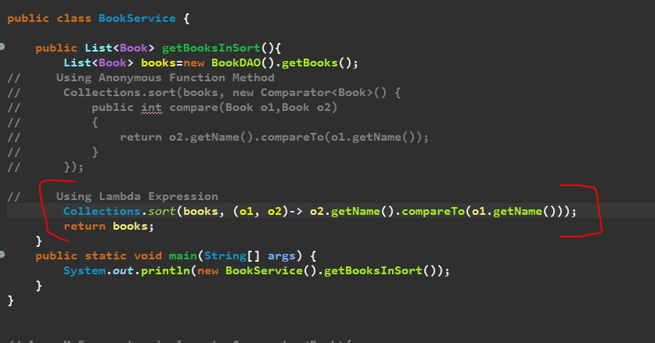
Since Comparator is our Functional Interface that why we are able to represent the compare() method using lambda expression.
For other Interface we can do like that only for functional Interface we can write lambda expression…

==================<< END of Lambda Expression >>=====================

====== Predefined Functional Interfaces : Consumer, Predicate & Supplier =======
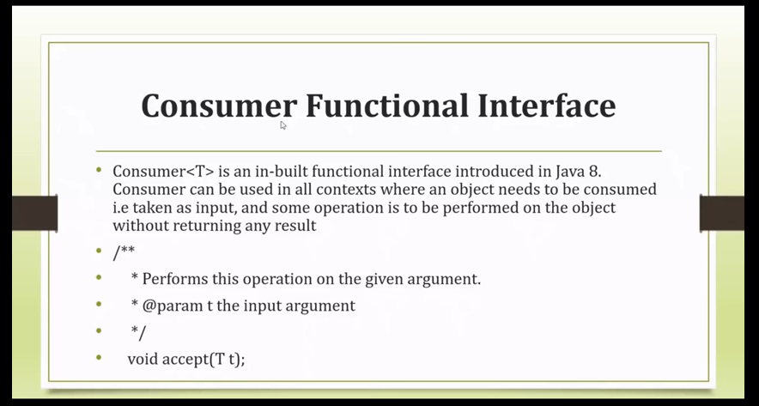
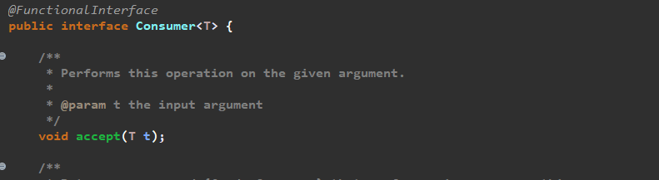
Note: Consumer is a Functional Interface which contains one abstract method. Abstract method which is taking input as generic object it can be any type of object and it is not returning anything, so the return type is void that means pass the input and perform some operations based on input or simply we can say either we can print, or we can do manipulation logic based on that given input.
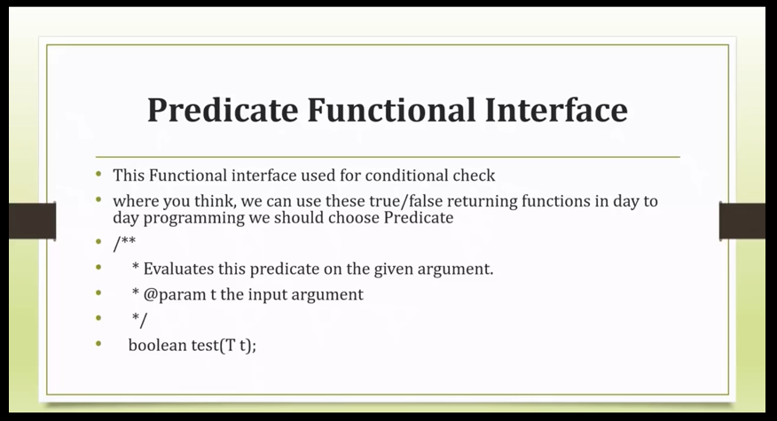
So, Based on the Input Argument it will always do the conditional check or perform some conditional operation and return output as a true or false as a Boolean value.
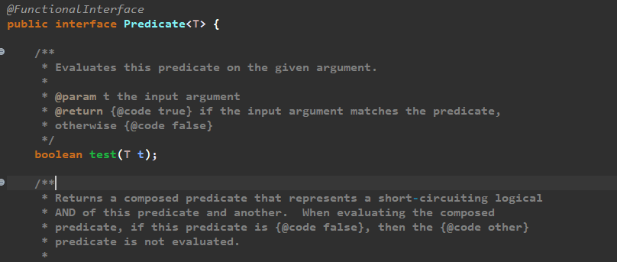
So, this Functional Interface contain one abstract method test, which take object as an input and after performing the operation it will return boolean (true/false) as an output.
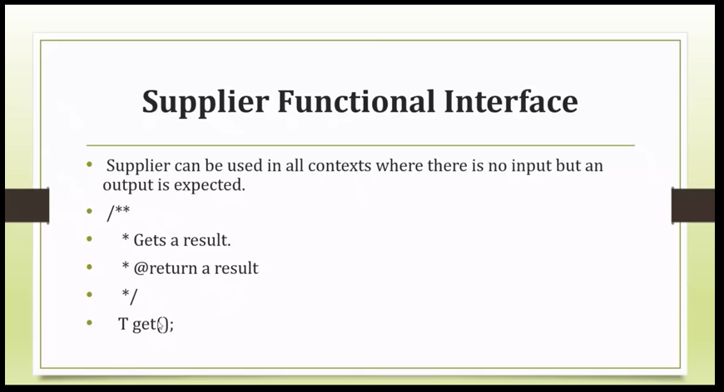
Supplier Functional Interface contain one abstract method that is get() it doesn’t have any input parameter, but it always returns as a Generic Type object. So, always It expect a return type.
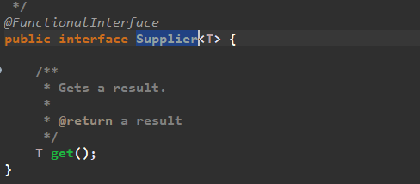
For example, just consume we are using list of 10 object, and we are performing some operation on it after that we are not returning anything so If I want to return some dummy result we can use Supplier, In that case. As an example, we are using list of 10 employee record object we are performing some percentile operations on it then we want to return some dummy result then we can go for a Supplier.
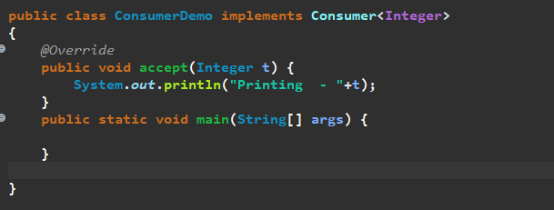
This accept is an abstract method which present into a Consumer Functional Interface so we can write a Lambda expression for it.so we can write a lambda expression for this accept method.
So, lets remove the implements Statement. Let’s copy paste accept method into a main method. So, we want to make it Anonymous Function, so we don’t want any method name and prefix lets remove it. And no need to specify data type also so just remove it. So now we have the parameter we have the method body only we have to add the lambda expression. And then we need to assign it to the functional Interface i.e here Consumer.
So, for the method of Functional Interface only we can write the lambda expression.
Consumer Interface contain the accept method so directly we can call using Interface reference.
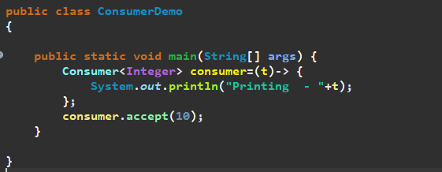
Since, only one argument so no need to give the bracket as well…
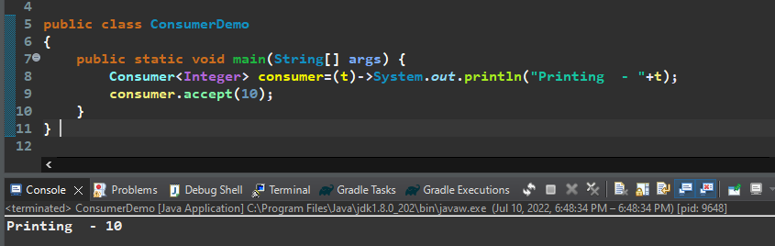
So, this accept method only take one input parameter and perform operations on it , it will not return any output.
So, In Java8 Stream API there is a method called forEach() method which always accept the Consumer Functional Interface. And consumer only can perform operation does not return anything, so we are just printing the value. So, instead of passing the consumer reference we can directly pass the lambda expression of the Consumer Functional Interface.
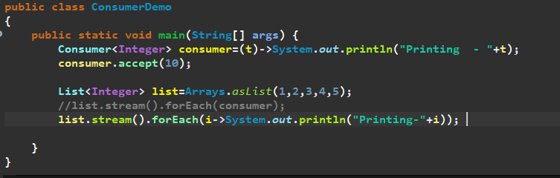
So forEach internally uses the Consumer Functional Interfaces, Consumer Internally uses the accept method.
Predicate Example:-
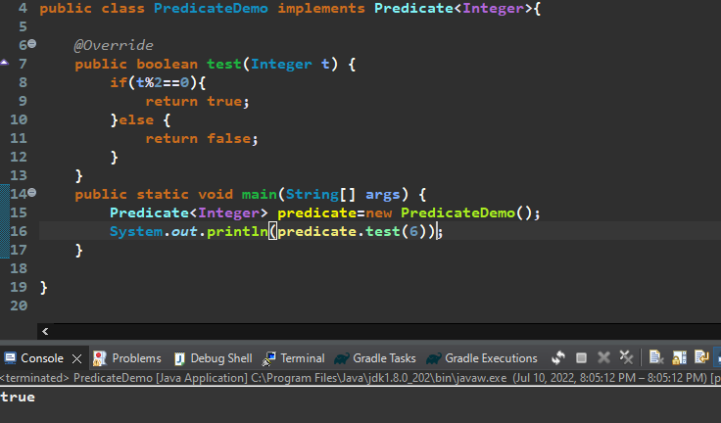
Now let’s make this traditional way into lambda expression…
So, let’s remove the implements Predicate Functional Interface. Let’s copy test method inside a main method then let’s remove the method name, data type and put Interface reference.
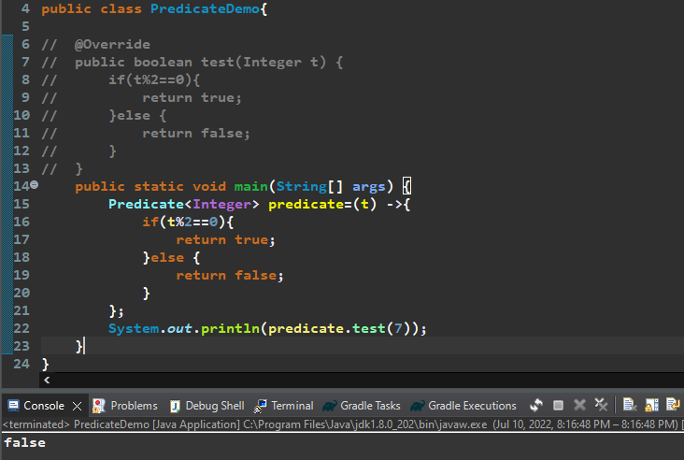
So, Predicate always returns either true or false based on our conditional check…
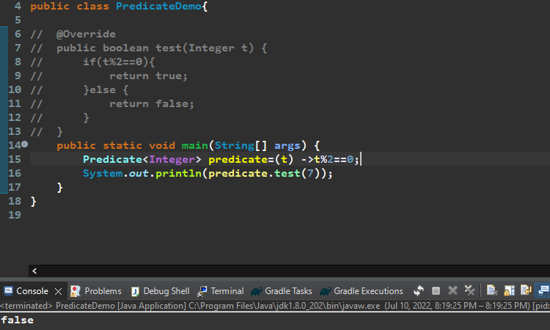
So, for an Example Stream API filter() method always use a Predicate Functional Interface….
Print only the Even Numbers from the list of Integers…...
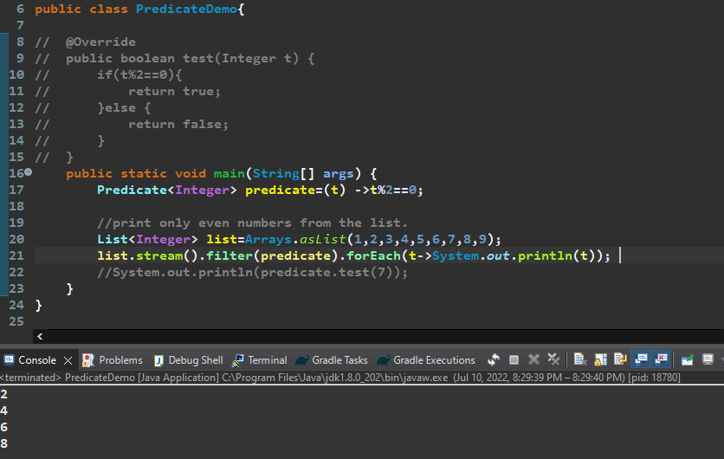
Let’s understand the Supplier Functional Interface …
So, Supplier which method doesn’t have any argument but it always expects some output.
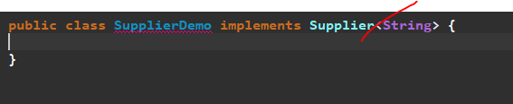
Means it will always return me the String value…
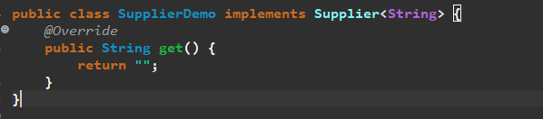
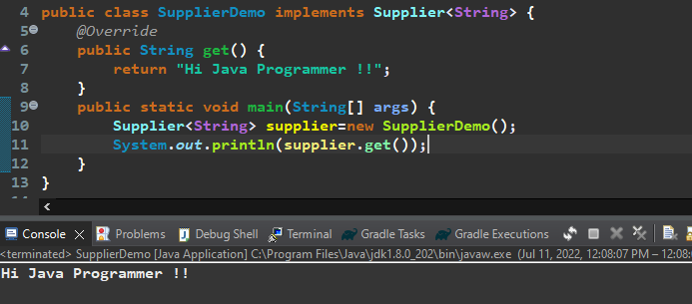
So, now let’s convert this traditional approach to lambda expression…
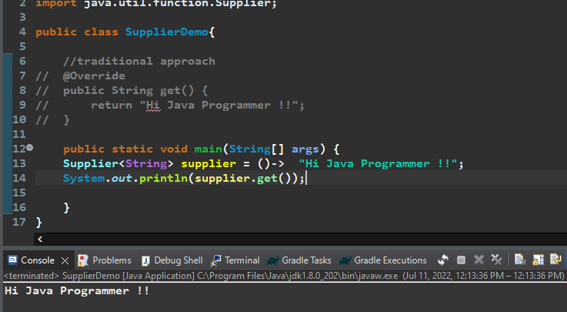
Supplier Functional Interface contain one method get() which always return a generic type.
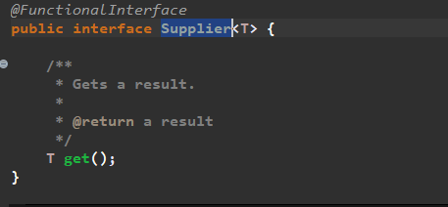
So, Supplier has only the return type no method argument….
In Real time Scenario In java 8 if we are doing filtering process and we are not getting any result, but you want some dummy data or some meaningful response in such case you can go for Supplier. orElseGet (Supplier) method get input as a supplier…..
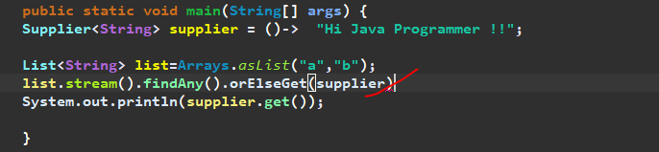
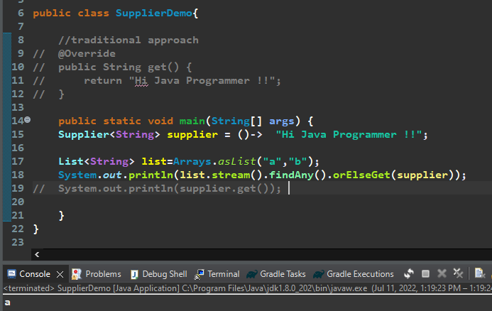
Since we do have a value in list i.e. a and b so it’s printing any one value…. but if list doesn’t contain any values… then supplier provide the dummy value. As list is empty…
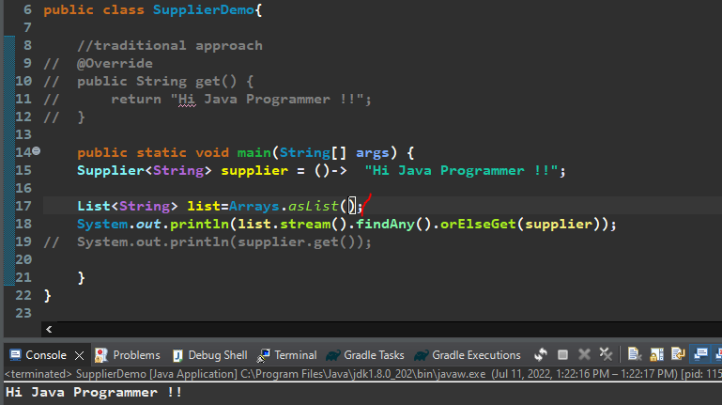

===================End of Consumer, Predicate & Supplier==================

=========== JAVA 8 Stream API | forEach | Filter Method Example ==========
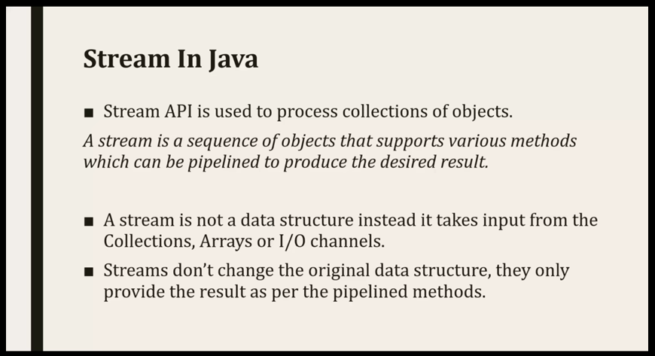
So, Stream won’t change any data structure it just performs operations based on pipeline provided method and gives a desired Result.
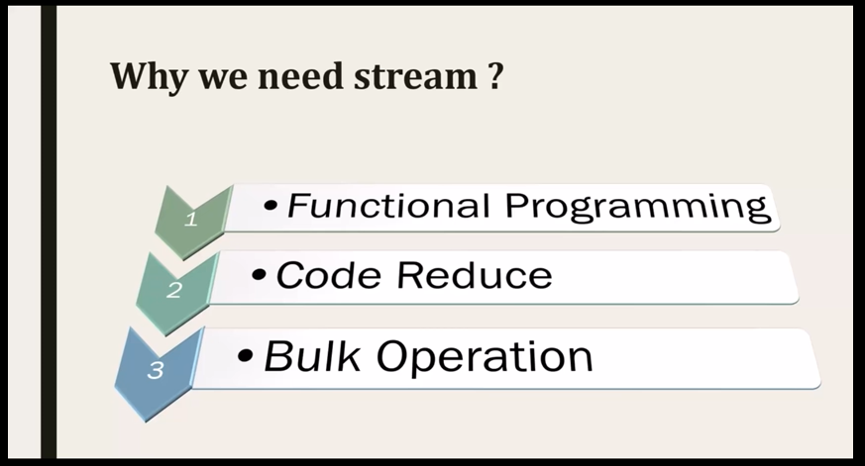

- first advantage is we can achieve Functional Programming, means If we have a Functional Interface then I can represent that with lambda expression.
- Second one is Code Reduce If you are using the lambda expression then length of the code will be minimized. And already we are aware for pipeline methods so if u do method chaining then the length of the code will reduce.
- Third one is bulk operation, If I have a collection with huge data and I want to perform some operation then I should go for Stream API.
Because as per our Traditional Approach Stream will gives us a Better Performance
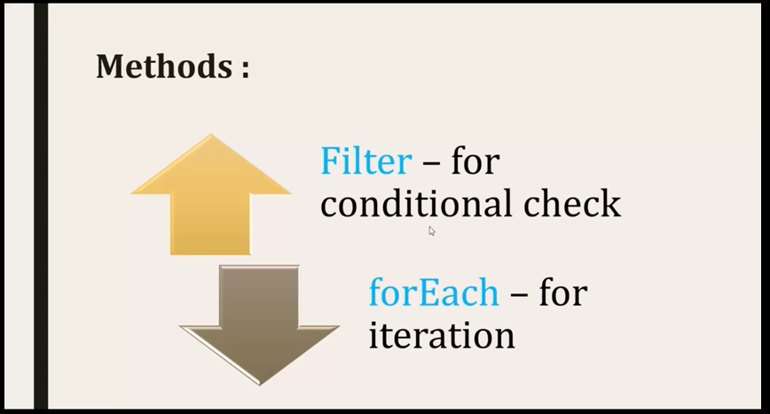
Let’s see Internal Structure for Filter and ForEach Method…..
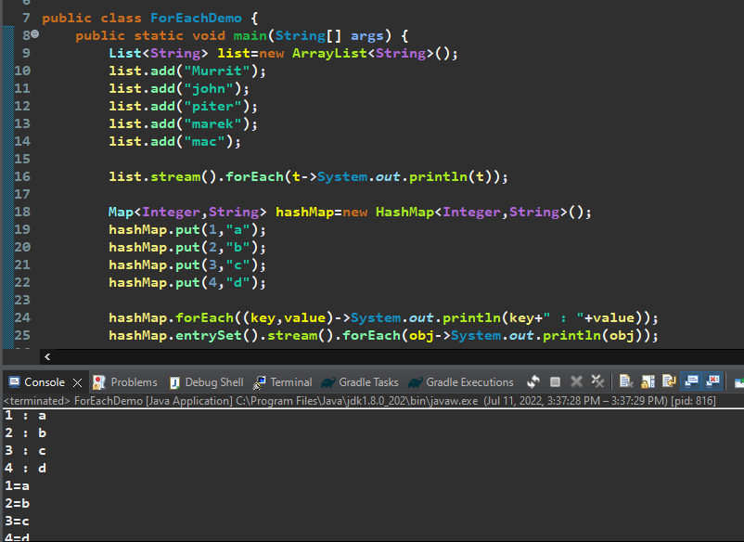
Note:-
hashMap.forEach( Bi-Consumer) -> It takes input as Bi-Consumer means 2 input one output
hashMap.entrySet().stream().forEach(Consumer)
list.stream().forEach(Consumer)
list.forEach(Consumer)

** How forEach() method works Internally?
As we know forEach() consume argument as a Consumer Functional Interface. And the Consumer Interface have the method called the accept() method which consume one parameter and doesn’t return any value. I am just taking the input and printing it…that’s what foreach() is doing…
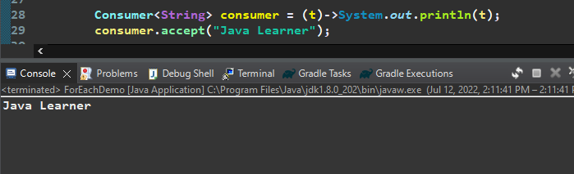
So, whatever we are passing to accept method its simply print the result, same thing forEach() method also do it just iterate the list and call consumer.accept() method to print all the results.
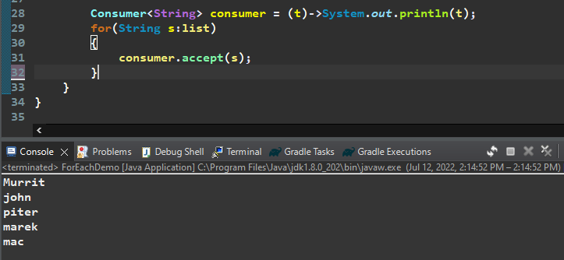
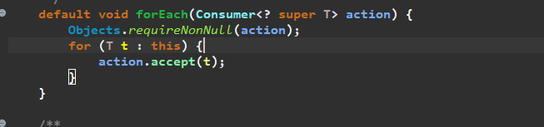
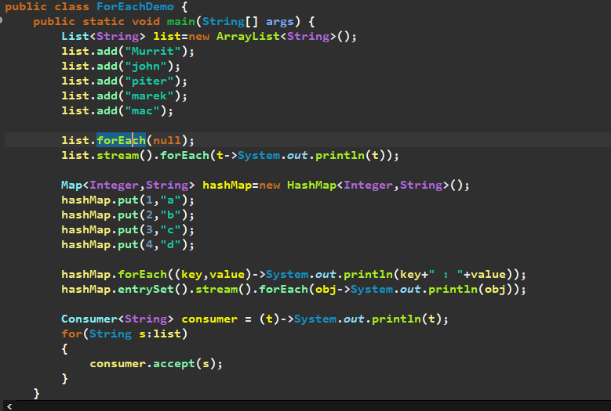

Let’s discuss for filter () method: -
Filter Conditional Check
Suppose I have a list of Objects and I want to Iterate it based on some condition.
We need to find the string which starts with M…
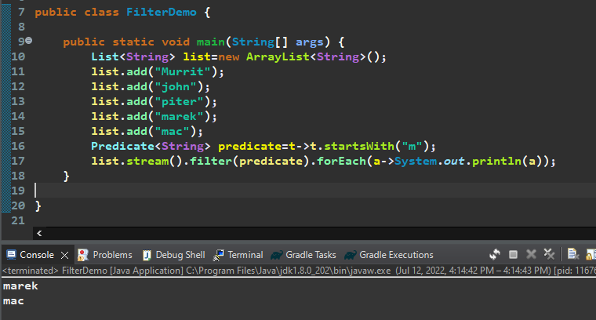

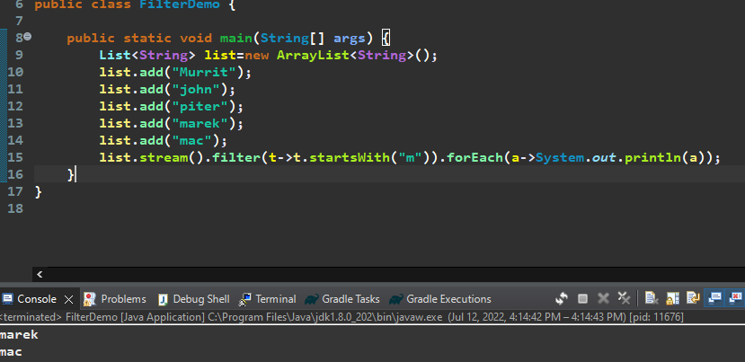
So, Filter internally using the Predicate Functional Interface, Predicate Internally having one abstract method i.e test () method, so we are writing lambda expression for that test method…
Let’s filter the map…
Get the Even key from the maps….
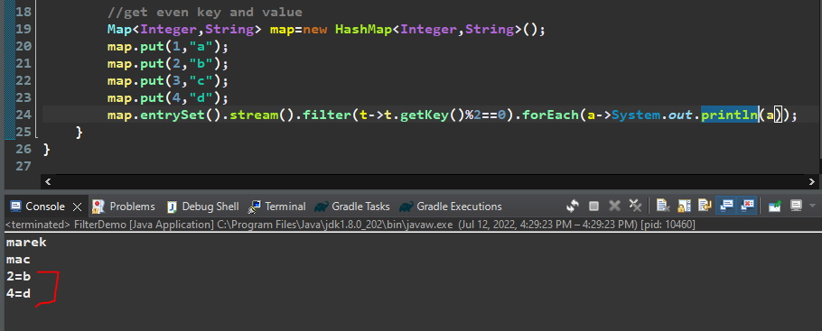
Realtime Example for Stream & filter-----
// I want to write a logic for An Employee who is eligible to Pay the Tax and who is not Eligible to Pay the Tax.
An Employee who is having Salary more than 5 Lakhs is Eligible to Pay the Tax.
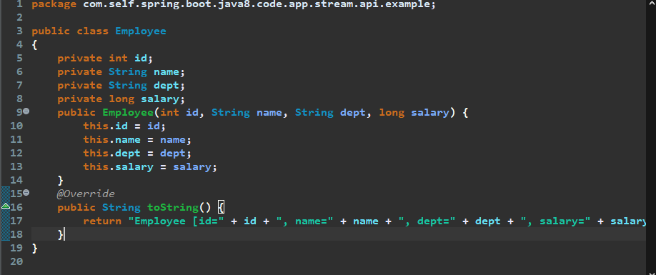
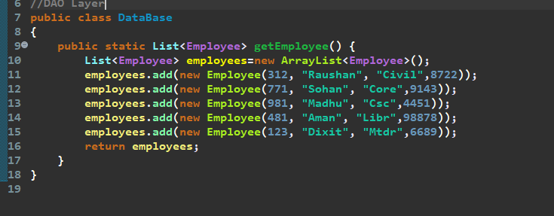
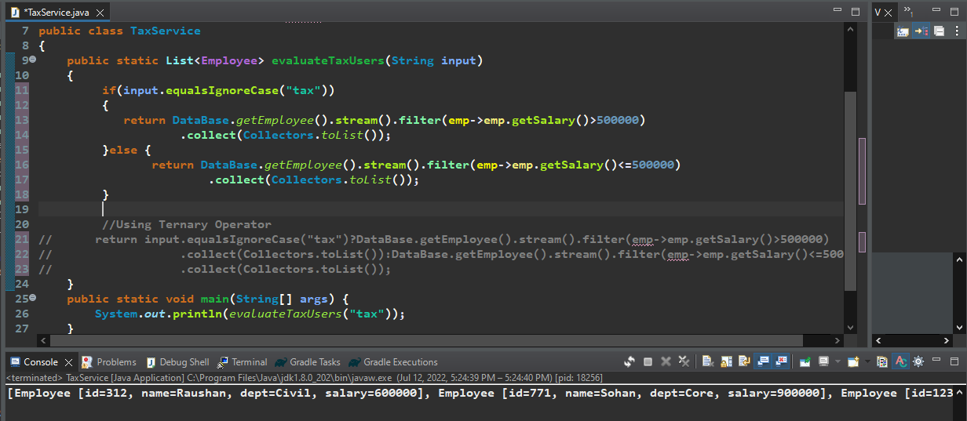
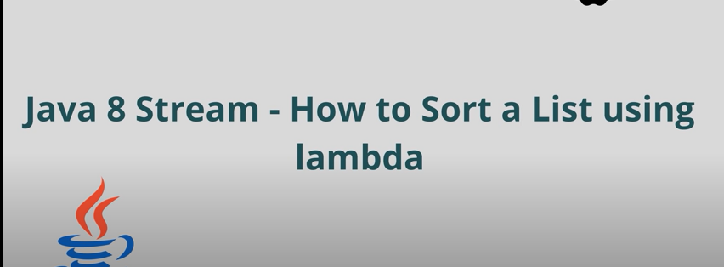
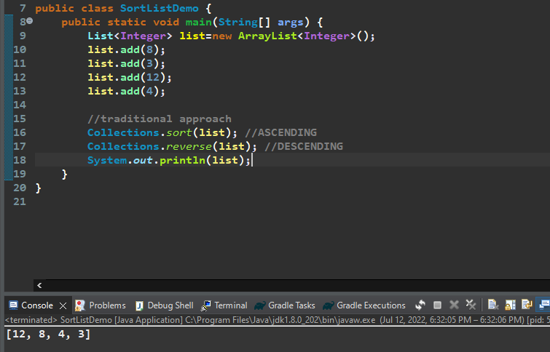
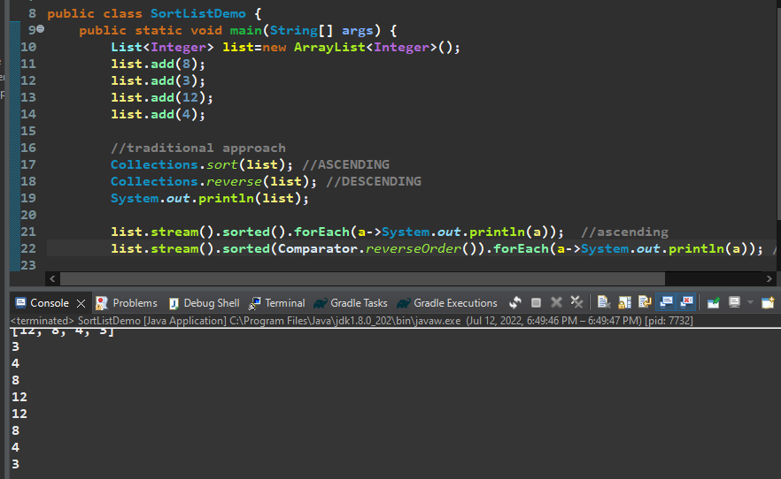
Suppose If we have a Custom Object and we want to sort based on few of the Fields…
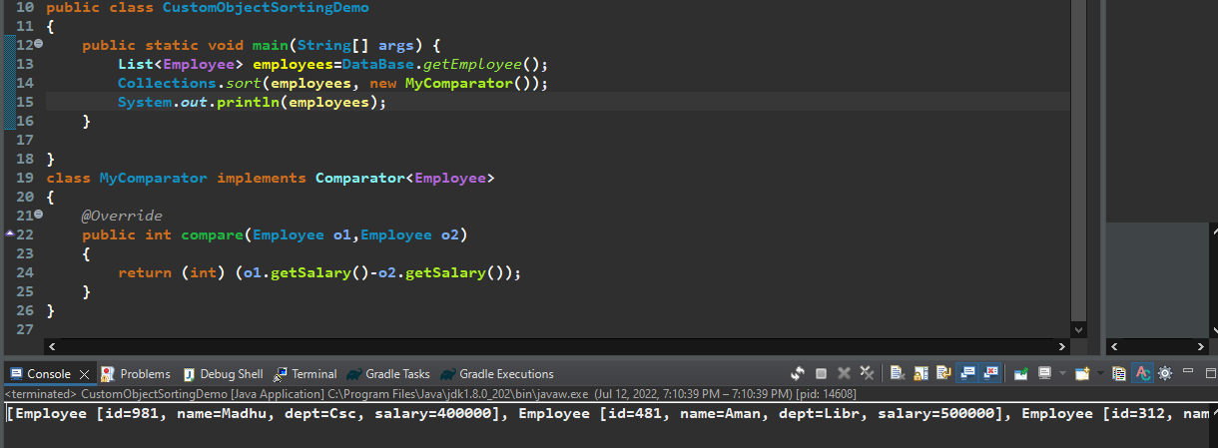
So instead of writing the traditional way …AS My Comparator is an Anonymous Function and Comparator is our Functional Interface so we can convert compare () method using lambda expression…
Now we are going to represent the Anonymous Function of that Interface….
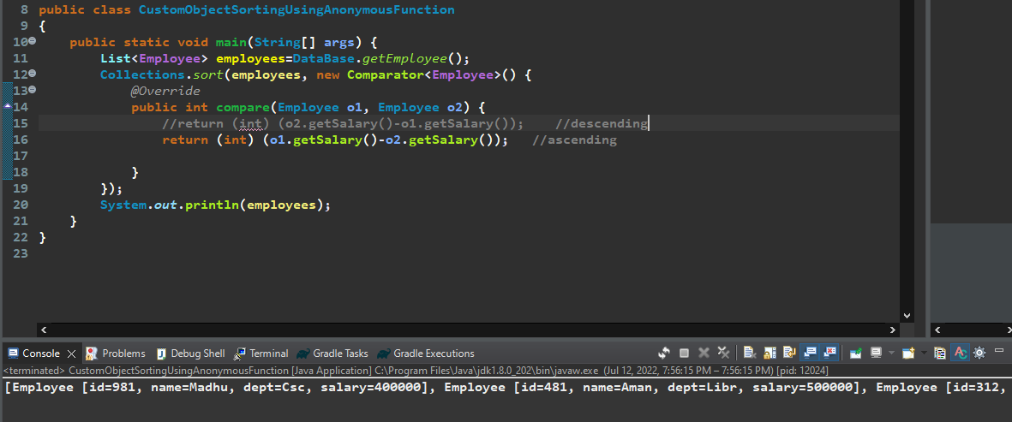
Now let’s convert this Anonymous Function into lambda expression
So, this comparator is having only one compare () method with 2 arguments so we don’t need any method name data type we just need parameter, so instead of anonymous function we can write a lambda expression….

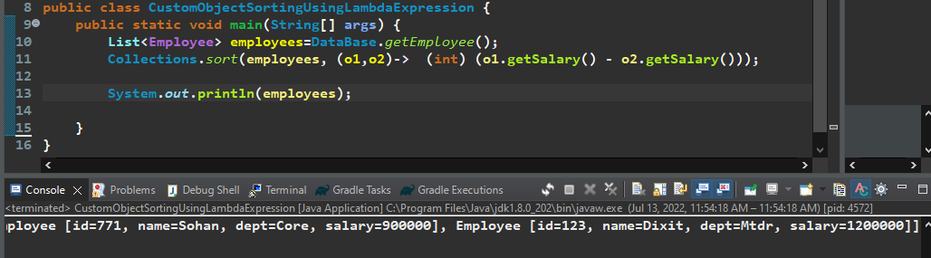
Just changing the object reference we are getting into descending order….
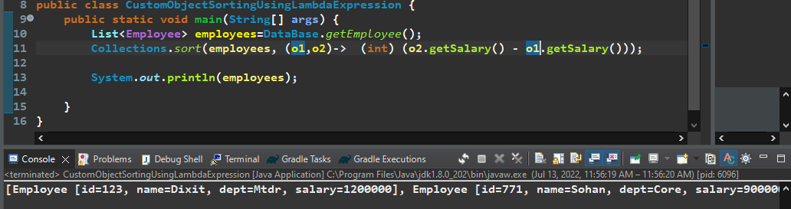
Now let’s see how we can sort using stream API
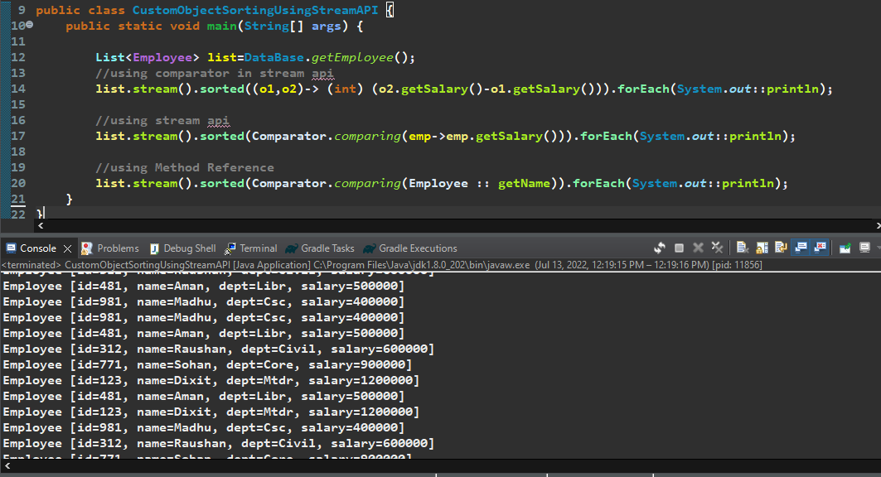

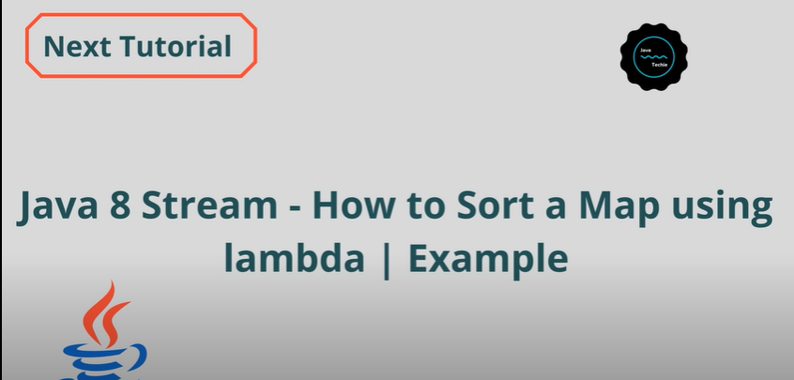
Using Traditional Approach –
,
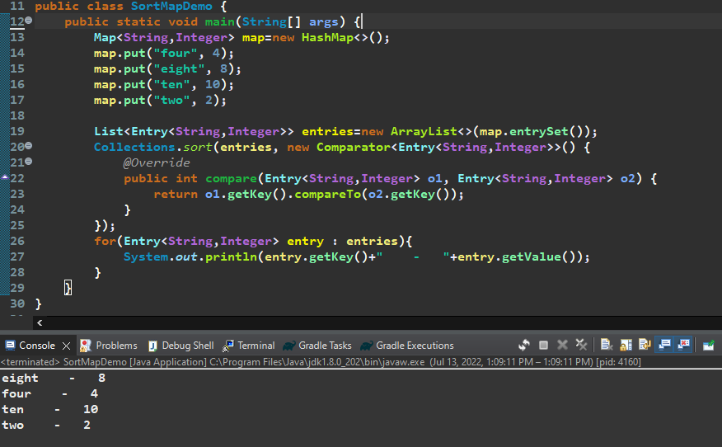
Using Lambda Expression lets transform Comparator Functional Interface….
So, no need to give method name, data type ….
Let’s sort based on map values….
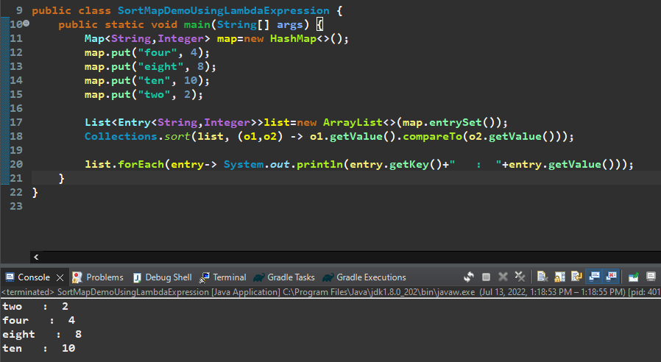
Let’s Sort Map Using Stream API----
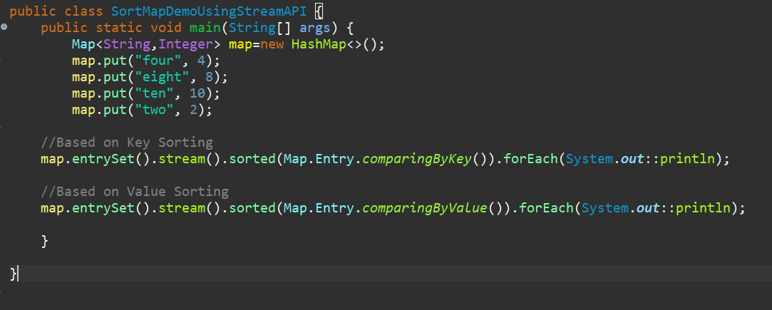

Sort Map Custom Key Object…
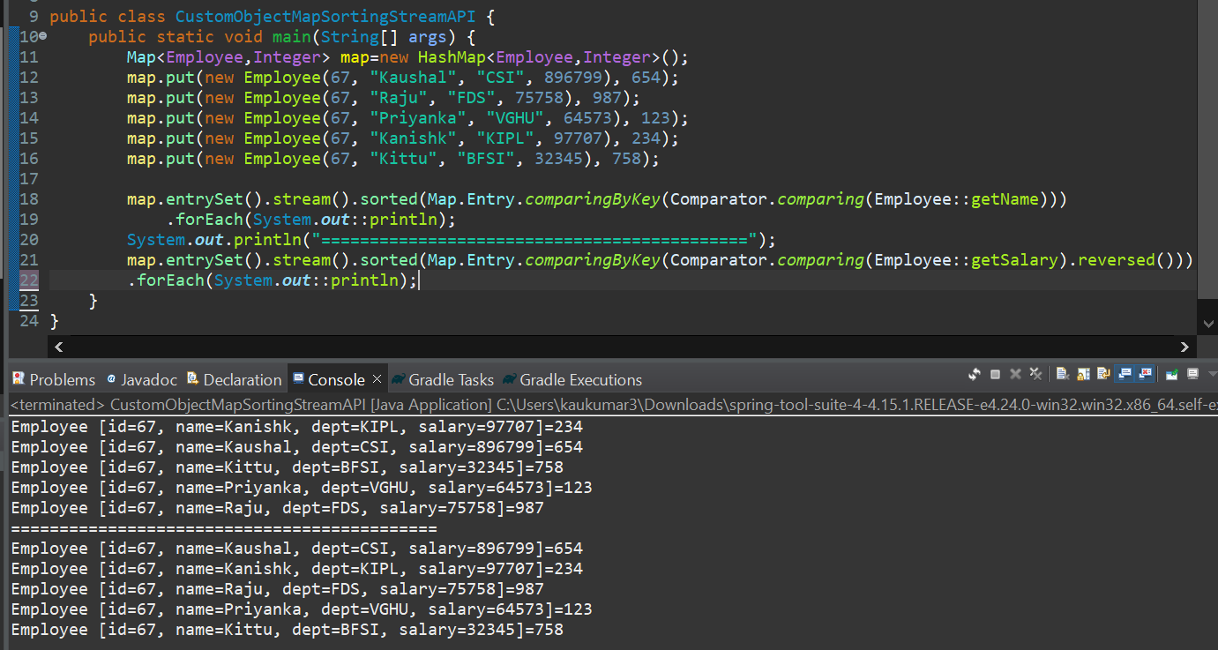

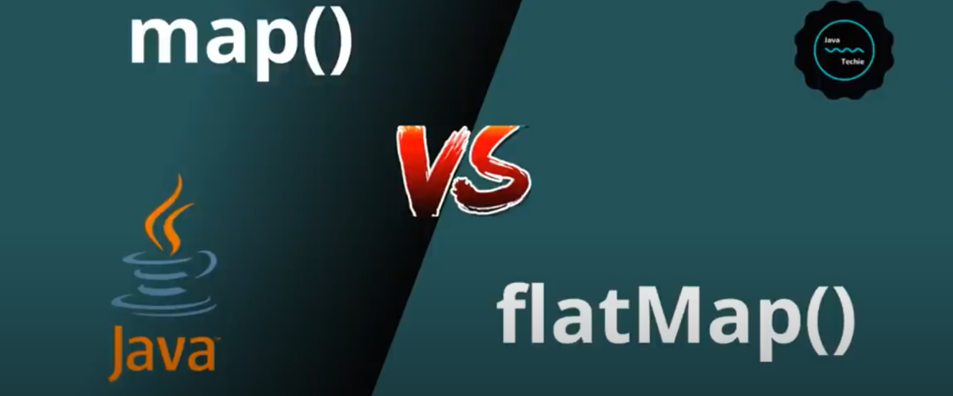

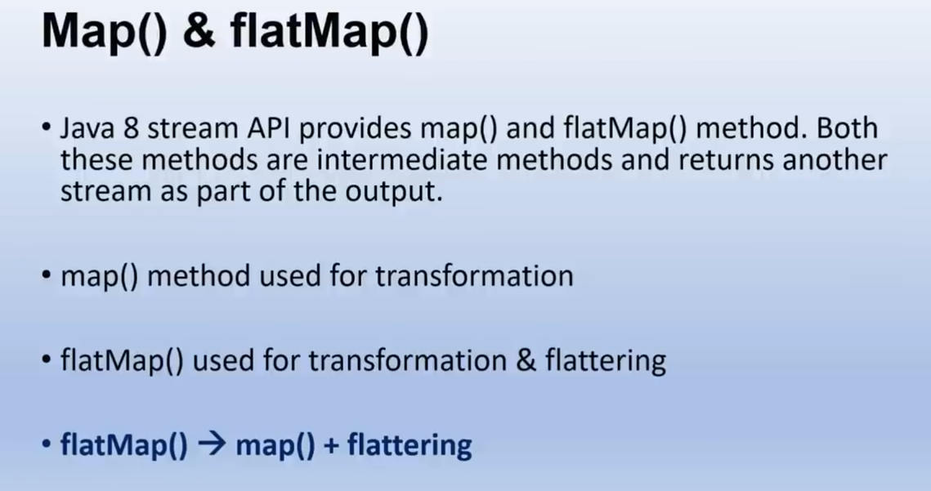
map() and flatMap() both are an Intermediate Methods and returns another stream as part of output.
map () method used for data transformation and flatMap() used for data transformation and flattering.
So, flatMap() is a Combination of both map() and flattering.
flatMap() -> map() + flattering.

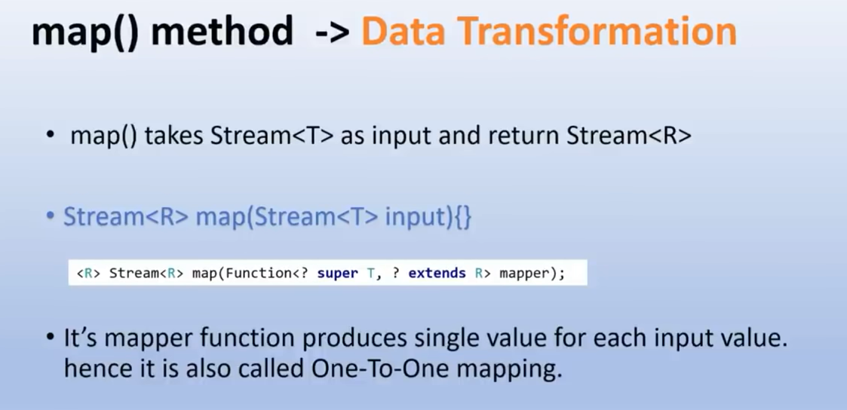
map () takes Stream as input and return Stream. Its mapper function produces single value for each input value. Hence it is also called One-To-One mapping.

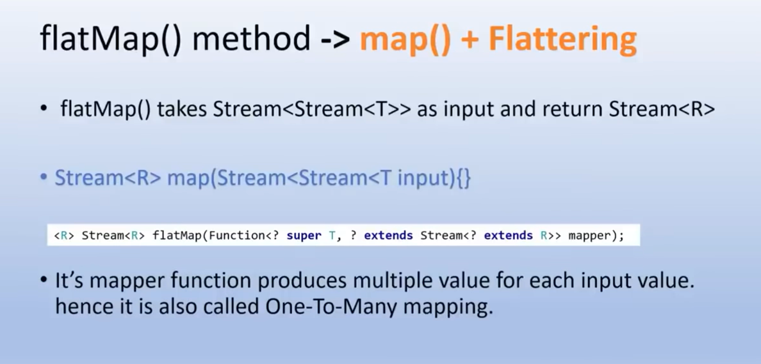
flatMap () -> used for data transformation as well as flattering the data. It takes Stream of Stream as an Input then convert Stream of Stream into a single Stream Object which is nothing called data flattering and then produce a Single Stream as an Output.
Its mapper function produces multiple value for each input value. Hence it is also called One-To-Many mapping.

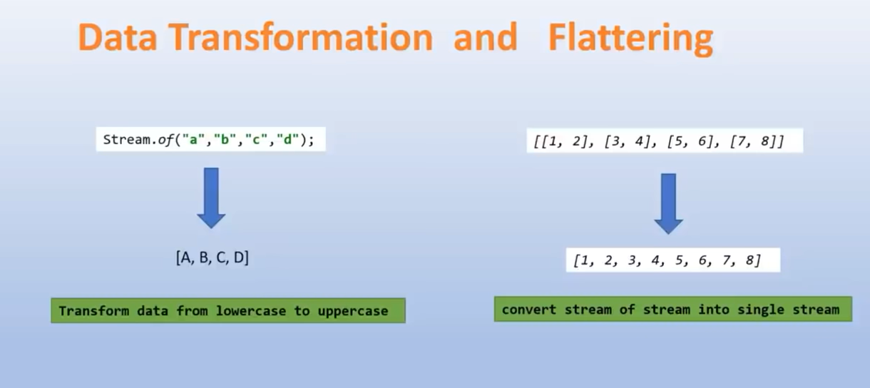

UseCase:- From List of Customer we need list of Email Id….
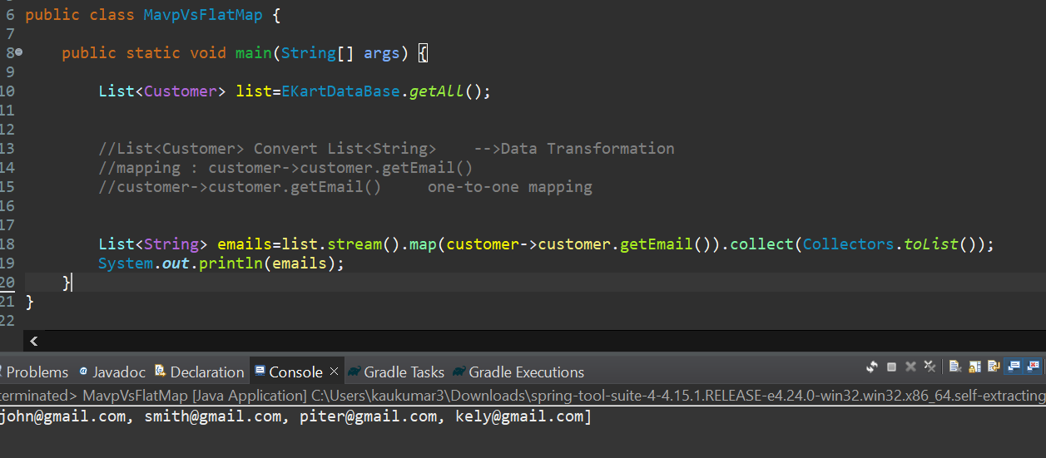
flatMap()-> from Customers we need phoneNumbers….
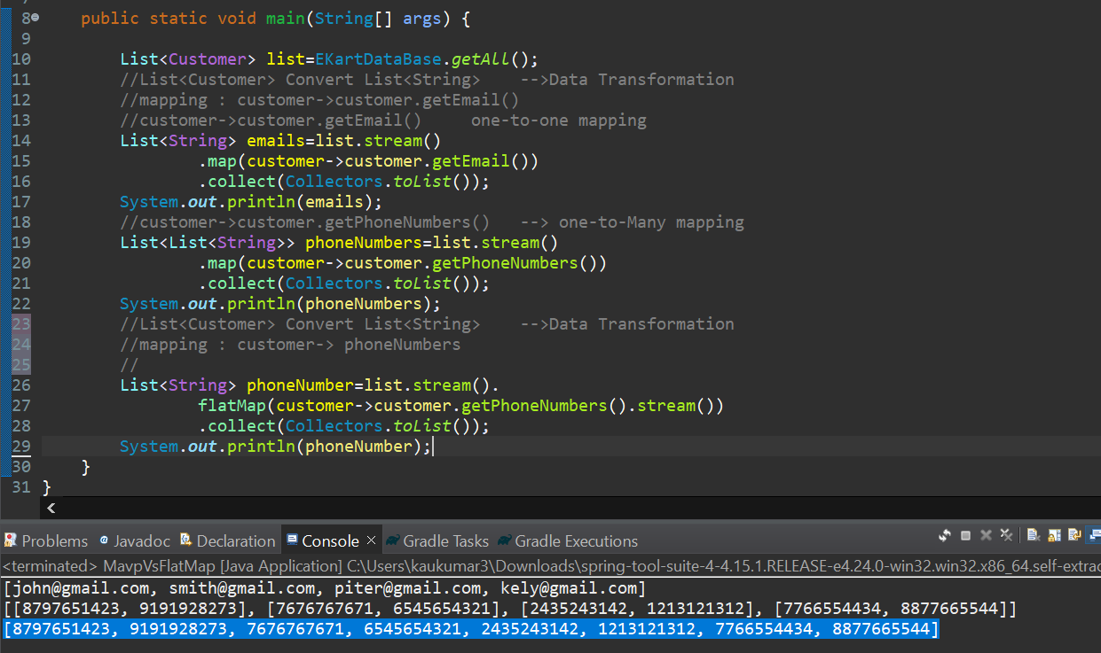

flatMap() takes Input as a Stream of Stream…..
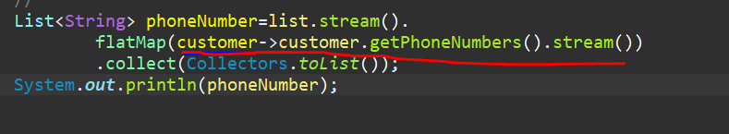
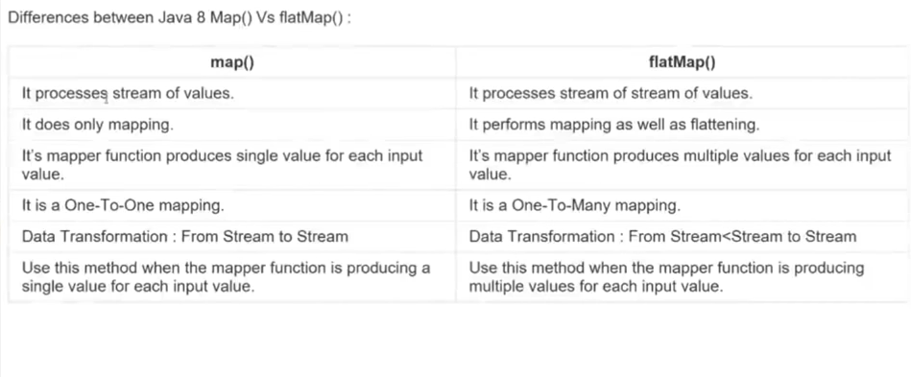

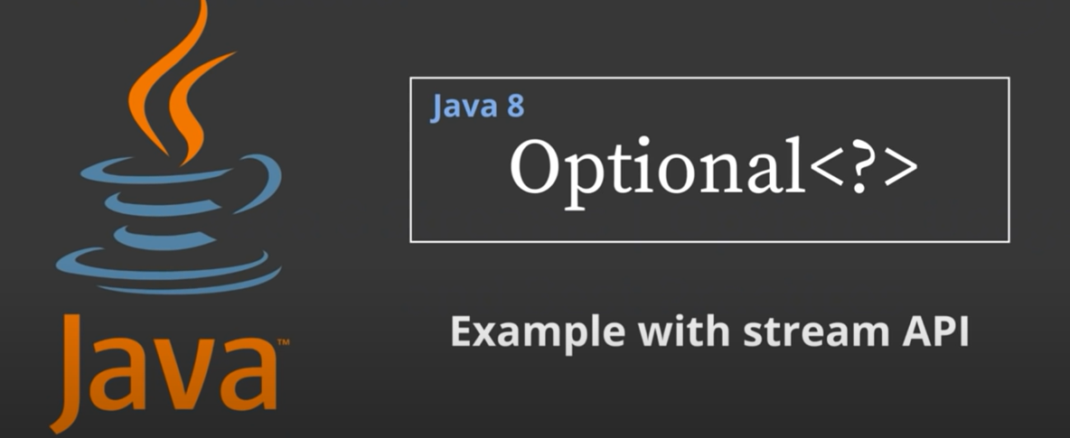
In our day-to-day life we always using Objects so either Object containing some data or Null value. So, If Object contain Null then our code will lead to Null Pointer Exception.
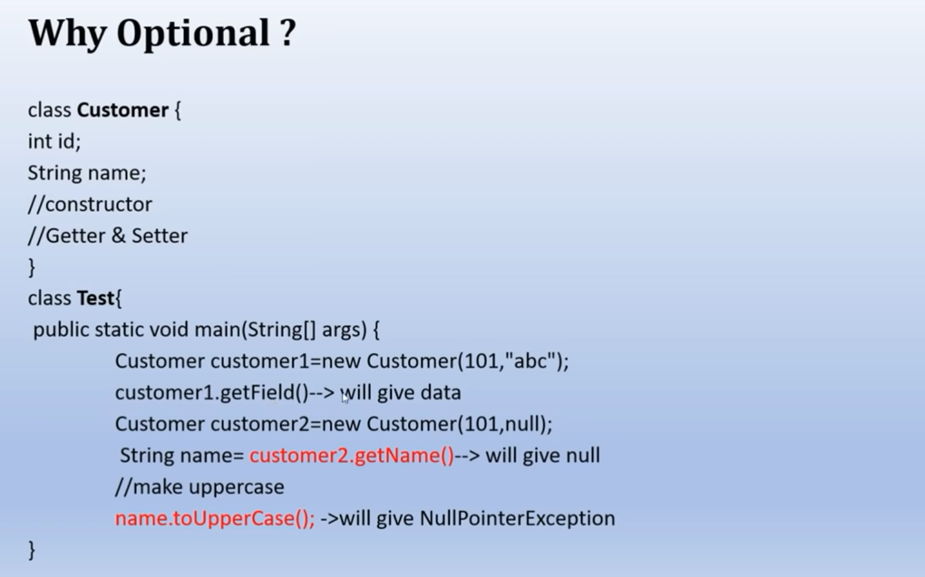
With a null reference if we do any operation, we will get Null Pointer Exception.
So, we can handle this by checking if (customer2.getName())!=null, but my question is how could I know this particular field value getting Null…here In our Customer only 2 field name and id so we can add null check but what if my Object contain 100 objects or attributes.
So, To avoid to write these many null checks and to avoid Unpredictable Null Pointer Exception Java 8 Introduces one class called Optional.
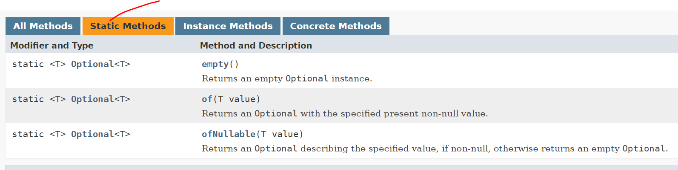
So, there are 3 ways to create an Optional Object ……using below methods
//empty
//of
//ofNullable
Since these all are static methods so we can directly call using Class name… If we go inside empty () method it will simply return an Empty Optional Object.
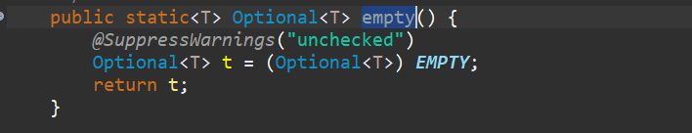
If you go inside EMPTY, it just creates an Optional Object and returned it.
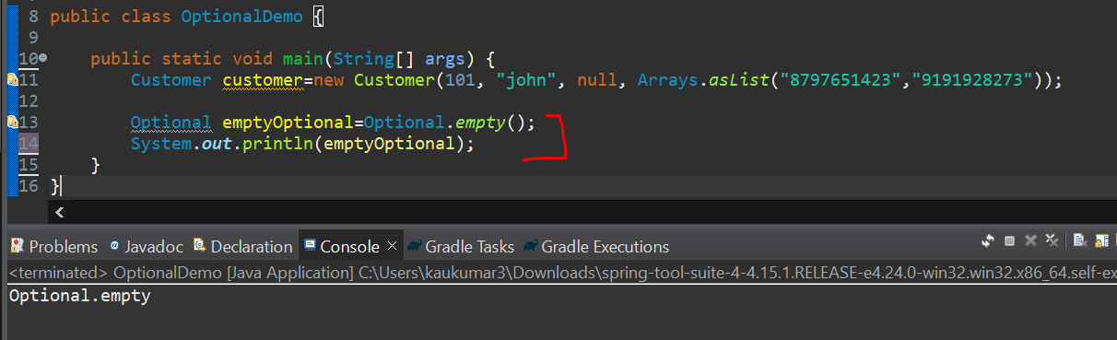
We are getting empty Optional…. there is another way to create an Optional Object…
---------------------
we have email as null, and we are using Optional.of() on it…so its throwing Null Pinter Exception…
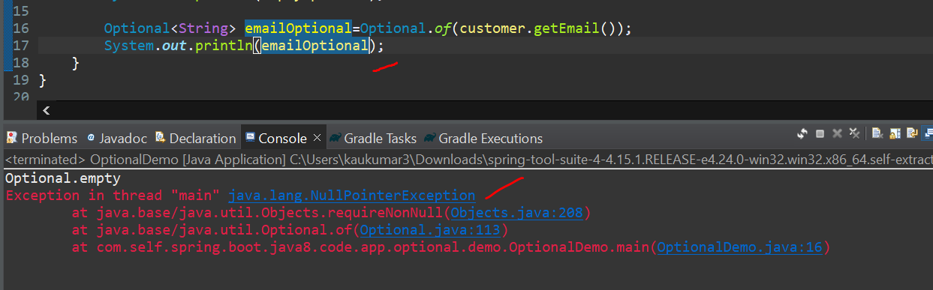
So when we sure that the object which is passing to the of() method is Not Null then only we should go for Optional.of() method…..
Let’s see Internal functionalities of of () method->
When we go inside of () method, its checking Objects.requireNonNull() for the passed value…
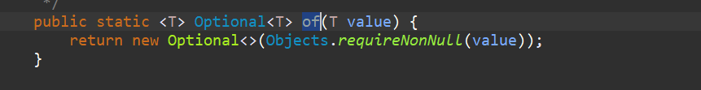
If we go inside requireNonNull () …if Object is Null its throwing Null Pointer Exception…
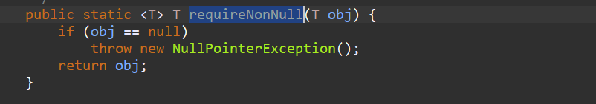
So, when we sure that the object is Not Null then only, we should go for Optional.of() method
--------------------------------------------
Optional.ofNullable()
So, If the Object is Null Return the empty Optional object instead of throwing the Null Pointer Exception, If the value Presents then just print the value.
Let’s go inside it…
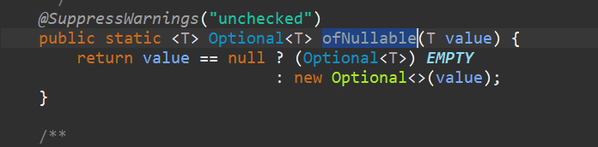\
So, If the value is null just return the EMPTY Object instead of throwing Null Pointer Exception or if value present just print the value.
Note: - So, ofNullable() is a combination of both empty () and of () method…
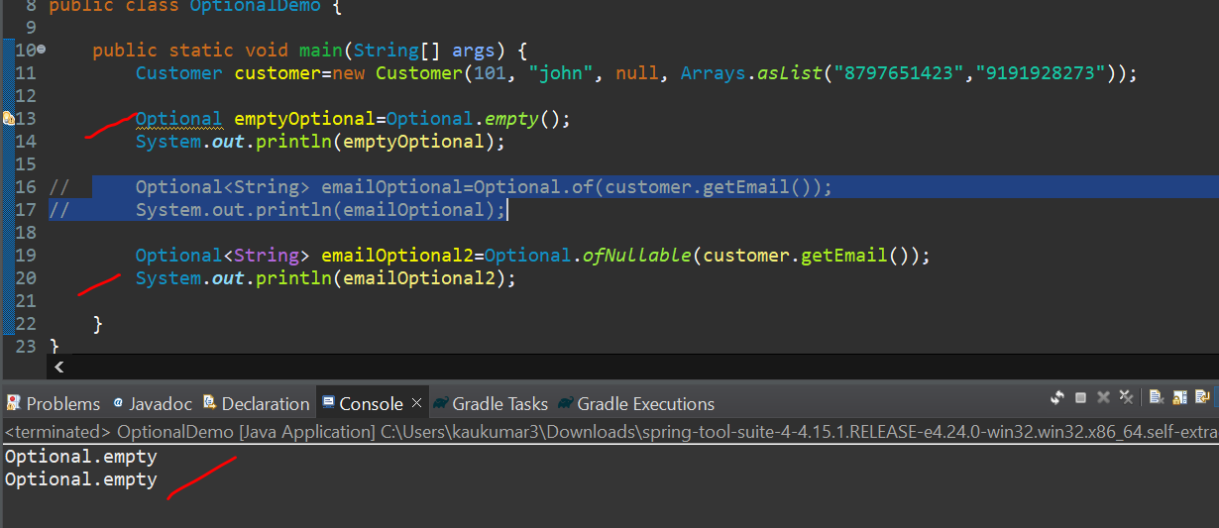
Now let me pass some value in email then try for ofNullable ()….
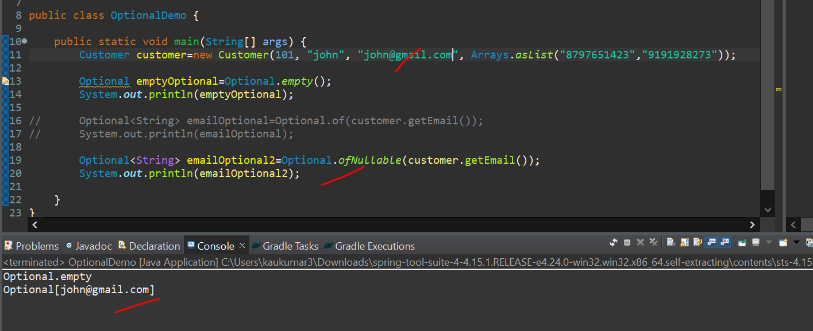
So, we saw 3 ways to create an Optional Object using of(), ofNullable() and empty() .
Note:- > If you make sure that the object which u are passing to of() method is Never Null then go for of() method, If you are thinking that the object what we are passing may or may not be Null then go for ofNullable() method.
Now let’s see some other in-build method of Optional.
isPresent() and get() method
if value is present then true else false and then use get() method to get actual value…
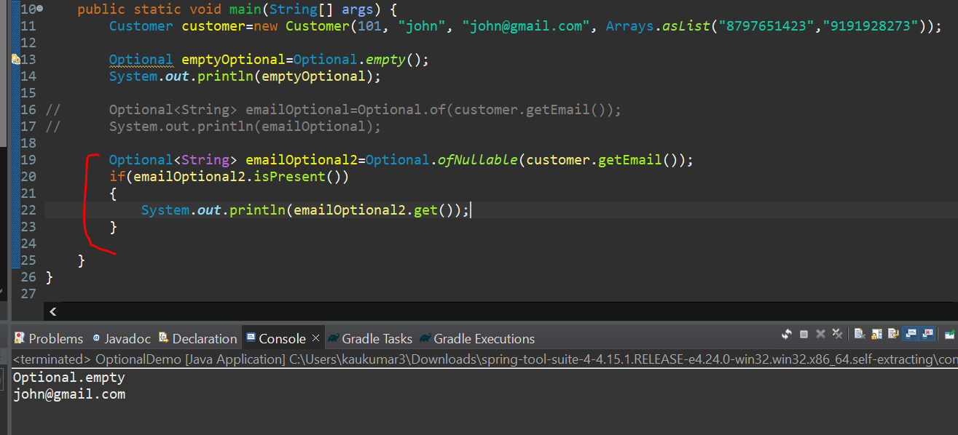
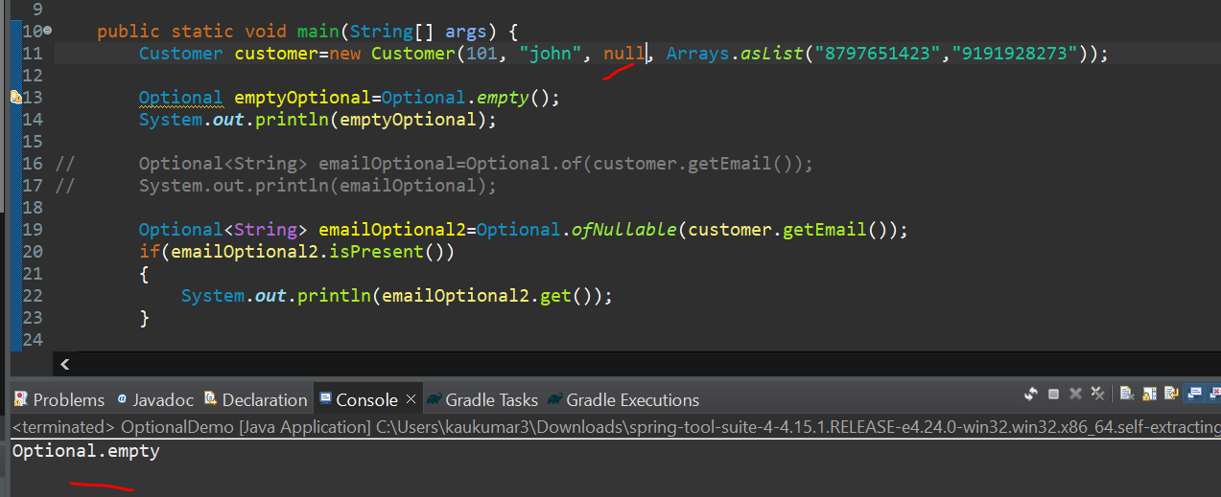
If the Object is null or empty, then get () method won’t return any values…. If we need some default value if the obj is null…
If the value is not Present, then we just want to return some default value…
We can use orElse () method If we want to return any default value for Null Object…

orElse () method –
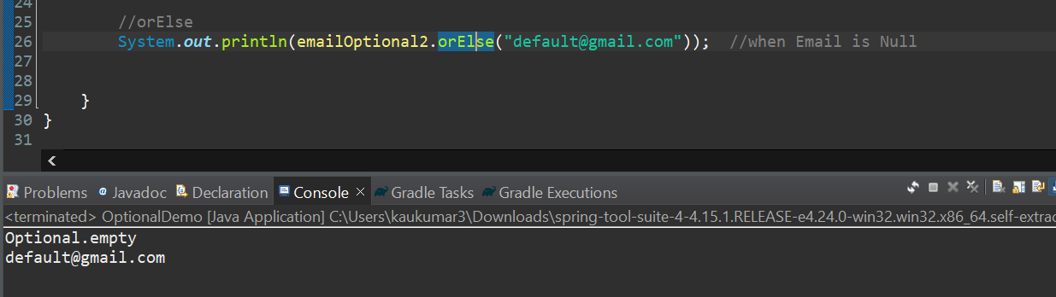
If the value is present, then we will get actual object value in orElse () if not present then Default value. If the value present then orElse won’t execute…
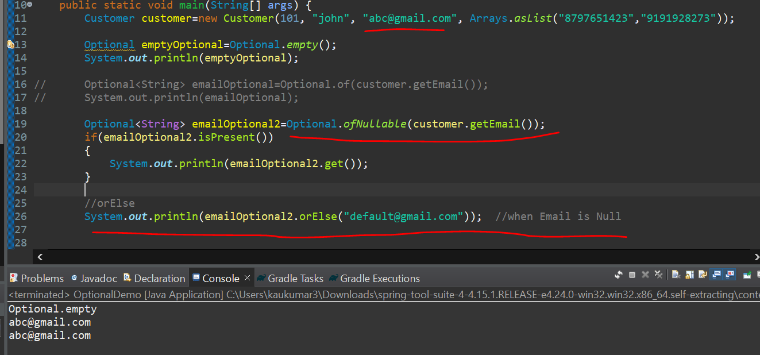
So, it’s taking actual object instead of default…
------------------------------
orElseThrow() method
If Object is null and you want to throw some Custom Exception then we should go for orElseThrow()
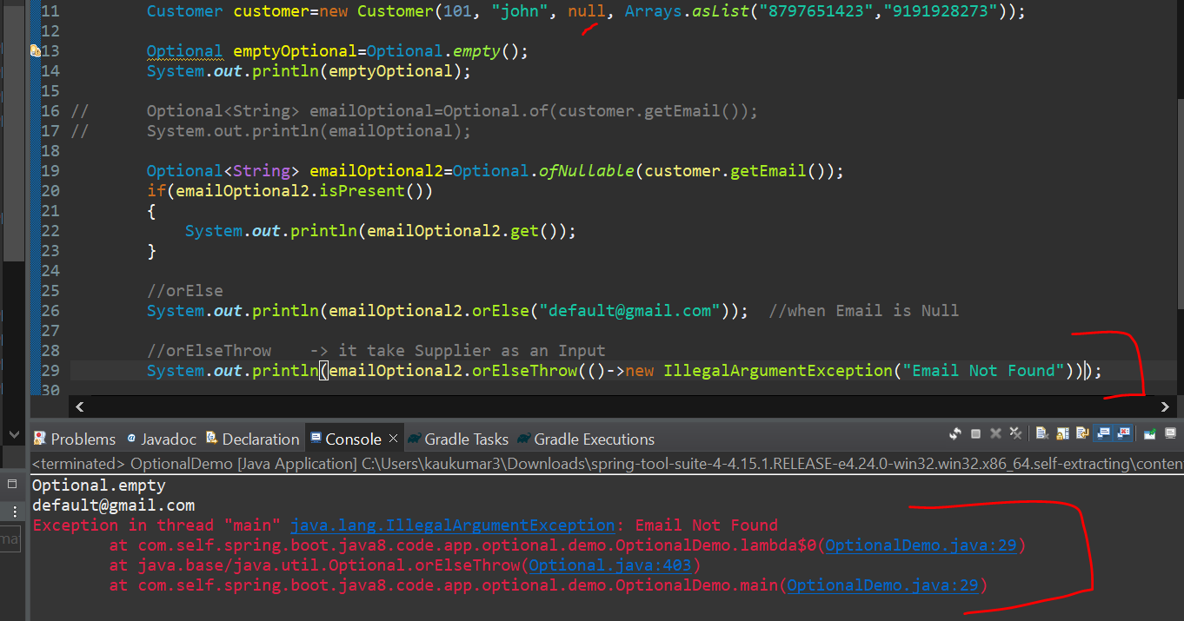
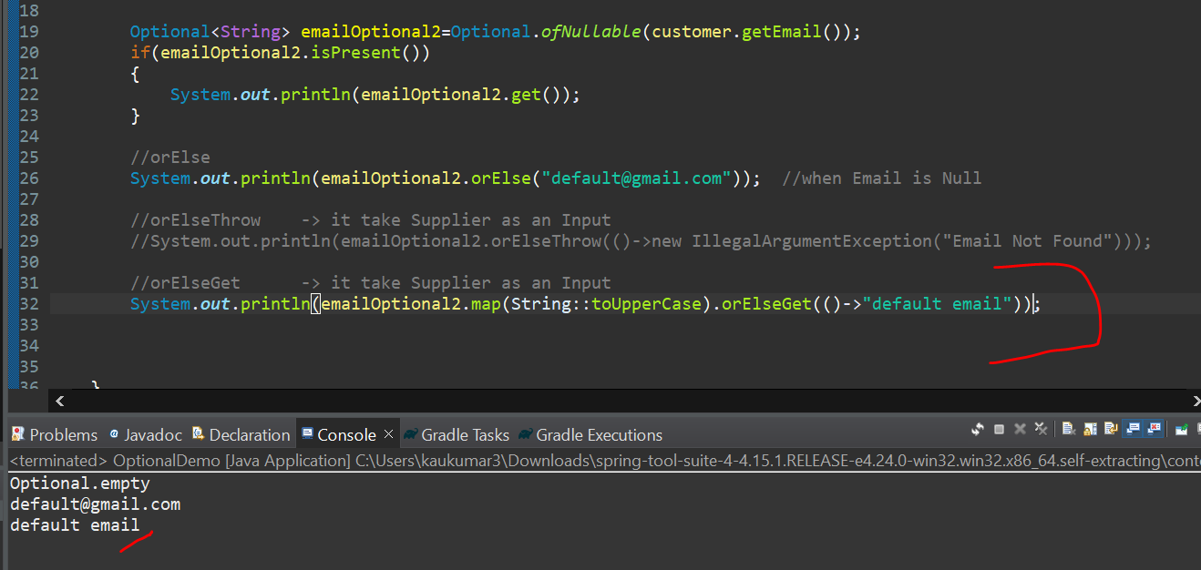
orElse () and orElseGet () both are similar only difference is orElse just take input as String but orElseGet () will take input as a Supplier….
orElseGet () and orElseThrow () both will take input as a Supplier…
now let’s add some value in Gmail and see how its behaving…if value is present then orElseGet () method won’t execute and it will print original value…
Let’s use Optional with Stream API….
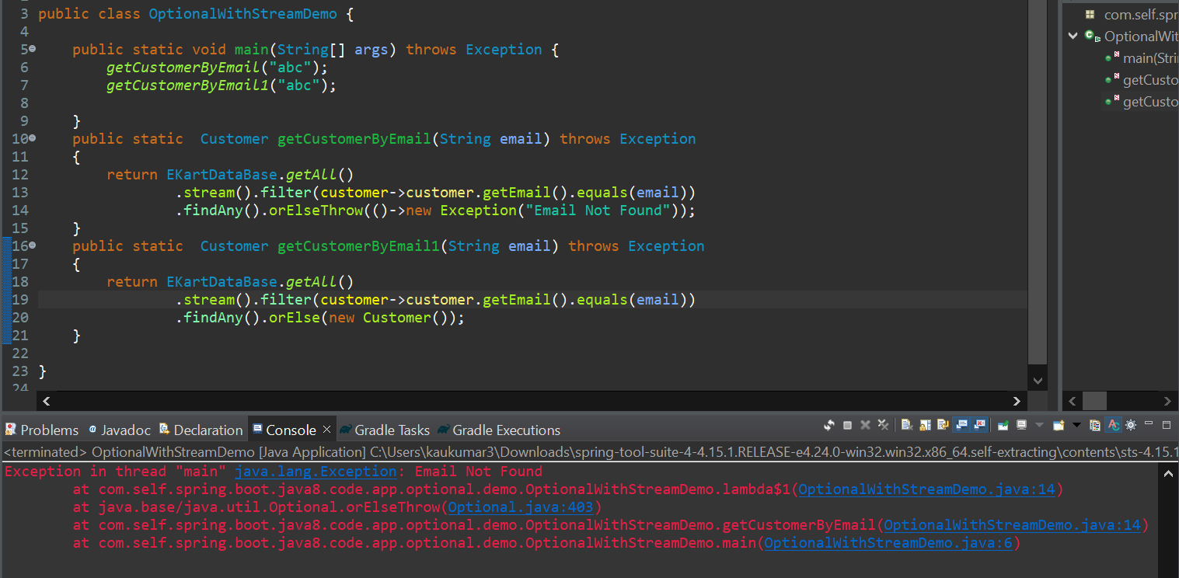
orElseThrow () uses Supplier as input but orElse () use String or Object as Input orElseGet() also use Supplier as Input all are Optional Method.

Note: -
There is one Best Practice for Optional…If you go to Pojo class I mean Customer
So, in the get method rather than returning the String type we can return the Optional
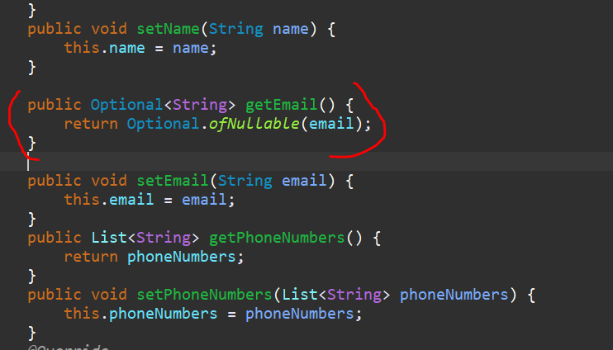
We can write like this so it would be more secure rather than passing the hardcode value ….
If u are using Stream API or Reactive Programming then please refer this u can use this for all getter method…..
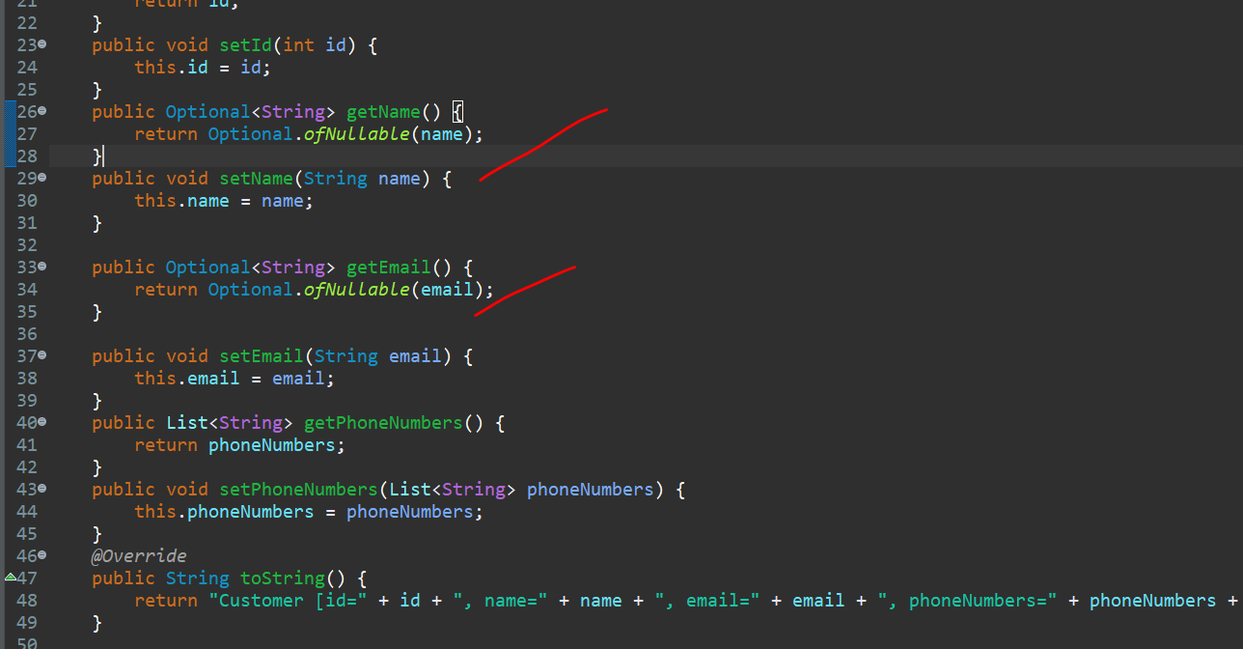

====================== END of Optional Class =========================

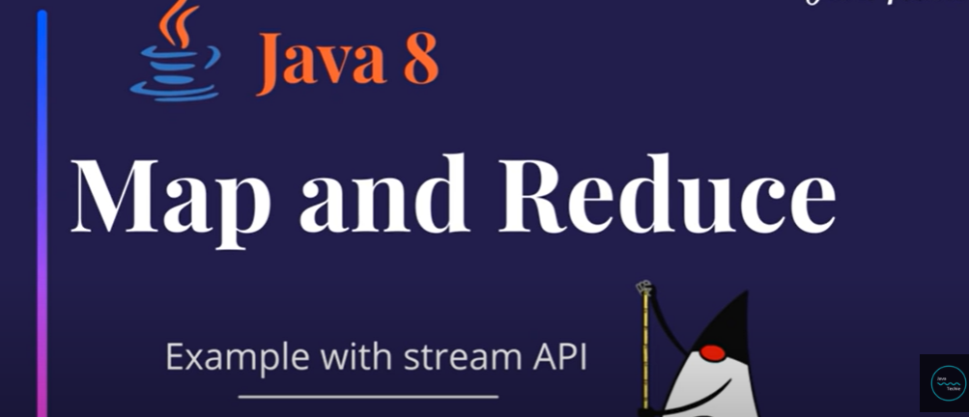

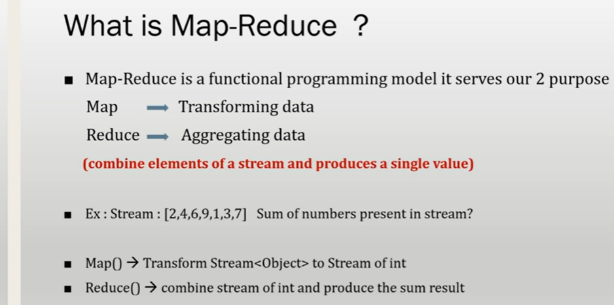
map () is used for Transforming the data and reduce() used for Aggregating the data, means combine elements of a stream and produce a single Result.
Example- map () Transform Stream<Object> to Stream of int and reduce () combine stream of int and produce the sum of result.

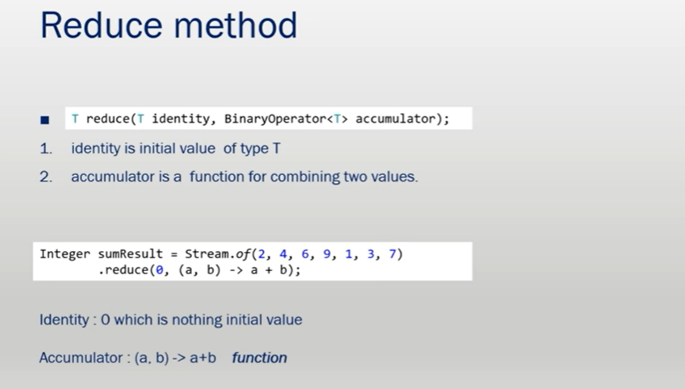
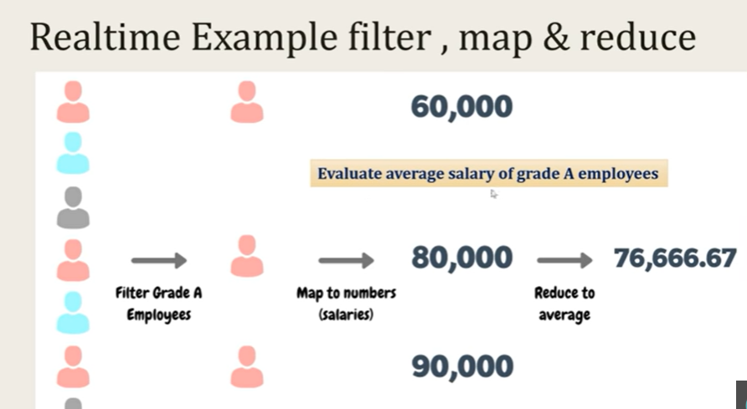
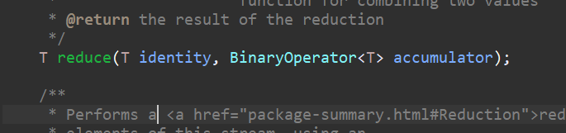
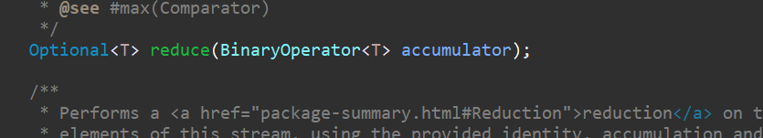
There are 2 types of reduce method…
1. 1st reduce method takes input as an identity and accumulator and return the Generic Type value like Integer
2. 2nd reduce method takes input as a Method Reference and return type would be Optional.
Examples: -
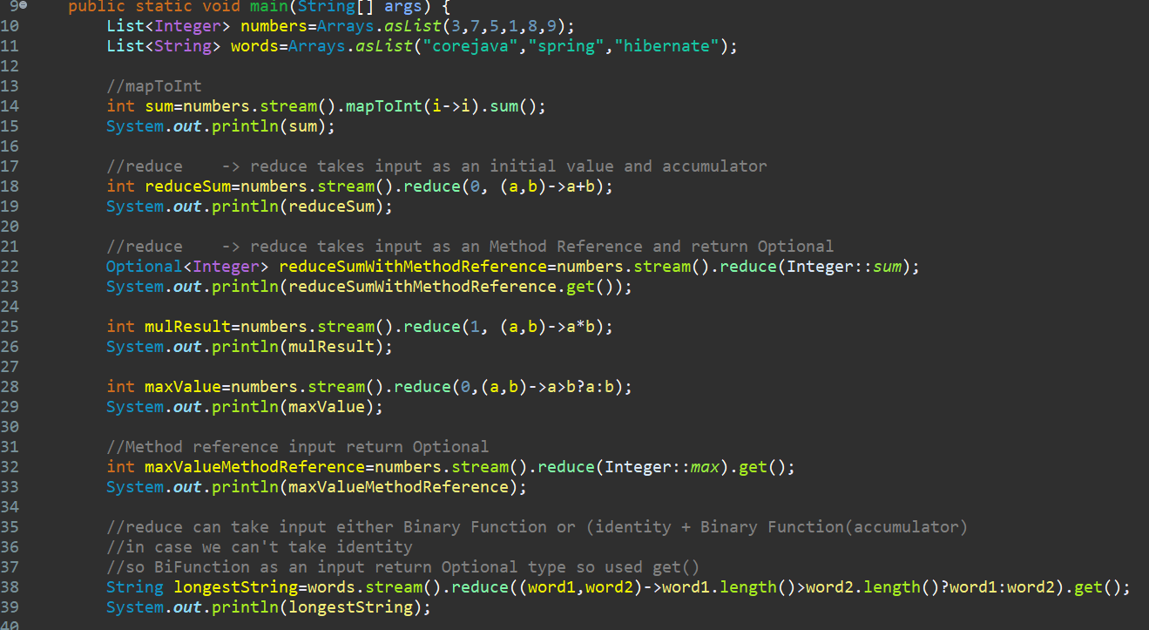

UseCase: find Average Salary of those Employee whose grade is “A “.
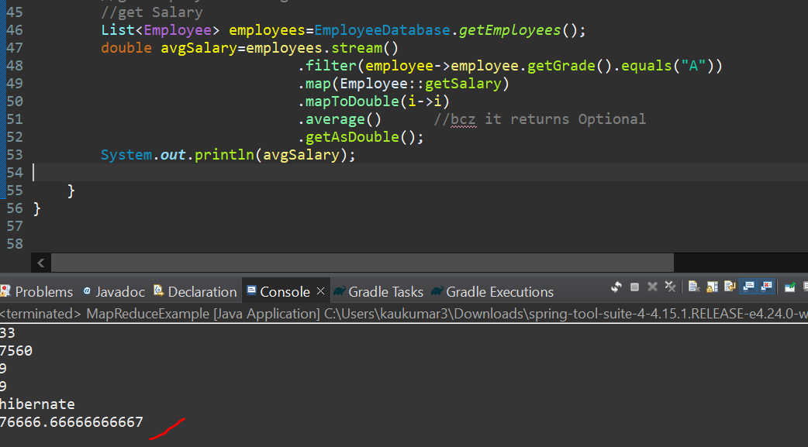
Like this we can perform other operation….
Let’s perform find Sum of Salary of those Employee whose grade is “A “.
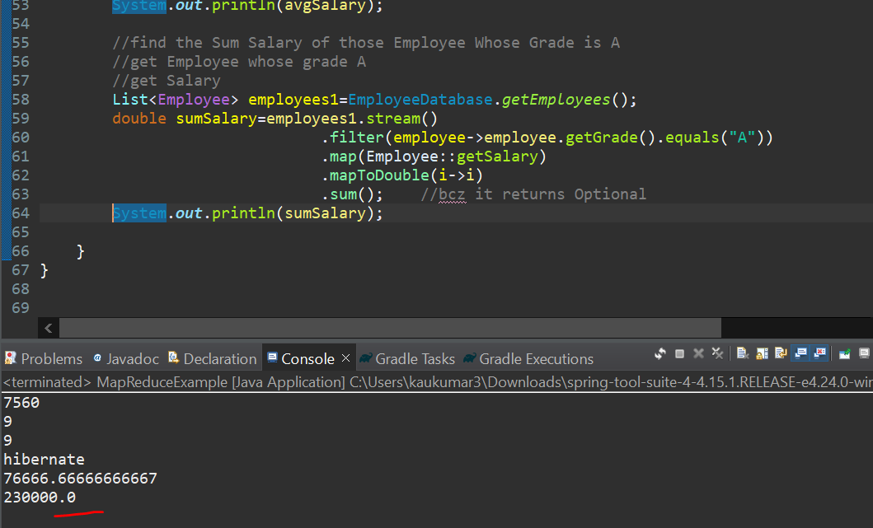
You just need to understand the syntax of reduce method and play with it…………
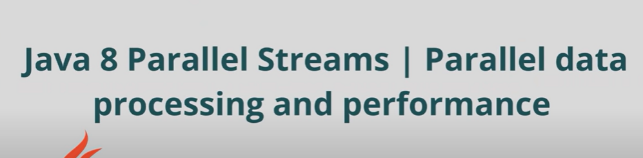
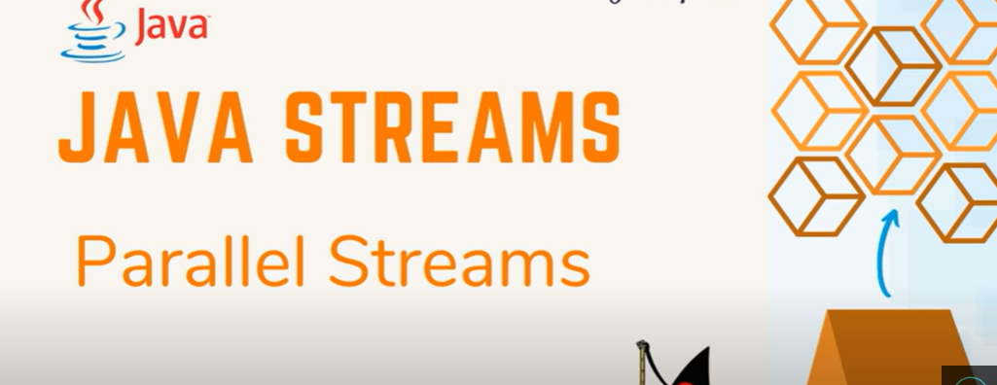
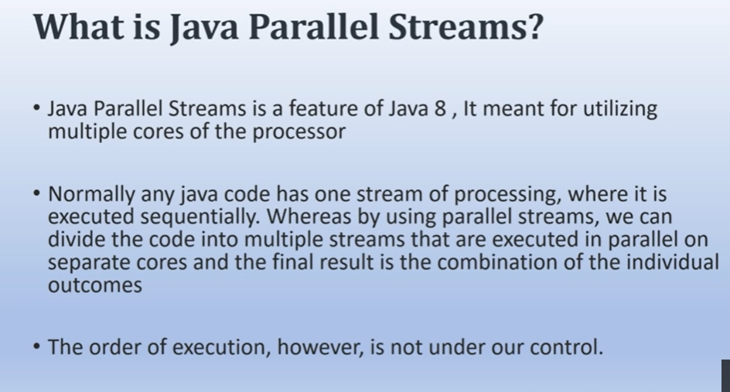
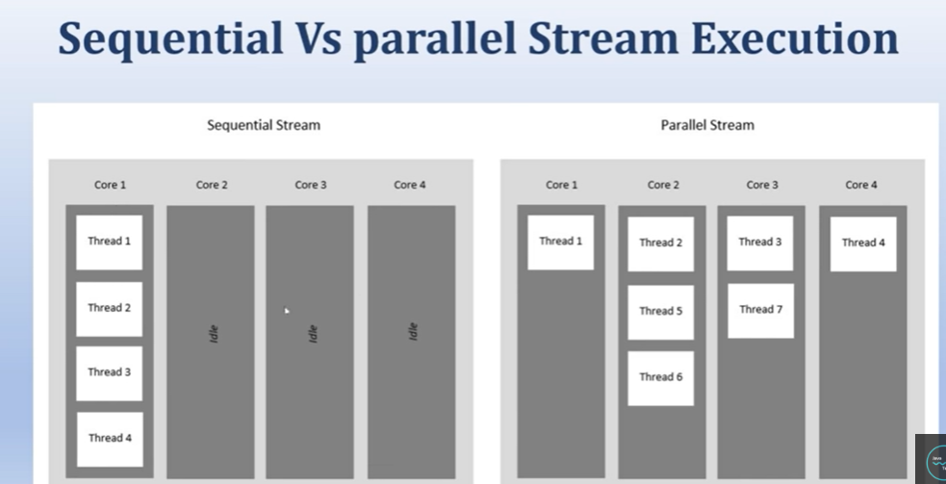
Now I will try to iterate the 100 records using both the Streams and see the Performance…
Will see how stream executes in a Single Core and how parallel Stream executes in a multiple core…….
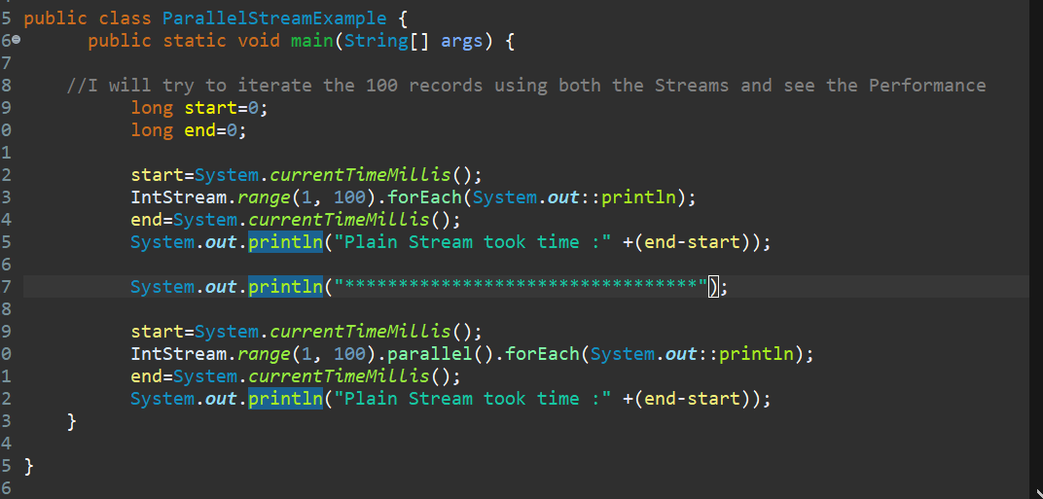
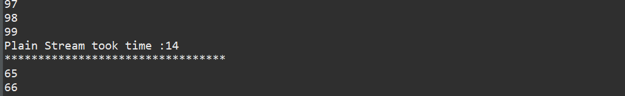
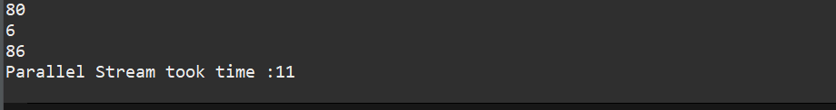
And order also not sure in Parallel stream bcz of multiple cores……..
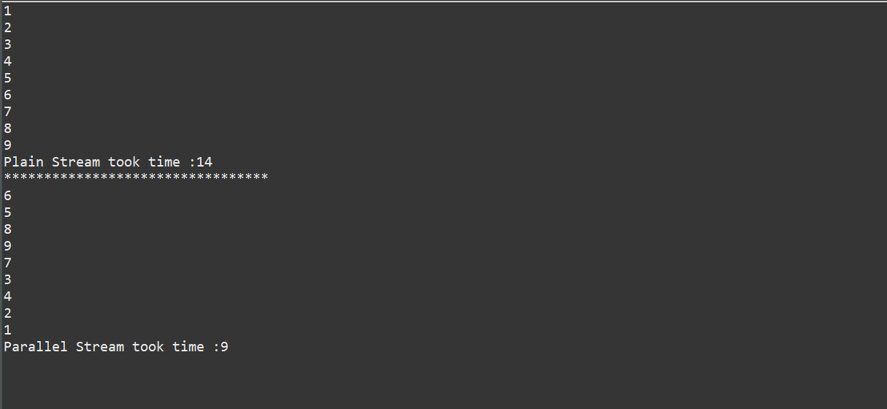
If we are printing 1 to 10 numbers………………

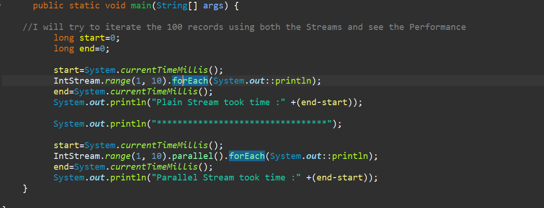
So, Order of Execution is not Constant in Parallel Stream but Response wise Parallel Stream is Better Sequential Stream….

Now we will see How this Parallel Stream will execute in Multiple core in my Processor so I will write a separate code for that….
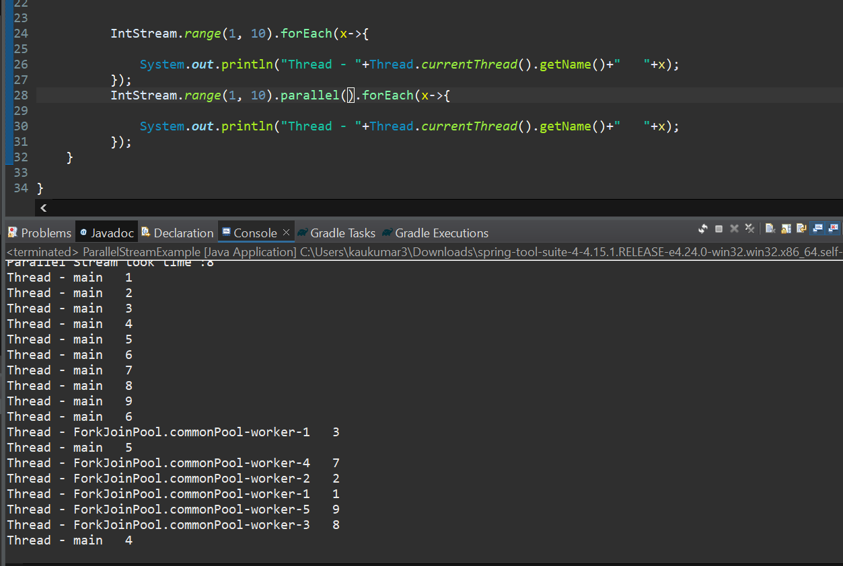
So, here actual stream is running through only Main Thread, but parallel stream is running by main as well as other thread from fork-join-pool thread…
So, normal stream takes more time bcz it executes into a single core, but parallel stream won’t take much time its performance is better than normal stream………. but order of parallel stream is uncertain…...
What is Caching and How Caching work ?
What is caching?
Caching -- pronounced "cashing" -- is the process of storing data in a cache, which is a temporary storage area that facilitates faster access to data with the goal of improving application and system performance. A common example of caching is a web browser that stores page content on a local disk for a designated period of time. When the user first visits the website, the content is downloaded from the web server and saved to a local directory. If the user revisits the website, the content comes from the local cache rather than the server. In this way, page content loads much faster into the browser than it would if it were downloaded from the web server. This saves the user time, reduces network traffic and minimizes the load on the web server. The idea behind caching is to temporarily copy data to a location that enables an application or component to access the data faster than if retrieving it from its primary source.
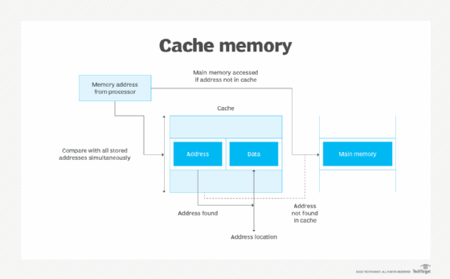
Cache memory is a memory block separate from main memory that is accessed before main memory.

What are different kinds of caching? T
he same principle that applies to internet caching pertains to a variety of other types of caching:
CPU caching. Most central processing units (CPUs) include high-speed caches, such as L1 and L2, that sit between the computer's main memory and the processor, providing the CPU with faster access to program instruction sets than the main memory can deliver.

In-memory caching. Applications often use a system's main memory to cache data stored on disk. For example, a database management system (DBMS) might use caching for read-heavy workloads or complex query.
Virtual memory caching. A computer's memory management unit (MMU) often includes a Translation Lookup Buffer (TLB) to cache recent translations between virtual and physical addresses.
Server-side caching. Web applications often cache data that comes from other systems. For example, a web application might cache data it retrieves regularly from a back-end database.
CDN caching. Content delivery networks (CDNs) store cached data in multiple proxy servers that are geographically distributed to serve content to users in closer proximity to where they reside, helping to improve a web application's performance.
=================================================================================
1. What are all features of java 8 did you used?
- Functional Interface ( include default & static method)
- Lambda Expression
- Stream APIs
- CompletableFuture
- Java DateTime API
2. What is Functional Interface ?
An Interface that contains only one abstract method is known as functional interface. It can have any number of default and static methods.
3. Can you tell few functional interface which is already there before java 8 ?
Runnable
Callable
Comparator ( Interviewer might be asked about equals() method inside comparator )
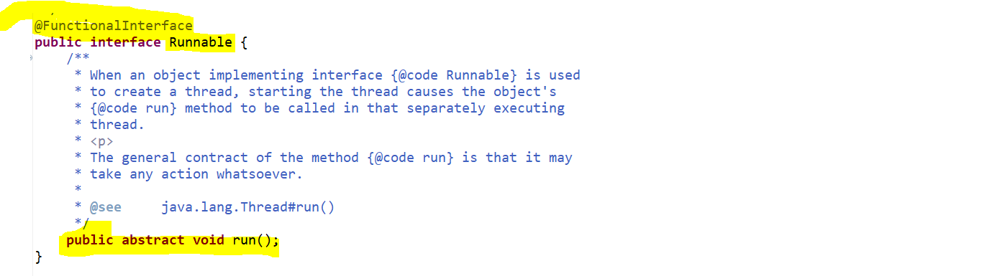

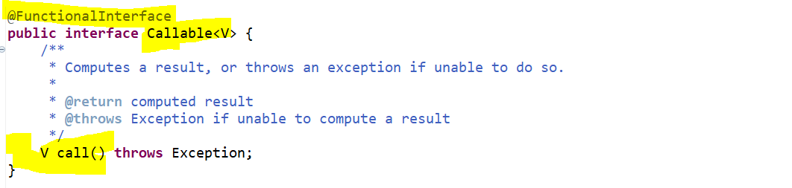
So, you can see here this contains only one abstract method. This annotation @FunctionalInterface is optional. If you class have only one abstract method, then that’s enough to define that as a Functional Interface.
Interviewer might be asked about equals() method inside comparator because inside Comparator interface there are 2 methods equals() and compare(a,b) method.
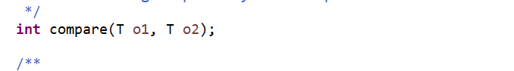
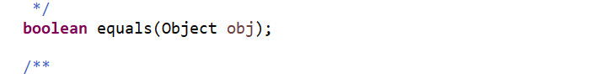
If u see the Comparator, it is a functional interface but if u see the method called compare() which is completely abstract method and there is another method called equals() which return Boolean value. but if u observed there are multiple defaults and static methods now the question is there are 2 methods then how this Comparator is functional interface.
Yes, Comparator is a functional interface bcz equals is an abstract method overriding from the Java.lang.Object. so, this doesn’t count as an abstract method. So, equals method inherited from the Object class not from this particular Comparator interface. That’s why we don’t count as an abstract method of this Comparator interface.
4. Can you write one Functional Interface ?
  - We need to provide the implementation for the method getScratchCard() otherwise it will treat as an abstract method, and we can’t write 2 abstract methods in our functional interface.
  - Public and abstract keyword is by default will be there in an Interface.
- So, as per the Functional Interface we define the abstract method, static method, and default method.
- We can define default and static method n number of times.

Purpose of default and static methods in Interface:-
- Since this doPayment() is an abstract method, it will force to all my implementation class to override this.
- But if you define a method as a default, it won’t force your implementation class to override it. If someone want scratch card feature then they can override it, if someone don’t want, they can ignore it there is no restriction.
So, there are no compilation error its up to us either we want to implement this or not.
It’s up to me either I can provide the parent or super class feature or if u want to customize it you can add.

- This static method will be act as a Utility class. Let’s say I am creating a project and I can define a Utility class and I can add few of the methods which is widely used in my project or repeatedly I am using that piece of code so I can keep them as a static method in my utility class.
- But rather than doing that you can keep inside a same interface which is being used as part of your implementation.
Let’s simplify this…
So, when a user is doing a payment, I want to return a payment Id or the transaction Id as well as the date, at what date you did the transaction.
Since all the Implementation class wants to use this datePattern() methods rather than creating a separate utility class I added in the same interface which is being implemented in the multiple classes.

5. Can we extends functional interface from another functional interface.
Yes, we can extend but if you extend that your functional interface will not act as a functional interface. Bcz it will find multiple abstract methods inside that.
We already created a functional interface called UPIPayment.
Actually, java have no restrictions to do that you can do that but if you do that your functional interface will not act as a functional interface. Now you can see there will be 2 abstract methods. So, if u remove @FunctionalInterface it will act as a normal interface. So, if u are extending your functional interface will behave as a normal interface.

6. what are all functional interface introduced in java 8 ?
- Function
- Predicate
- Consumer
- Supplier

If you can observe that these all-functional interfaces came from java.util.function package.
These all-functional interfaces are having only one abstract method and apart from that multiple default and static methods are presents inside the functional interface.
Function functional interface will have one abstract method called apply will take one input and return one output.
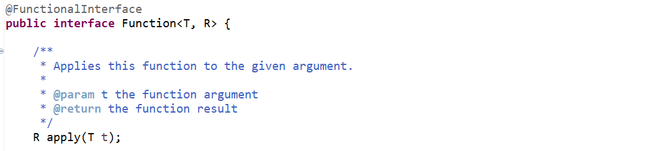
Consumer functional interface will have one abstract method called accept will take one input, but it does not return anything.
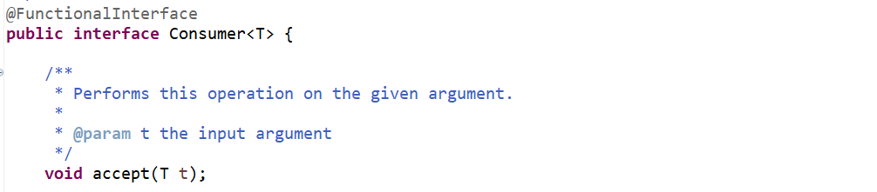
Supplier functional interface will have one abstract method called get will just provide some values it won’t take any input
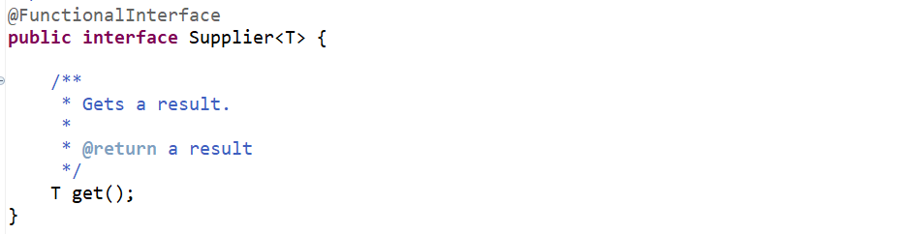
Predicate functional interface will have one abstract method called test. It will return the Boolean, it will just evaluate the expression and it will just return the Boolean.
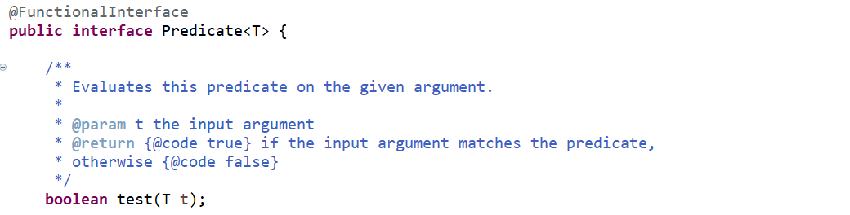

7. What is lambda expression ?
- Lambda expression basically express instances of functional interfaces, in other words it provides a clear and concise way to represent method of a functional interfaces using an expression.
- So, this is just an expression to define your functional interface.
Since we know that Runnable, Callable, Function and Consumer are a functional interface, so let me take Runnable in our example.
Since Runnable is an Interface, we cannot create an object of it but we can create Anonymous Implementation of it.
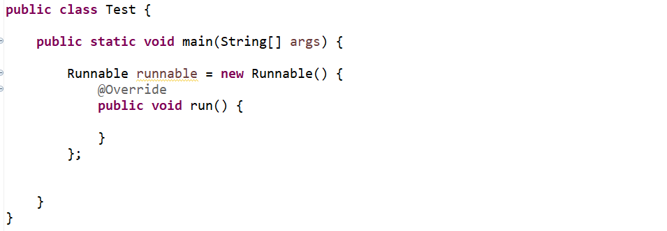
Now since this is a functional interface now you need to understand how we can define this abstract method of this functional interface using lambda expression.
In our traditional way we were writing like…
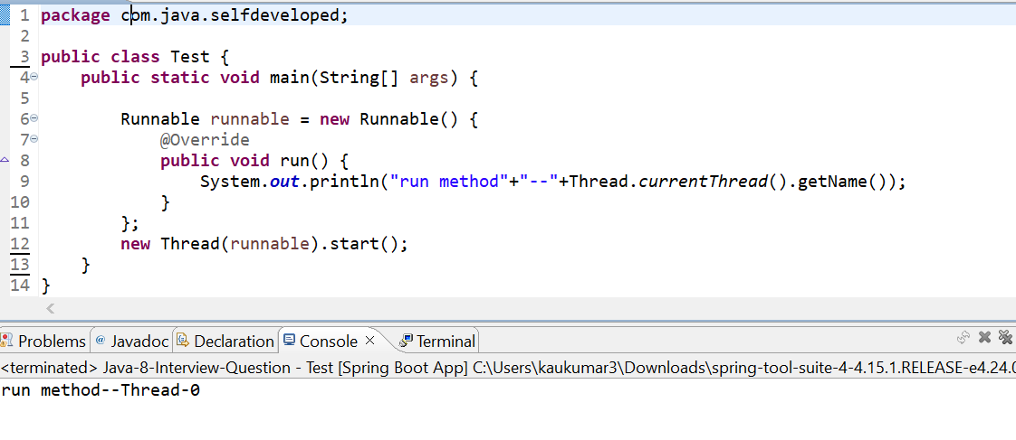
The trick is very simple just copy the method signature and just remove all method prefix all return type method name and data types from arguments and after that finally lambda expression will return the Functional Interface and then we can call that method using interface name.
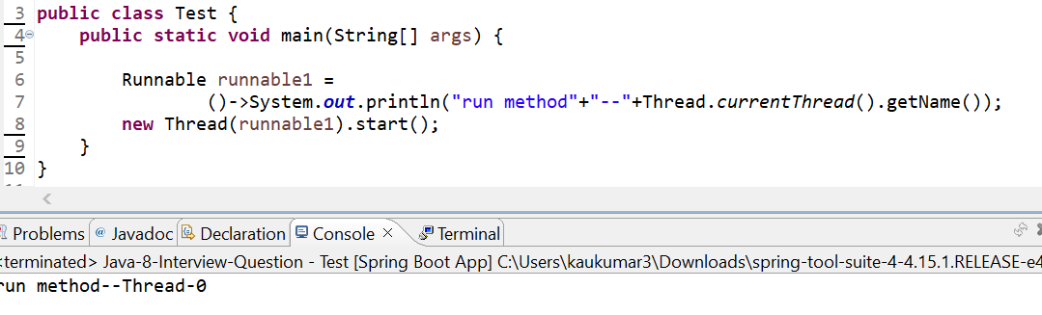
Below one is not a separate thread …it’s a main thread.
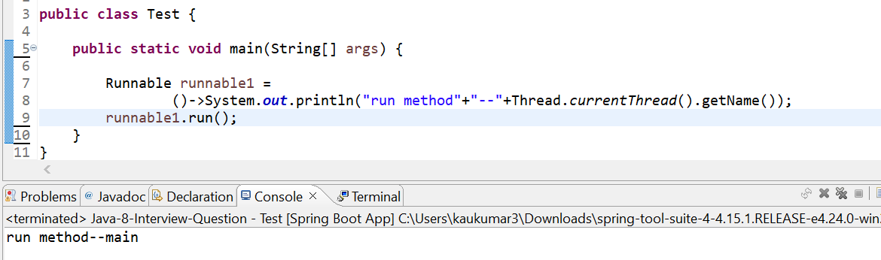

Few of the examples with Function Interface using lambda expression….

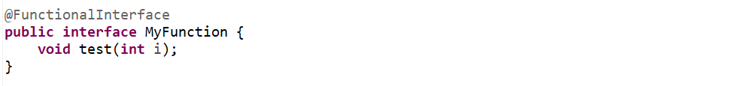
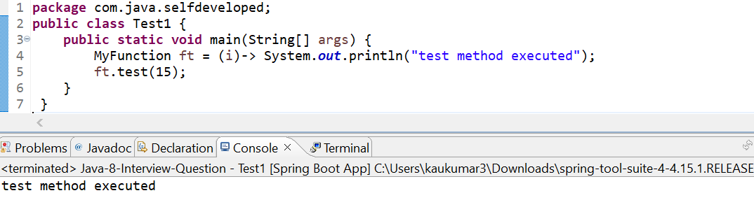
-----------------------------------------------------------------------------------------------------------------------
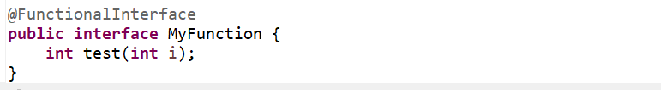
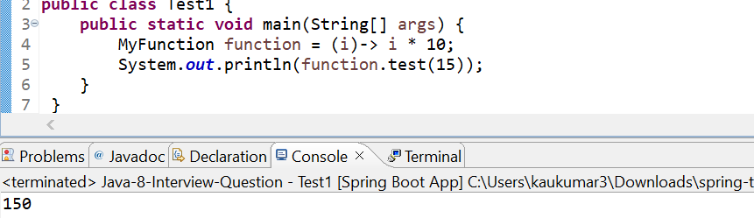
------------------------------------------------------------------------------------------------------------------------
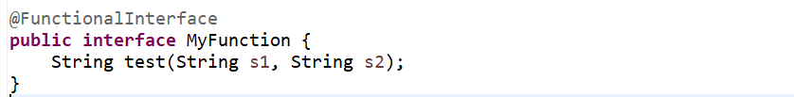
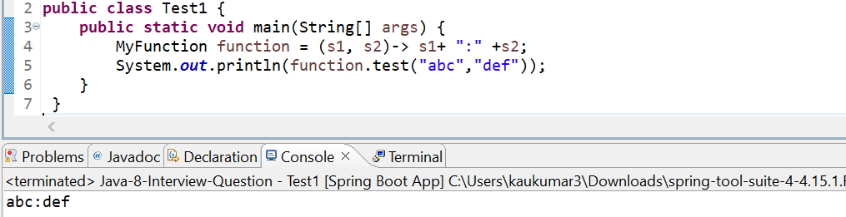
------------------------------------------------------------------------------------------------------------------------
Now let me take an example from any of the functional Interface like Function which contain one abstract method apply() which take an input of generic type and return one output.so, it takes integer as an input and string as an output.
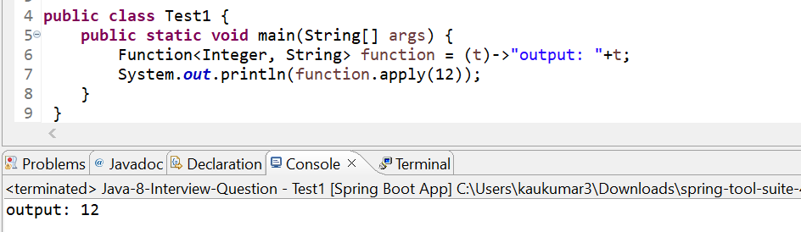
8. what’s the advantage and disadvantages of lambda expression?
Advantages:
  - Avoid writing anonymous implementation.
  - It saves a lot of code.
  - The code is directly readable without interpretation.
Disadvantages:
  - Hard to use without an IDE
  - Complex to debug ( if it is in single stream pipeline )

9. What is Stream API ?
Stream API introduced in java 8 and it is used to process collections of objects with functional style of coding using lambda expression.
10. What is Stream in Java 8 ?
A stream is a sequence of objects that supports various methods which can be pipelined to produce the desired result.
  - A stream is not a data structure instead it takes input from the Collections, Arrays or I/O channels
  - Streams don’t change the original data structure, they only provide the result as per the pipelined methods.
Example- find the number which is greater than 4 and also maintain the ascending order.
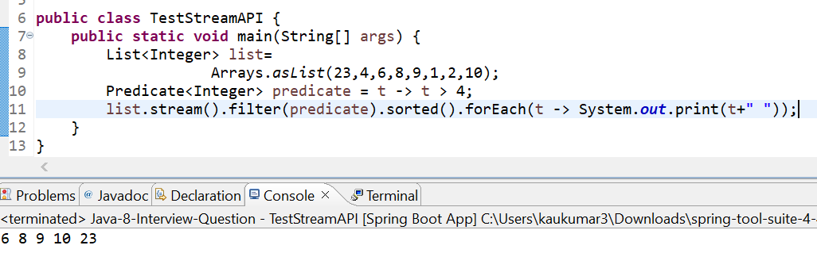
Description:-
  - always if we have a group of objects, we need to convert into stream object.
  - Here you can add lot of pipeline methods.
  - Since first we want to do the filter, since you can observe filter take Predicate functional interface as an argument and this Predicate contain one abstract method called test method. boolean test(T t).
Using method reference---
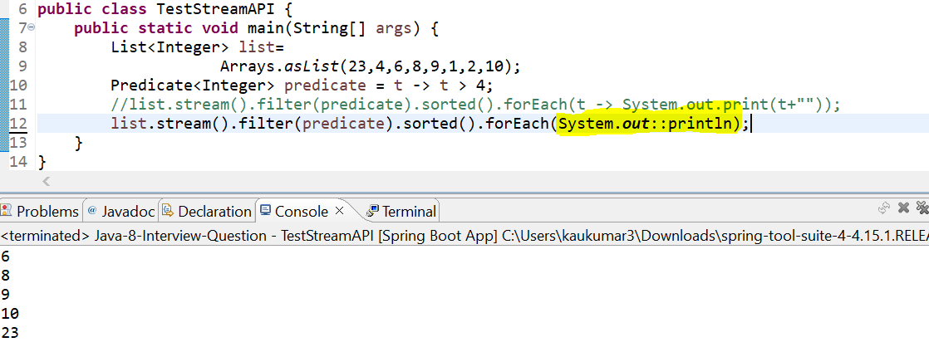

11. What is Method Reference in Java 8 ?
  - Method reference is a Shorthand notation of a lambda expression to call a method .
  - Lambda can be replaced with a method reference.
  - Method Reference can be of 2 types static method reference and instance method reference.
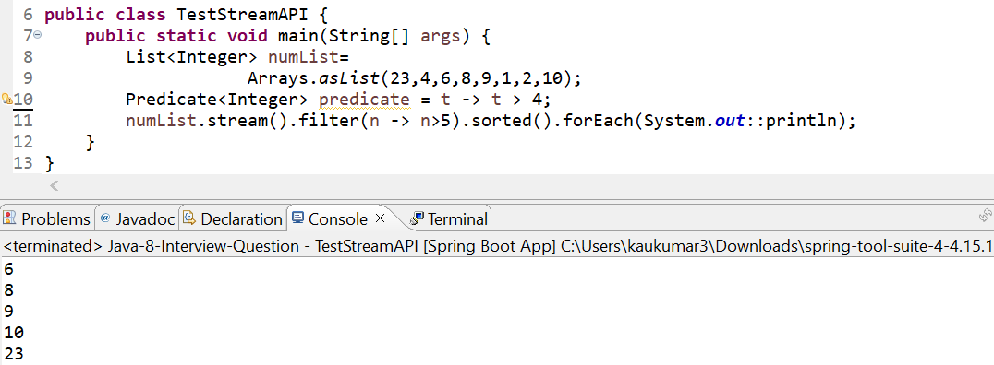
Let’s create a static method and let’s call using Method reference.
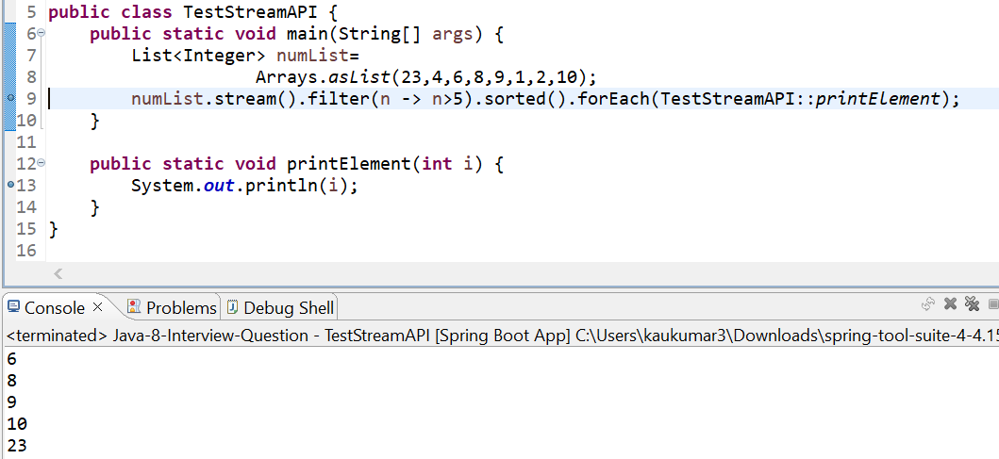
Let’s create a non-static or instance method and let’s call using Method reference.
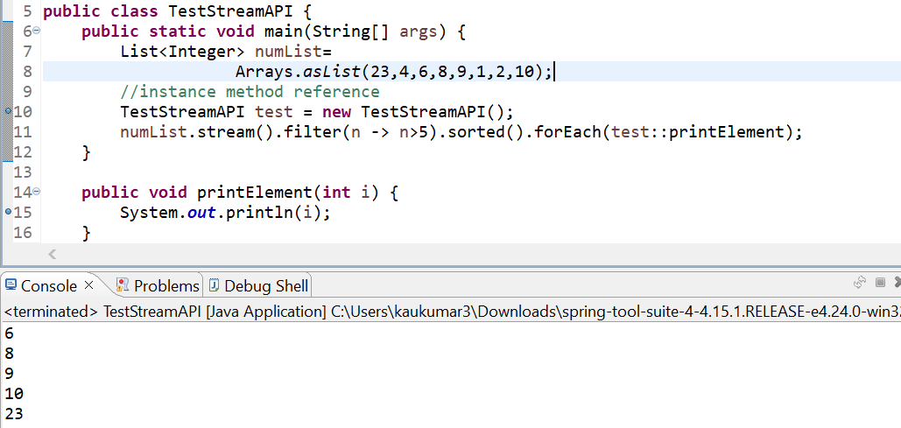

12. Spell few Stream method you used in your project ?
- filter
- forEach
- sorted
- map
- flatMap
- reduce
- groupingBy
- count
- collect
13. When to use map & flatMap ?
Now let’s assume you have a requirement to gather all the phone number of all the users. Just assume u have a user which stored in a database with name, phone number and list of emails but you want to fetch only the phone number of all the users.
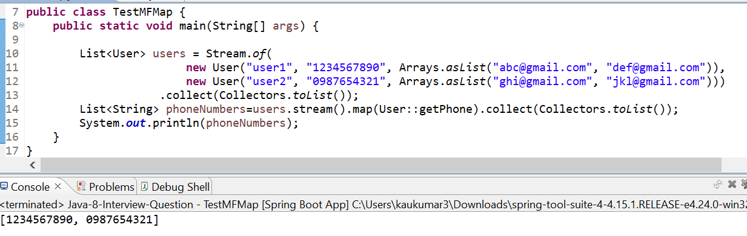
We are getting the phone numbers in a list. If in your class having the single field, then directly you can use a map.
But if you go to your User class the email is not a single field it’s a list of objects. One user can have many emails. So, in this one-to-many scenario always recommended to use flatMap.
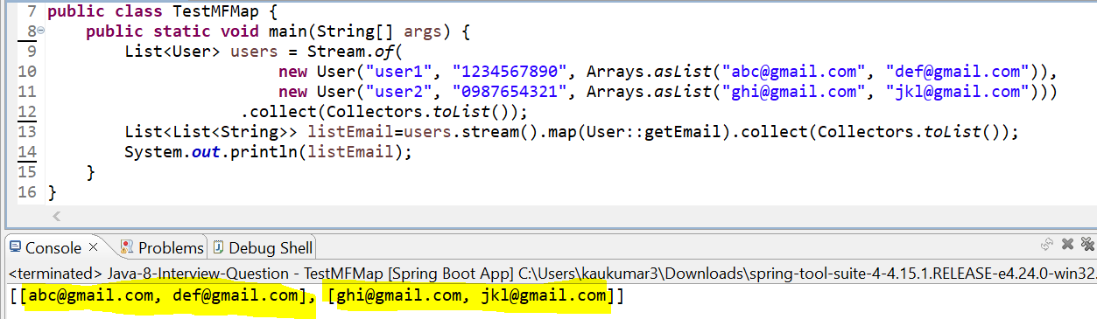
If you are using map instead of flatMap in case of one-to-many scenario, return type is List of List of String. But I just want List of String as an all the emails. So, if u will use map u will not get required structure or required format you want. Because the scenario is one-to-many so better to use flatMap instead of Map.
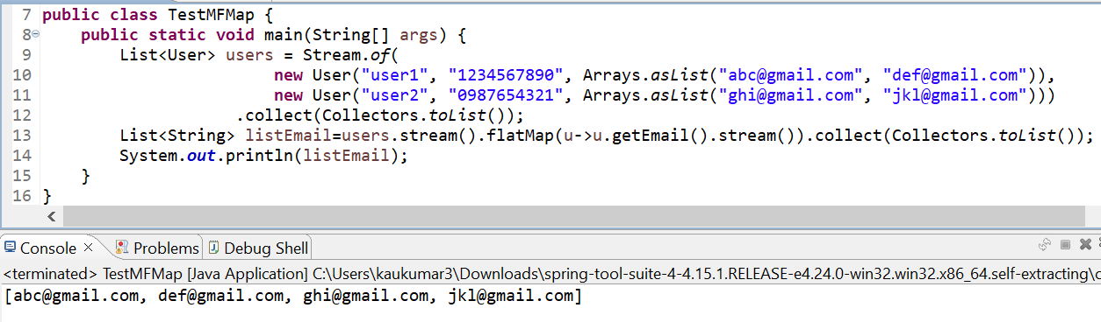

14. WAP using stream to Find frequency of each character in a given String ?
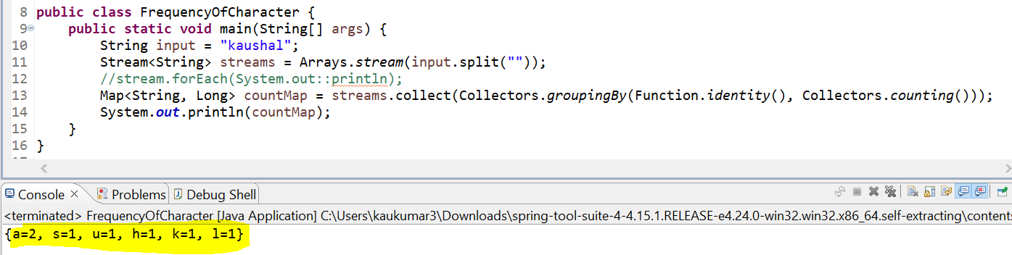
15. To count the elements in stream of String
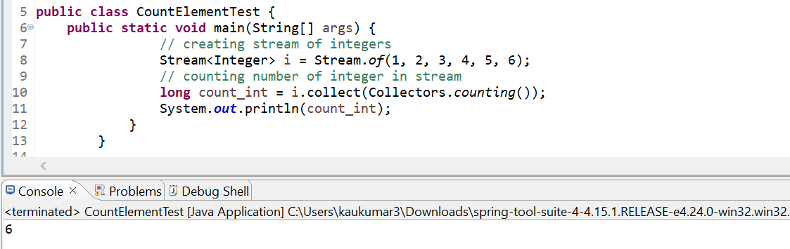
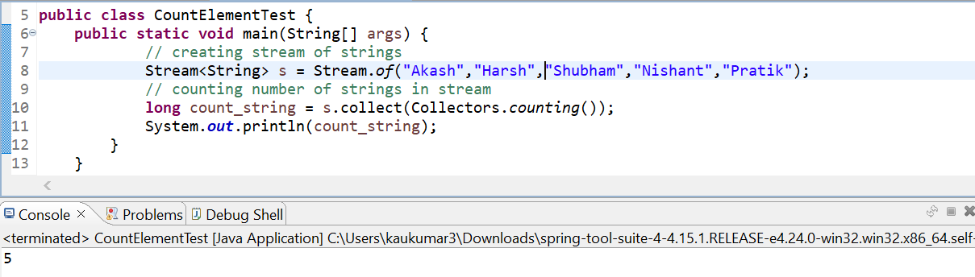
Either we can use Arrays.stream() or Stream.of() both will return the Stream type of list of objects.
16. Assume you have list of employees in various dept, WAP to find all the employee department wise ?
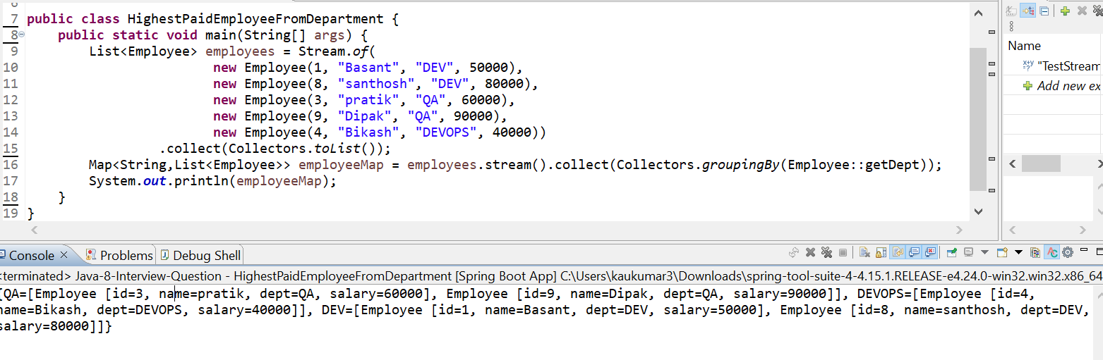
With which field you want to group, I just want to group by department, it will just display key as a Dept. name and value as a list of employee belongs to that department.
17. Assume you have list of employees in various dept, WAP to find highest paid employee from each department ?
- With which field you want to group, I just want to group by department, we are using Collectors.groupingBy(filedName) it will just display key as a Dept. name and value as a list of employee belongs to that department.
- Now once I group the list of employees’ objects by Dept I need some comparator to compare the salary for each object based on the employee salary.
- We are just grouping by the department then we just created one comparator to compare from each department based on the salary.
Approach -1
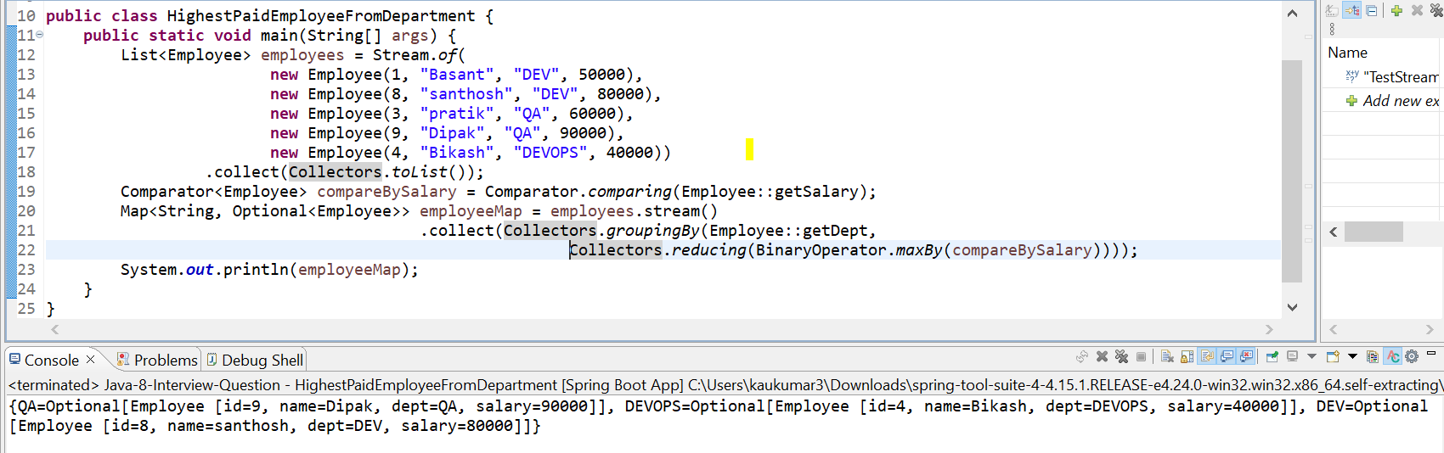
Approach -2
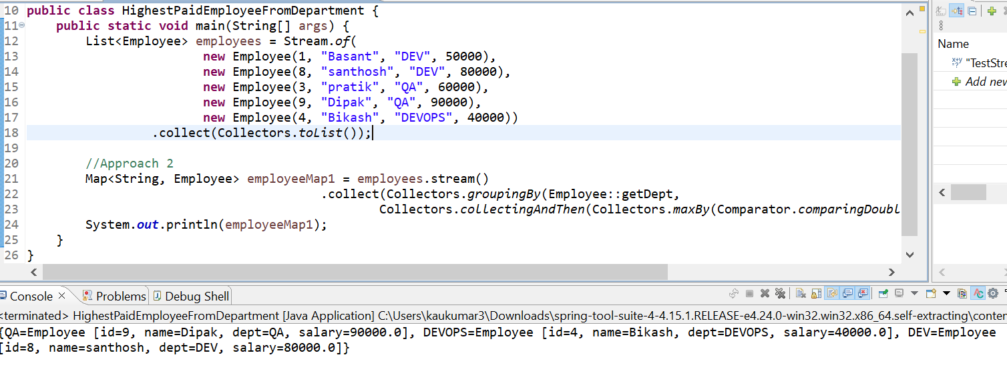
18. Stream VS parallel Stream ?
Both are used to process group of objects. However, stream executes in a single core of your machine with sequential flow where parallel stream uses multiple cores of your machine.
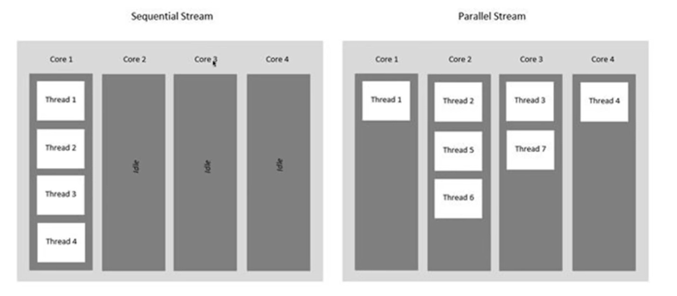
- If you can observe this diagram if you are using stream, it will just use the single core of your CPU or your system. If you are using parallel stream all the thread will use multiple core of your system.
- Since parallel stream uses multiple cores definitely will achieve better performance but its always not recommended to use parallel stream.
- Whenever you are doing some read operations then you can go ahead and use parallel stream. For write operation to maintain the consistency its always recommended to use the stream not parallel stream.

Let me print number from 1 to 10 and I will show you which all threads are getting involve in stream and parallel stream.
So, first line will execute in sequential flow, but second line will execute in parallel flow.
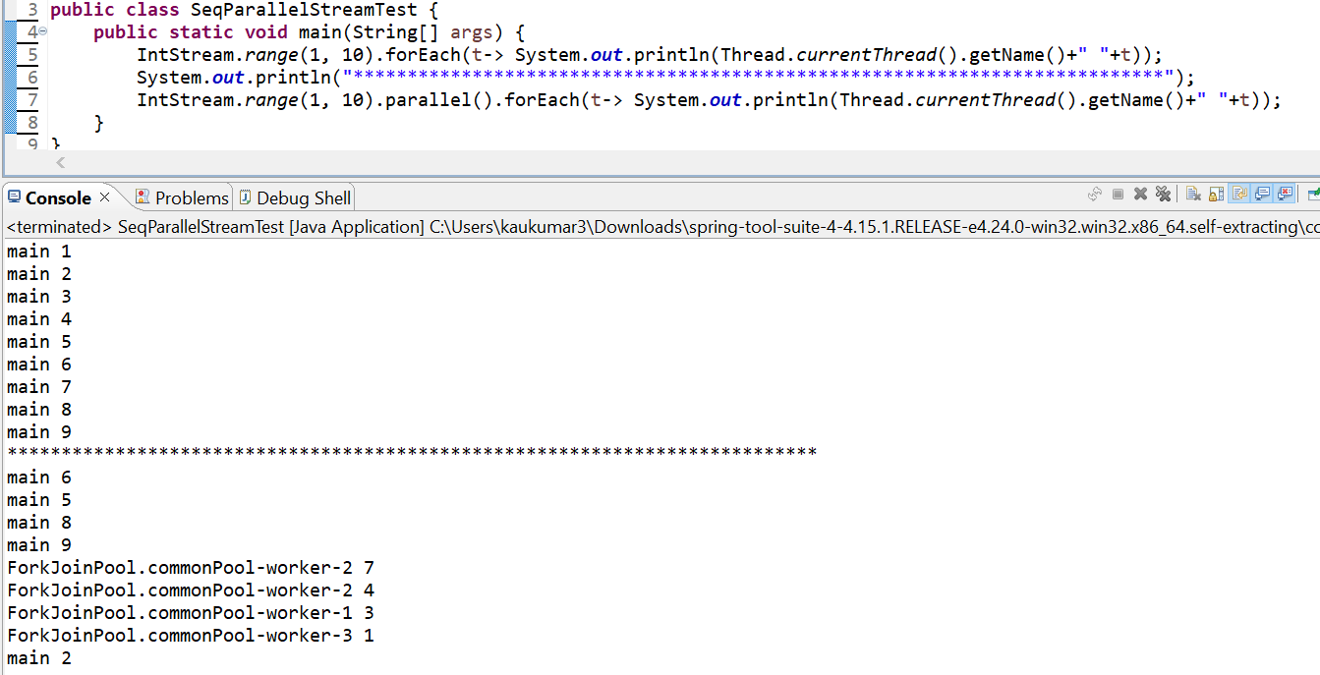
Now u can observe in normal stream all the execution happened in main thread and for parallel stream if u can see it get the threads from the fork join pool and its started executing. So, you saw there are different threads using your different core of the machine.
So, if u compare the time, you will get better time in case of parallel stream.

19. what is CompletableFuture ?
CompletableFuture is an enhance of a Future object which introduced in jdk 5. CompletableFuture is used for asynchronous programming in java. Asynchronous programming is a means of writing non-blocking code by running a task on a separate thread than the main application thread and notifying the main thread about its progress, competition and failure.
20. Why CompletableFuture why not Future ?
Future object as we discussed is introduced in java 5.
- It cannot be manually completed. We don’t have any option to forcefully complete. Future object once you execute until and unless you will not call .get() method it will not complete the execution. It will keep blocking your thread, it cannot release the result until you call .get() method.
- Multiple Futures can not be chained together. Let’s say I created 5 Future objects I can not chained future 1 that do something future 2 that do something like using the Future, but we can do using the CompletableFuture object.
- You cannot combine multiple Futures together. Let’s say I have created 5 future objects. future 1, future 2…5 future objects. After getting all response I just want to consolidate a final response back to the API, I can’t do it using Future object. Because we don’t know which thread will execute first and which thread will take long time to give the result.
- No Exception Handling. In Future implementation there is no proper exception handling.

We have described in detail CompletableFuture at the end of this docs.
21. How to decide Thread Pool size?
  - CPU Intensive Tasks
  - IO Intensive Tasks
It depends on the type of task you want to execute. Whether you want to do CPU intensive task or IO intensive task. If u are using CPU intensive task such as cryptography, hash function, then max thread pool size should be equals to the number of cores in your processor. For example, a 4-core processor can only run the 4 threads at a time. So, the thread pool size should be 4.
But If you are using any IO Intensive Tasks such as any Database operation or HTTP call whare a thread have a tendency to wait after requesting for a resource in such case max Thread pool size should be larger than the number of core processor. For example, for a thread pool size 20 if 16 threads are waiting for resources or they are blocked other 4 thread will take the concurrency task and they can execute with the 4-core processor.
So, you need to evaluate the core size of machine. It depends on which task u want to perform either this is CPU Intensive Tasks Or IO Intensive Tasks.

22. WAP to print even and odd using 2 threads?
Lets do suing java 7 and java 8 using CompletableFuture.
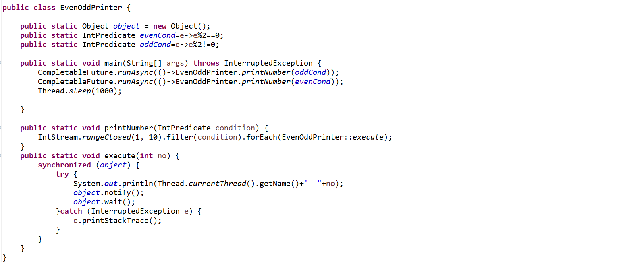
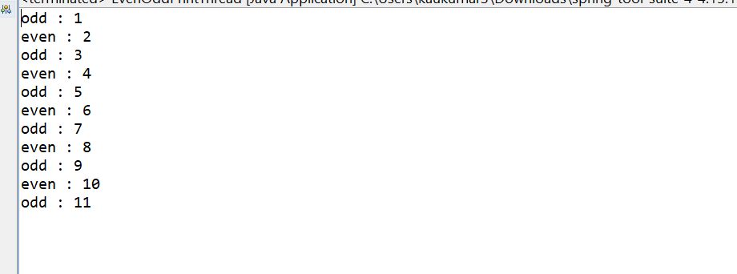

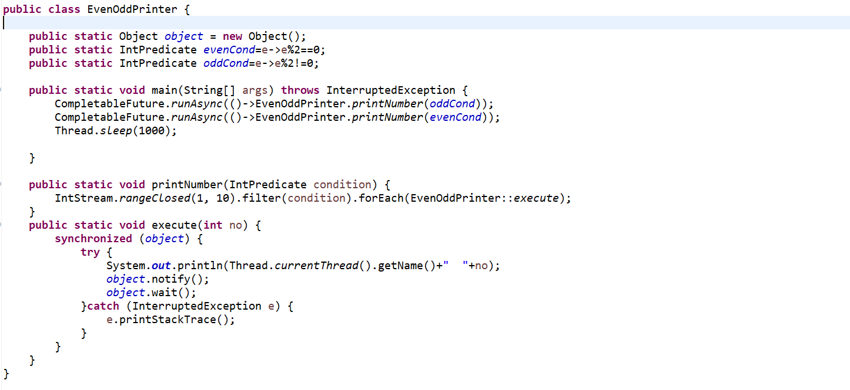
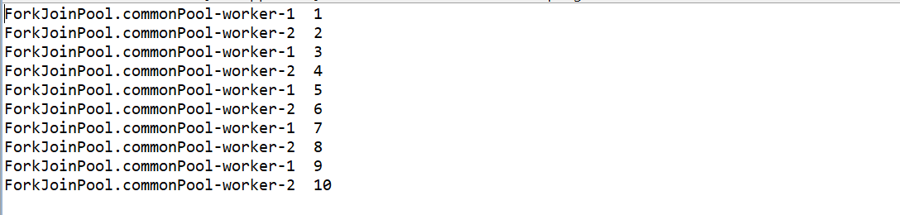

Check Core available Core in your Machine: Runtime.getRunTime().availableProcessors()

what is CompletableFuture ?
CompletableFuture is an enhance of a Future object which introduced in jdk 5. CompletableFuture is used for asynchronous programming in java. Asynchronous programming is a means of writing non-blocking code by running a task on a separate thread rather than the main application thread and notifying the main thread about its progress, competition and failure.
Why CompletableFuture why not Future ?
Future object as we discussed is introduced in java 5.
- It cannot be manually completed. We don’t have any option to forcefully complete. Future object once you execute until and unless you will not call .get() method it will not complete the execution. It will keep blocking your thread, it cannot release the result until you call .get() method.
- Multiple Futures cannot be chained together. Let’s say I created 5 Future objects I cannot chained future 1 that do something future 2 that do something like using the Future, but we can do using the CompletableFuture object.
- You cannot combine multiple Futures together. Let’s say I have created 5 future objects. future 1, future 2…5 future objects. After getting all response I just want to consolidate a final response back to the API, I can’t do it using Future object. Because we don’t know which thread will execute first and which thread will take long time to give the result.
- No Exception Handling. In Future implementation there is no proper exception handling.

What is CompletableFuture ?
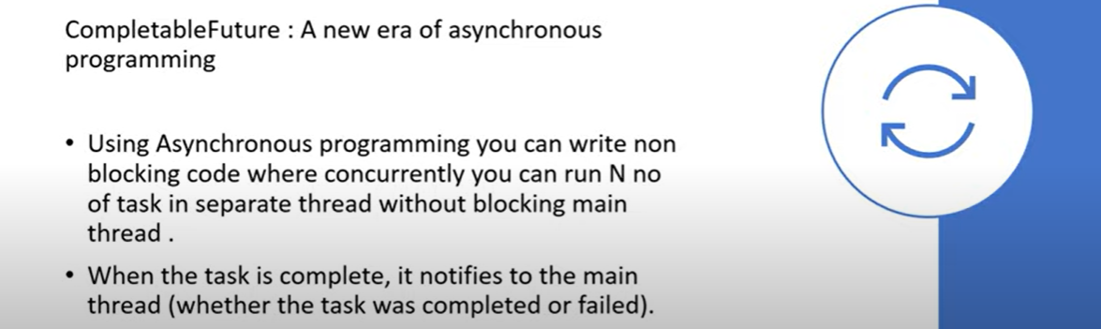

Why CompletableFuture ?
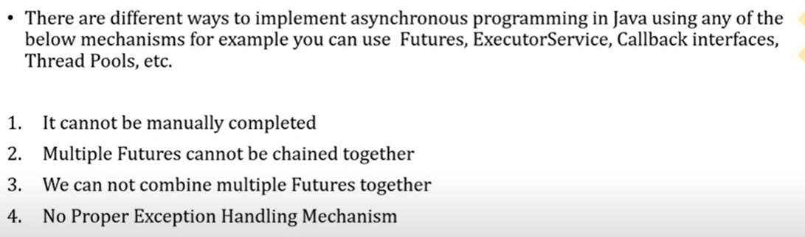

It Can not be manually completed?
What is the difference between submit() and execute() method of Executor Framework ?

ExecutorService service = Executors.newFixedThreadPool(10);
      - service.submit()
      - service.execute()

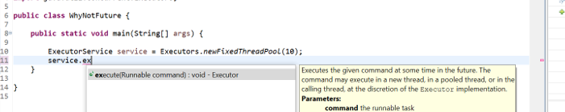

------------------------------------------------------------------------------
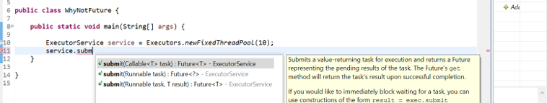

If u can see the method arguments execute() takes the argument as a Runnable where submit() takes the method argument as a Callable. Runnable and Callable both are a functional interface which contain abstract method like void run() and V call(), where Callable return some value so we will use in our CompletableFuture.

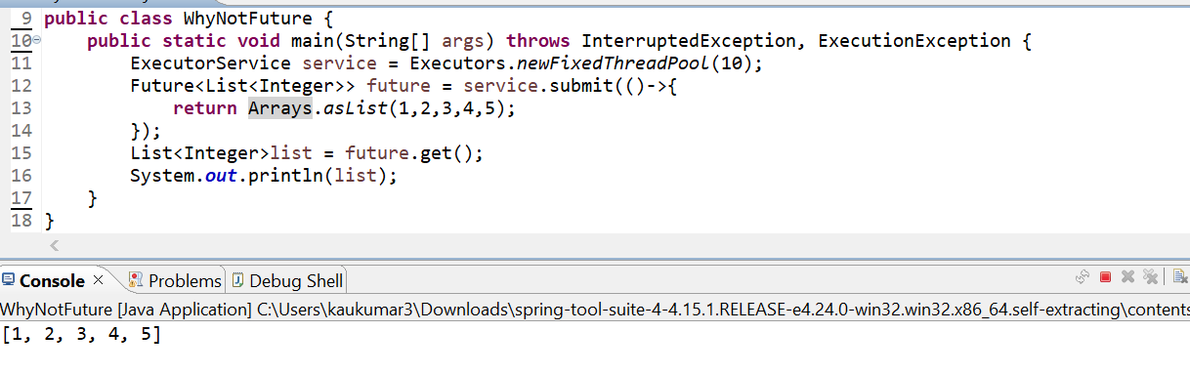
I am directly getting the response here.
Let’s assume from this I am doing some API call. Just assume API is just taking 1 minute time to give you response back.
Now in this case the main thread will block for 1 minute. I am just manually specifying here to block the thread to show you we can’t complete the future object manually.
Now in this scenario it will keep blocking your thread until and unless its execution is not completed.
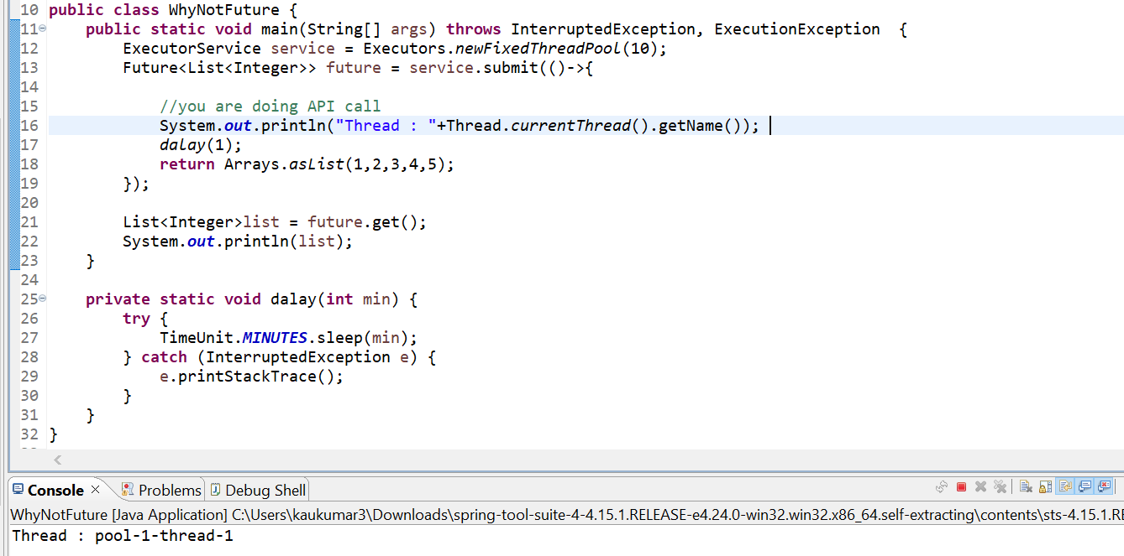
So, if you observed that after one minute, we are getting a response and Future will return the response back.
So, in this case this thread-1 will completely blocked for one minute. That is what even if we want, we can not manually complete it forcefully. This is what the one disadvantages of future object.
-> We cannot combine multiple futures together
Now we have a 3 future objects. Now I can run it separately future1.get(), future2.get()… I can’t join these 3 like future1+future2+…. or future1.future2…… bcz there are no methods available for that. I mean I just want to combine all the 3-thread execution that is not possible.
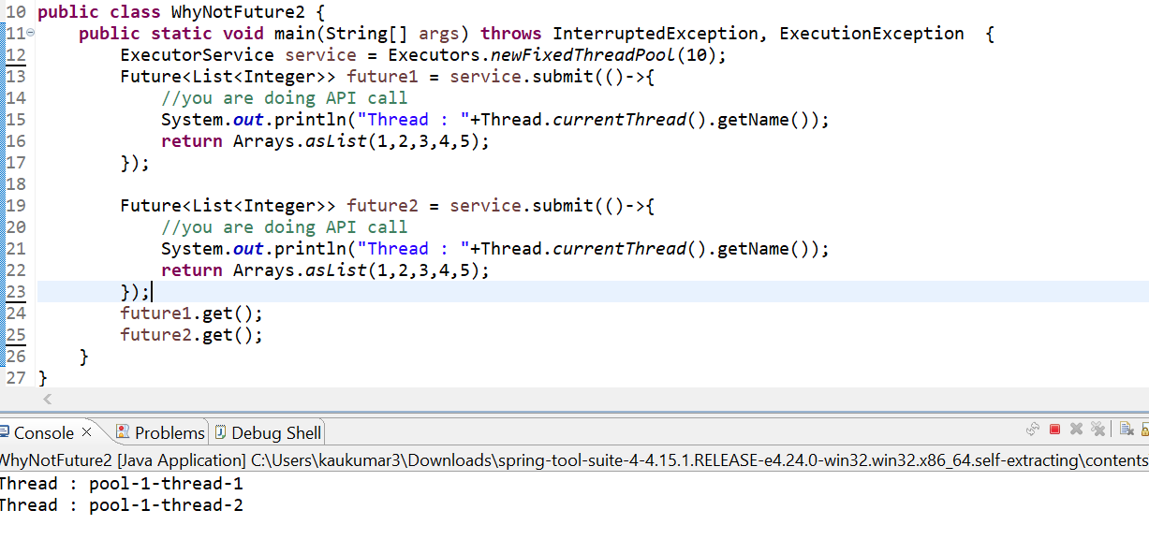
So, using future not possible to run multiple future thread simultaneously. So, in this case if I want to execute future 1 so I will just directly go to future1.get(). Similarly, if I want to execute future 2 so I will directly go to future2.get().
-> No Exception Handling mechanism provided in Future Object
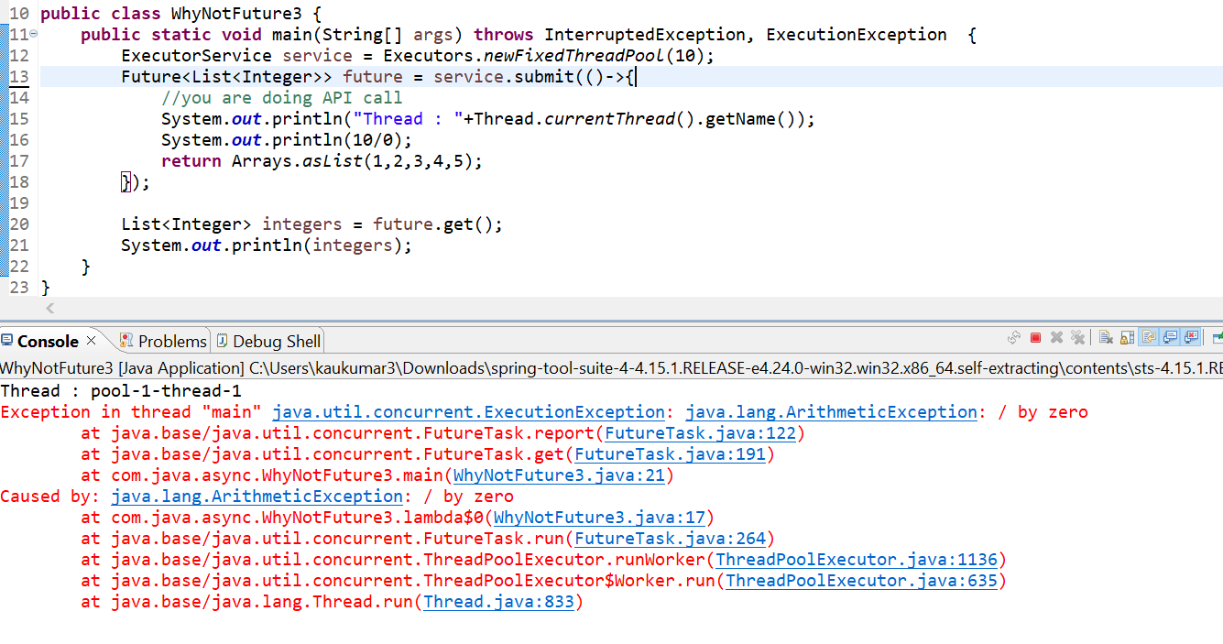
We don’t have any option to handle the future object.
How to create CompletableFuture object ?
In this completable future we can call the get() method. Now once we call the get() method again it will block the main thread until and unless this completable future does not succeed. It will still block my thread to avoid that there is a feature called complete() method. If thread is taking a long time, then forcefully you can complete it and return some dummy data.

What is runAsync() & supplyAsync() method? How to use it?
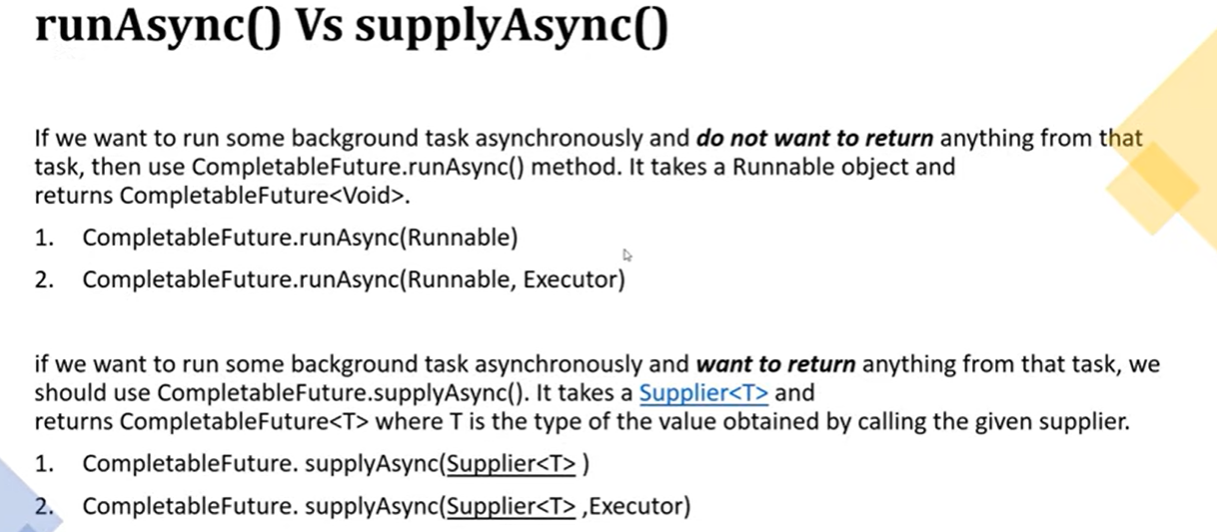

- If you want to execute your thread and if you are not expecting any return type after your thread execution, then you can go with runAsync() method. The return type of runAsync() method is CompletableFuture<Void>, it will not return anything after the thread execution. But if you are expecting some return type after your thread execution then you should go for supplyAsync() method.
- If you see the method signature of runAsync() it takes an argument as Runnable and another one is the overloaded method of CompletableFuture, and overloaded method takes another argument as Executor. Similarly, if you observed the signature of supplyAsync() method it takes an argument of Supplier because you are expecting some return type after thread execution and another one is the overloaded method takes another argument as Executor.
- If you use runAsync(Runnable) if u are not giving any executor, then we need to understand how this CompletableFuture will get the thread to execute my code. So, in that case CompletableFuture will get the thread from Fork Join Global pool. It will get the thread from Fork Join pool, and it will execute the code.
- If you are giving executor mean your custom executor, then CompletableFuture will get the thread from custom executor not from the fork join pool that’s the reason they provided 2 overloaded methods. In case you are not giving your executor object then it will get the thread from the fork join pool and it will start executing your code.
We need to use this runAsync() method if u are not expecting any return type after your thread execution. Let’s say I have some file and I want to extract that file and I want to process that object to my database, and after that I can directly verify the data into the database rather than giving some return statement from thread.in that case you can go for runAsync() method().

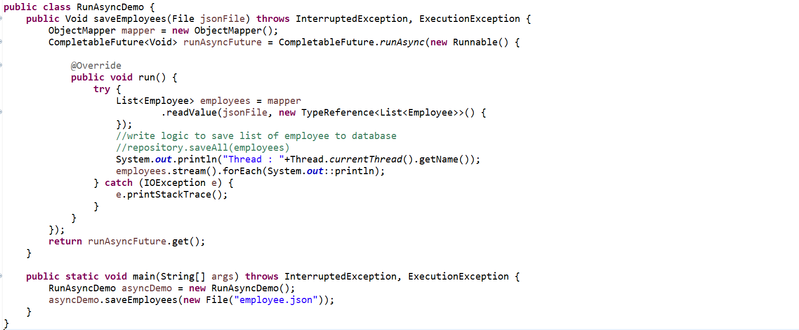
When we will get only a single json we can use Entity.class instead of TypeReference otw for multiple json better to use TypeReference.
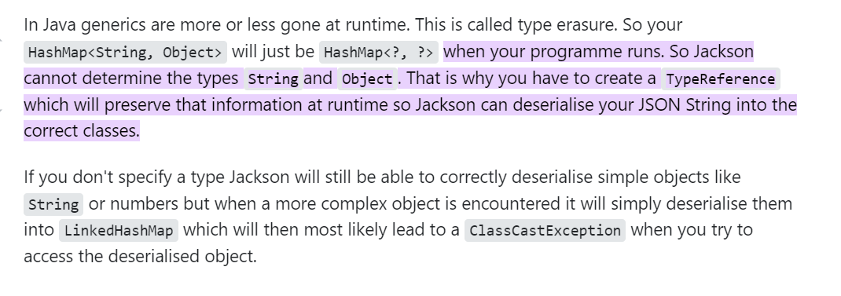
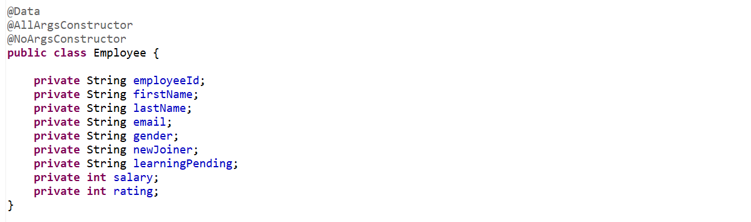
To read json file and convert json to java object we need to add dependencies Jackson-core and Jackson-databinding.
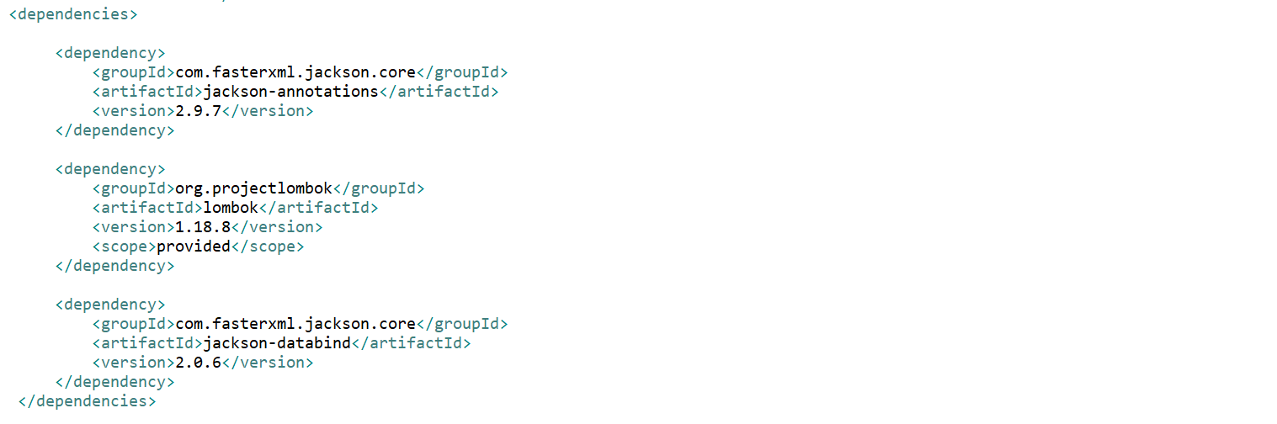
I have an employee.json object which contains 1000 of employee objects.
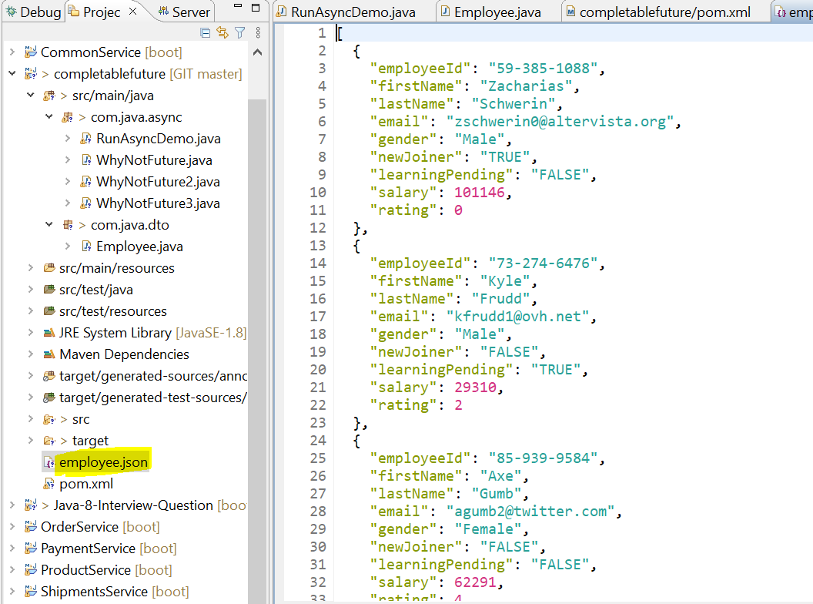
So, we can see we are getting the output here.
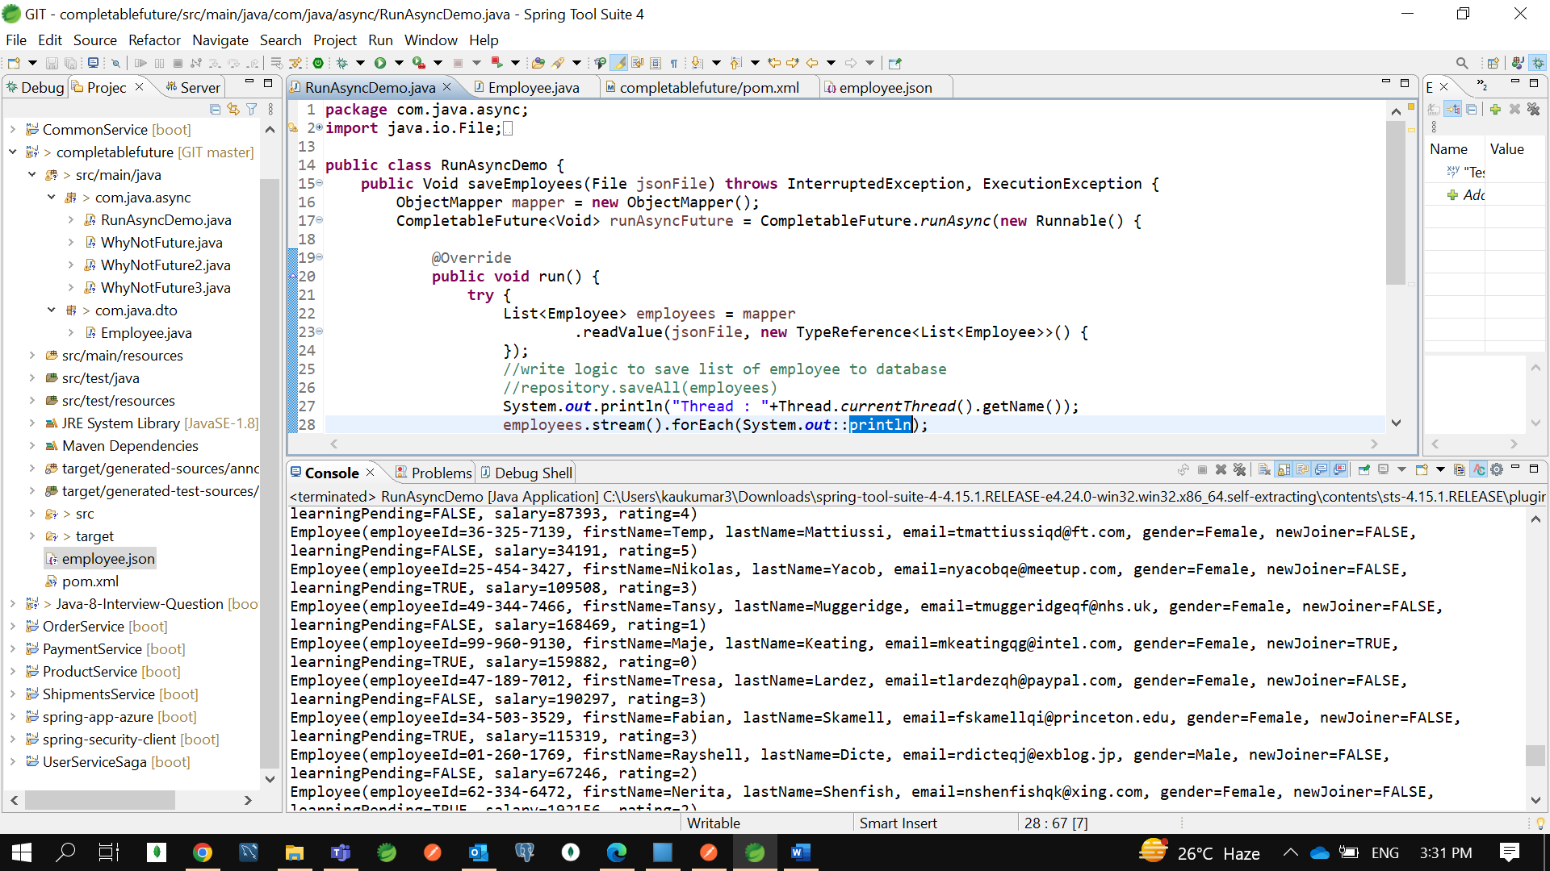

Now we are getting 1000 employee objects. If u can see it is getting the Thread from the fork join pool- common pool. That is what there is one global fork join pool where it will get a thread and it will start executing your code.

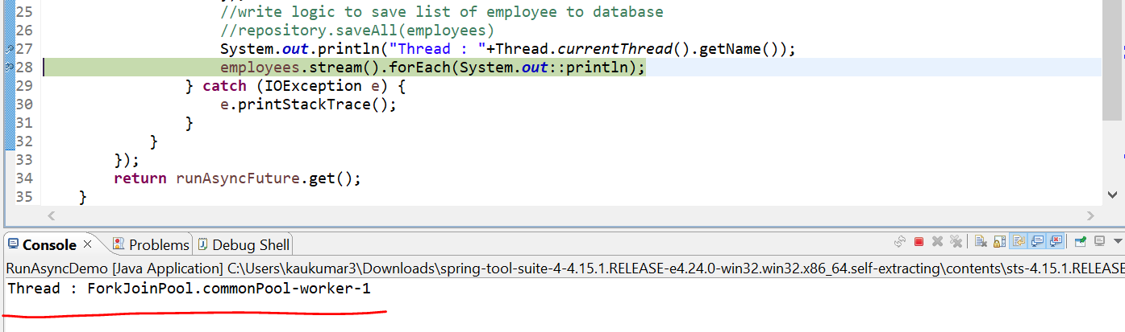

So, worker-1 thread is getting from the common thread pool by CompletableFuture. If you don’t want that you need to provide your own Executor framework. That’s the reason there is 2 overloaded methods.
Now since we already know how to write lambda, so instead of this complex logic we can write lambda expression.
So, let’s write another method here.
Earlier one was Anonymous implementation of Runnable and let’s do using lambda expression.
So, if you observed there is 2 overloaded methods runAsync(Runnable) with runnable and runAsync(Runnable, Executor) runnable as well as executor framework.
In first method we didn’t provide any custom executor that the reason it got the thread from the fork-join pool that is global pool. Let’s use the overloaded method I mean second method. So, second method will get the thread from my custom executor, and it will start executing. Rather than looking into the fork join global pool.
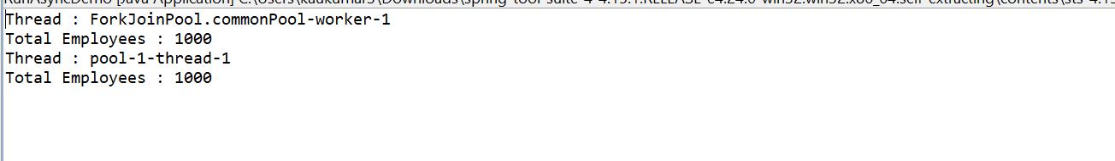

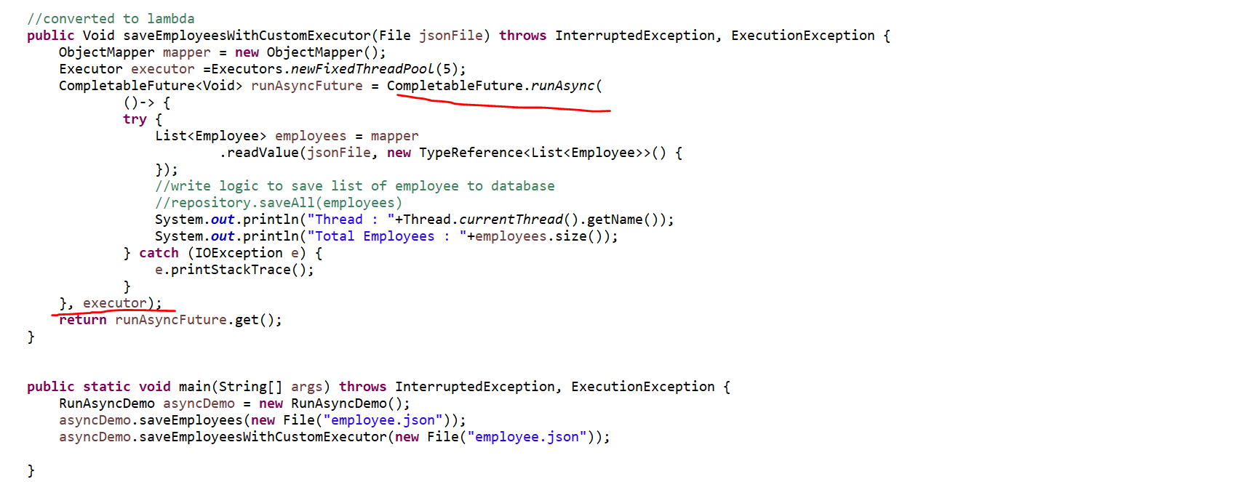

So, if u provide your own executor, then it will get the thread from there if not then it will get thread from the global pool and start executing.
If you don’t want to return anything after your thread execution, then happily go with runAsync() method because its return type is CompletableFuture<Void>.
If you want, you can complete your thread manually. Let’s say this is blocking your code then you can use runAsync.toCompletableFuture() to complete the execution if its blocking. So to complete manually you can use runAsync.toCompletableFuture().
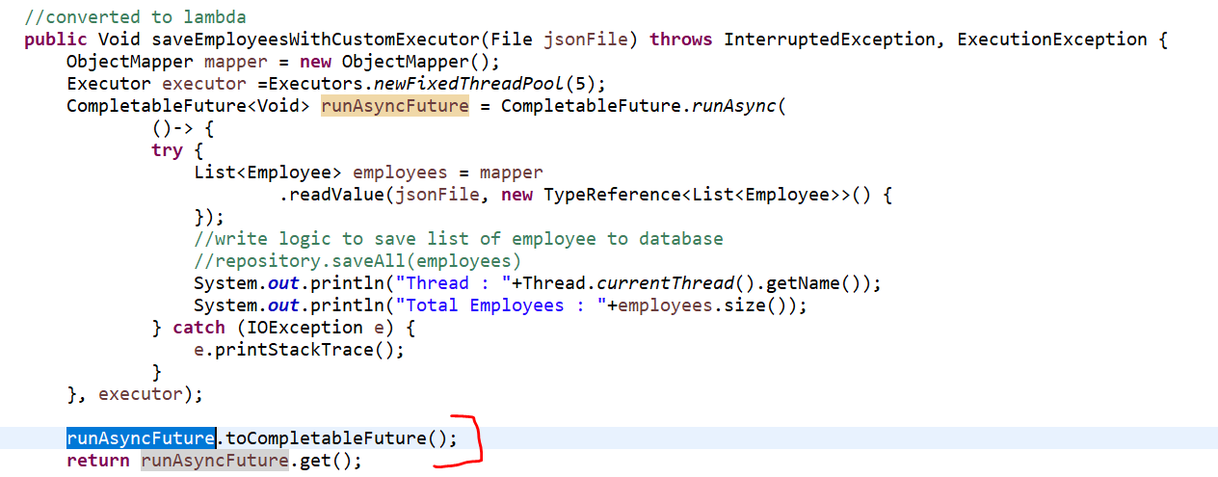
How we can use supplyAsync() method ?
Let’s understand how we can use supplyAsync() method where my thread after executing it will return some values. So that going forward we will use that value, or we can pass it to other thread, or we will do some data transformation on that return type or on those results.
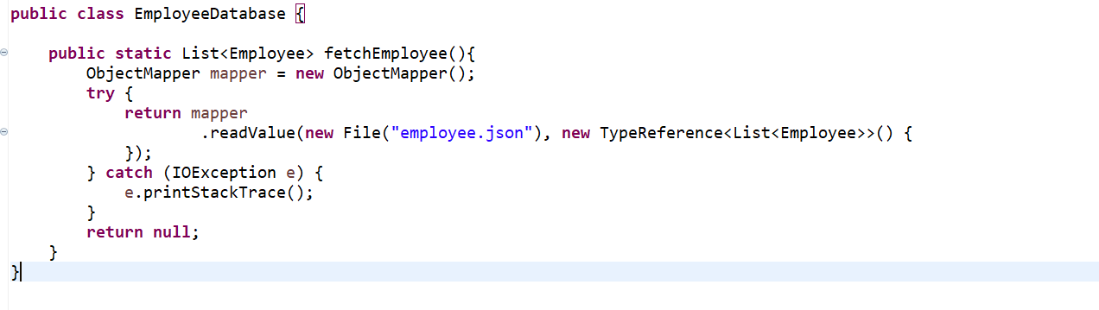
Let’s assume I have a database where we will fetch the list of employee object and my thread will connect to the database and return the list of employee objects. Inside EmployeeDatabase we will write same logic what we did in runAsync() method.
supplyAsync() expecting the argument as Supplier
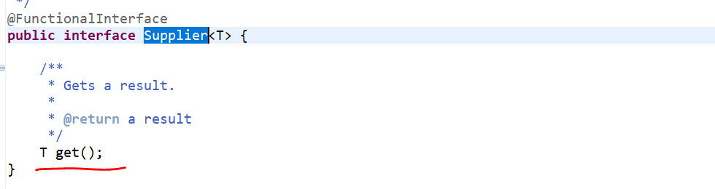
When we will go to supplier, we can see it won’t take any input, but it is expecting something to return
The purpose of using this supplyAsync() , after executing the thread I am expecting the result something which is List of Employee. I am just getting this value from the database. if you want to sort that value or if u want to do some data manipulation. That transformation logic you can perform using other methods provided in CompletableFuture i.e thenApply(), thenAccept() and thenRun().

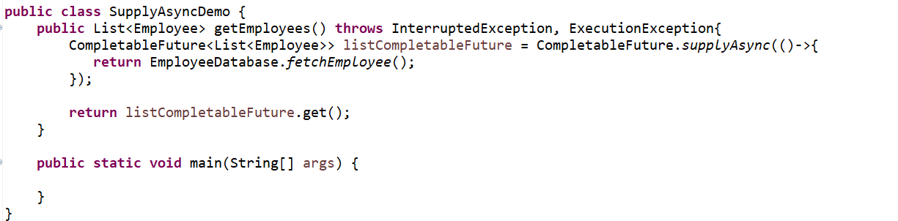
If you can see this supplyAsync() is also an overloaded method. First is with Supplier and second is the Supplier with Executor.
You can use your own executor also.
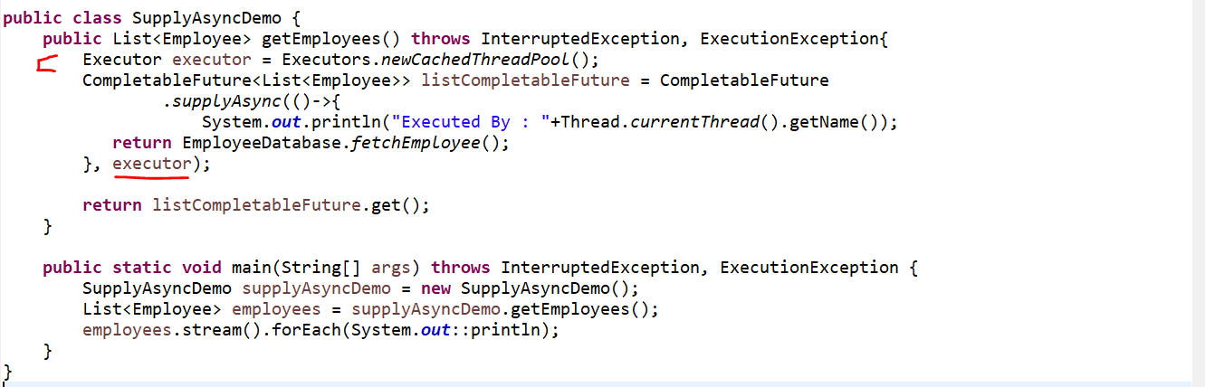
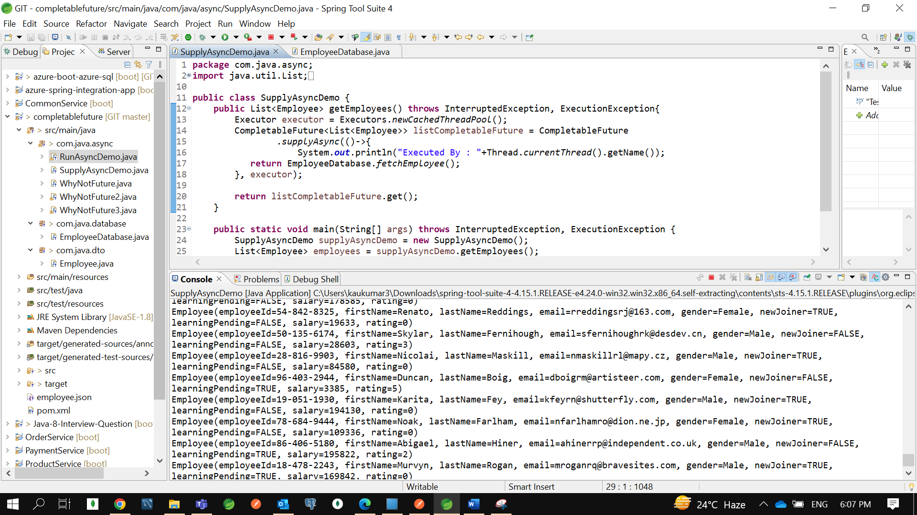

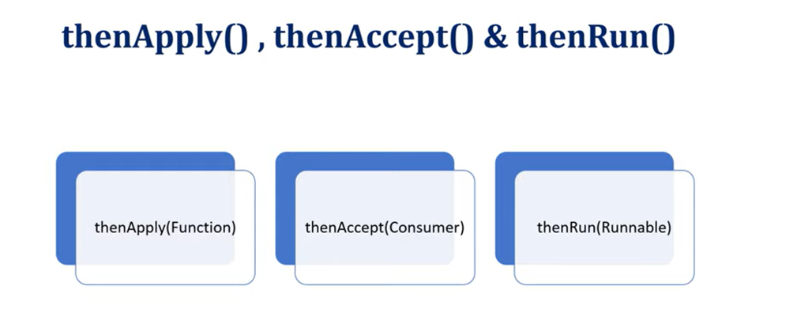

In this part we will understand how to chain multiple future together. I mean after getting result from thread execution how we can transform that value or how we can pass that value to another thread for execution.
There are a few methods provided by CompletableFuture :
- thenApply(Function)
- thenAccept(Consumer)
- thenRun(Runnable)
if you see the arguments of each method :
thenApply() takes the argument as Function which means it will take the input from you or after thread execution it will get the input and it will do data manipulation then it will return something.
thenAccept () takes the argument as Consumer, and as you know Consumer is a Functional Interface. It will always take input, but it won’t return anything.
thenRun() if you see thenAccept() and thenRun() both are a same kind of methods. But the argument is only different. In case of thenRun() it will take input as a runnable. In both the methods it won’t return anything.
So, you can use anyone either thenAccept() or thenRun() based on your need.

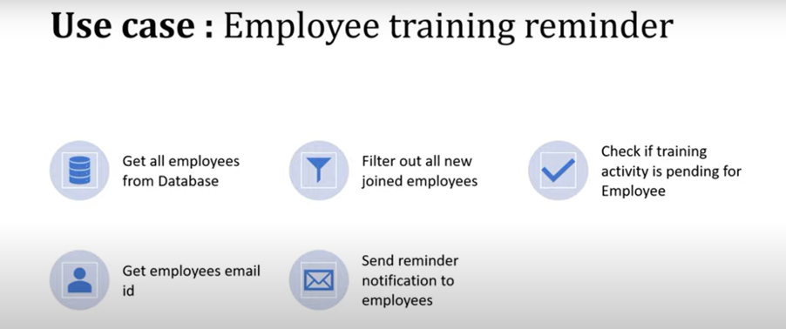

If you can see here, there is total of 5 tasks. Each task I want to execute in a separate thread.
- First Thread will get the all-employee data from database, and it will pass the list of employees to the second thread.
- Second thread will filter out all the new joined employees and again list of new joined employees will pass to the next thread.
- Third thread will check if the training activity is pending for new joined employees, it will filter all the list of employees who didn’t complete the training activity.
- Fourth thread will again extract the email id from the list of employee id or list of employees who didn’t complete the training activity.
- Finally, Fifth thread will send the notification to the employees.

First thread will execute, and it will get the result and return to the second thread, then second thread will execute and get result and returned that result to the third thread …this is how I will just attach callback to the next CompletableFuture. That is why I can achieve using thenAccept(), thenApply() and thenRun() method.
I am going to use the same code base which we have used already for supplyAsync() and runAsync() and the same json employee.json raw data I am going to use. I can filter out either the employee is a new joiner or not. Or either that employee learning activity is pending or not. That is what the 2 fields I have used in our json directly we can use it.
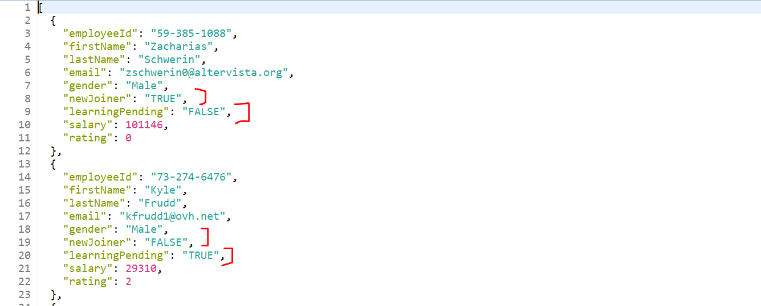

If you go to Employee class all the fields, we have mapped here.
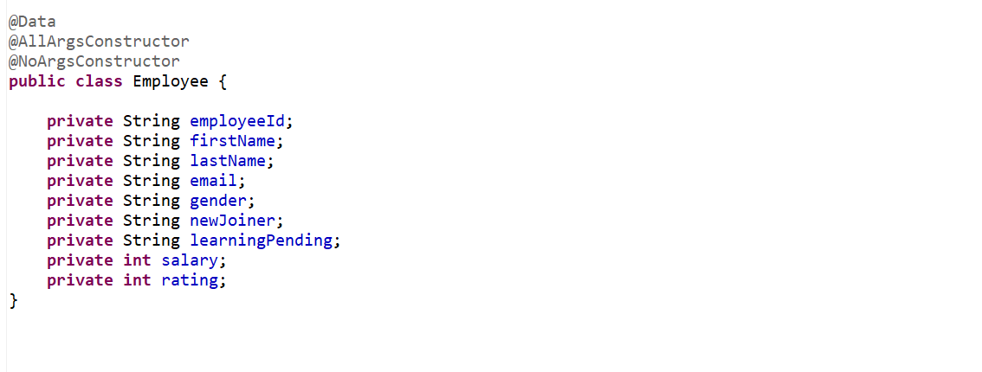
Let’s create a class EmployeeReminderService. Now first thread will fetch all the employees from database. so, I can directly use the supplyAsync(). So, it will take argument as Supplier. It won’t take input but return some output.
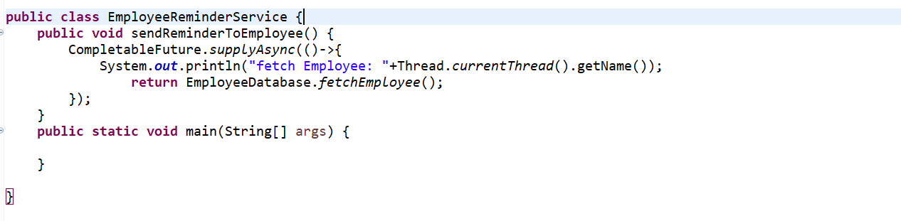
This will return the list of employees as per the ppt the next thread I want to filter out who are the new joined.
Here I just want to pass the list of employees to another thread.
So, I can directly use thenApply() , if u see the argument of thenApply() is Function. So, Function will take one input and return output.
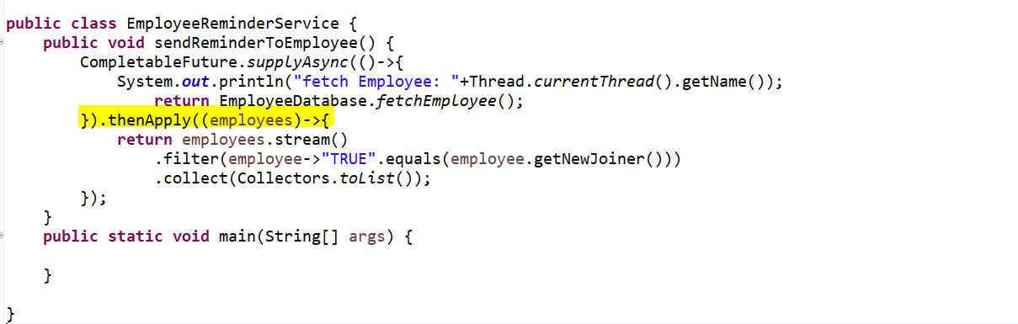

Now first thread will return the list of employee’s objects. Second thread will take a result as an input and just filter out all the employees who is new joined.
Here also let’s add the thread name so I can show you each logic is execute in a different thread.
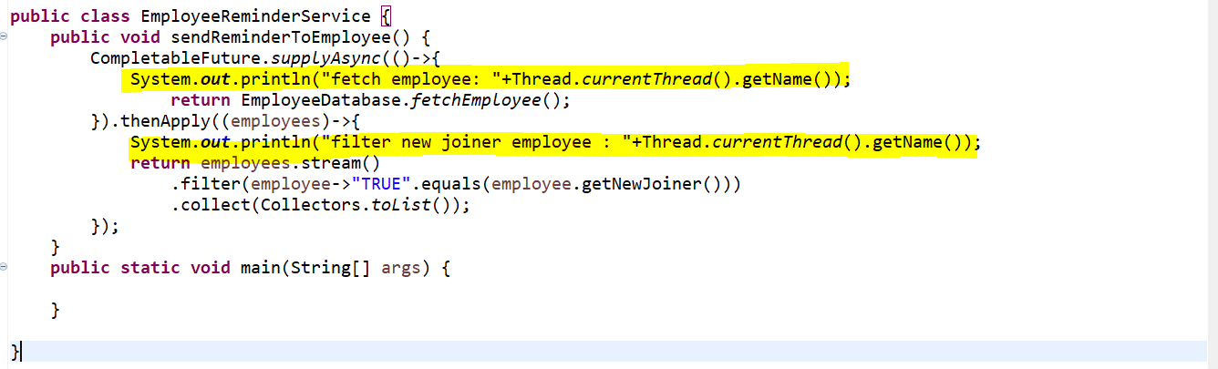
Now the next thread will take input as a new joined and filter out who all didn’t complete training activity.
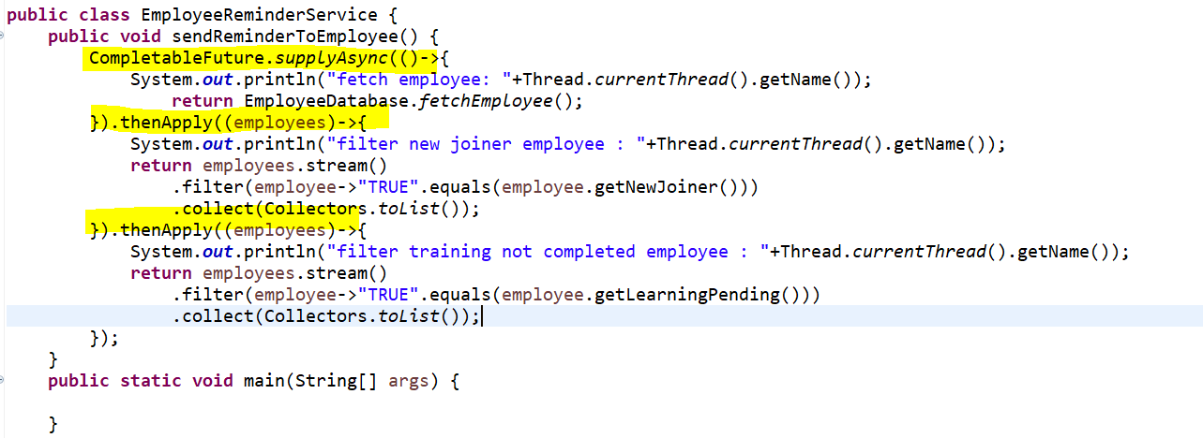

Now the fourth thread will fetch list of employee email from all list of employee.

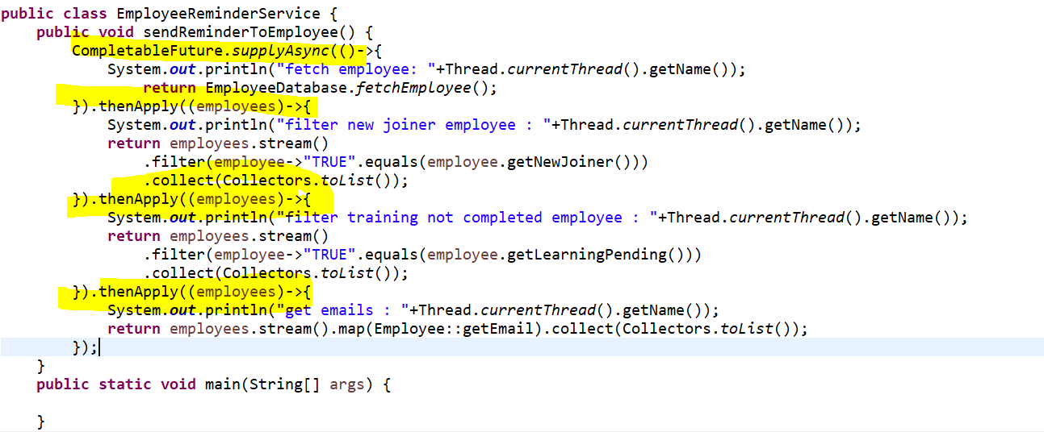
If u observed, I have created 4 threads thenApply() 3 times. I used thenApply() because after getting the result from these thread execution I just want to take that as an input, and I just want to do a data manipulation and again I just want to return employee to the next thread call or a next CompletableFuture.
Now once I get an email, I just want to trigger email mechanism in my code. So, in this case while sending a mail I don’t want to return anything.so, here either I can go for thenAccept() or thenRun(). If u don’t want to return anything after execution u can go for anyone. Now I am using here thenAccept() which take input as a Consumer. So, consumer will take a input but no output.
I can directly converted into the Method Reference bcz I have created a static method. forEach take input as a Consumer.
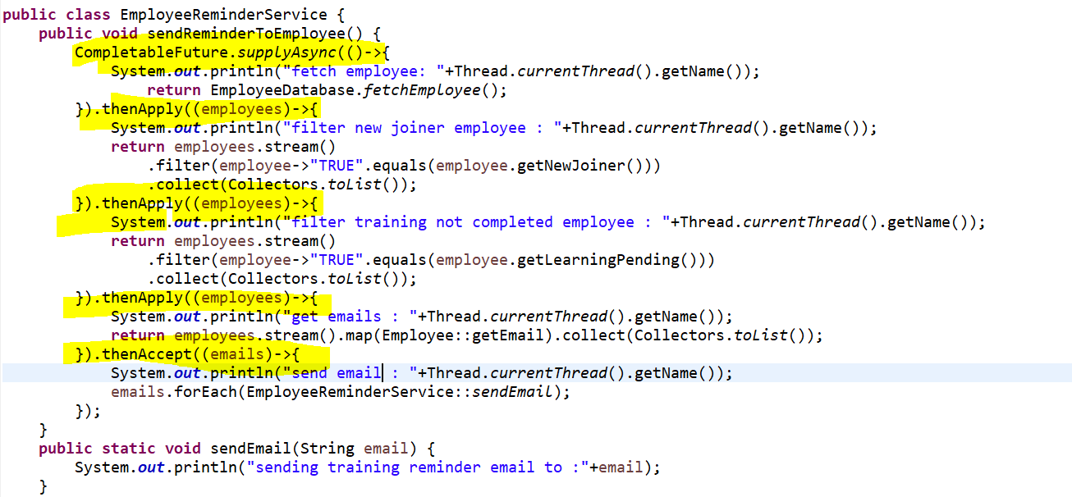
Now we have done all 5 tasks in a 5 separate threads.
Now let me use local variable CompletableFuture<Void> which our task will return.
Now let’s run.

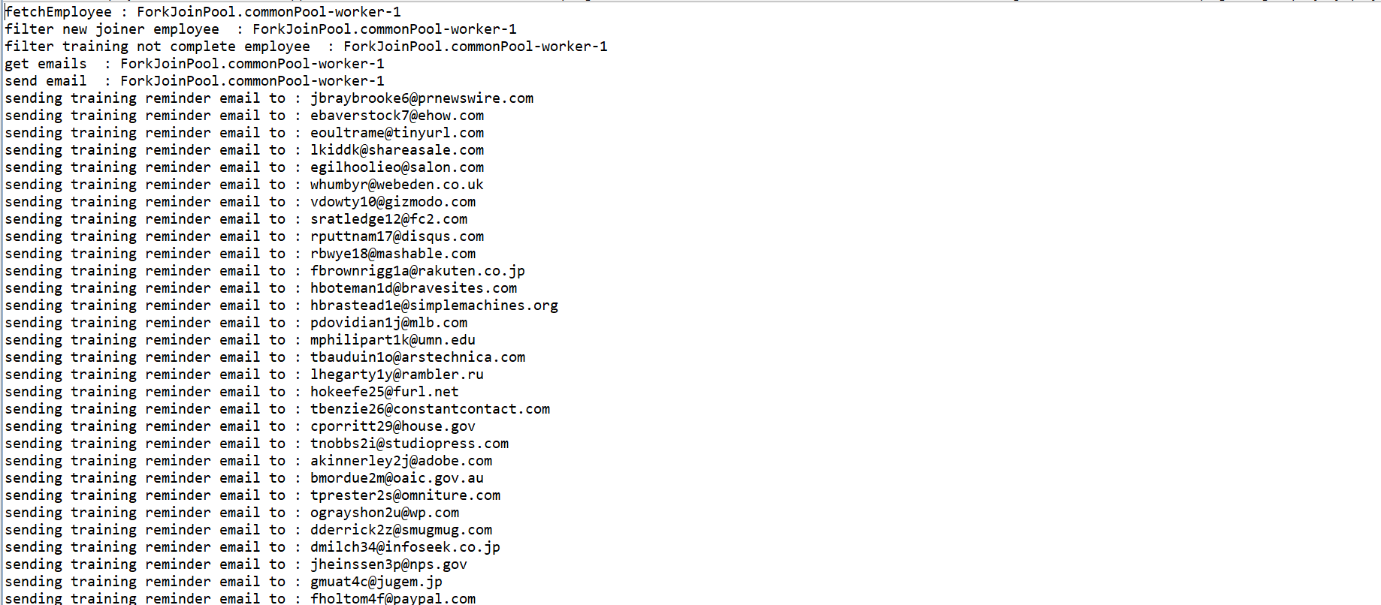
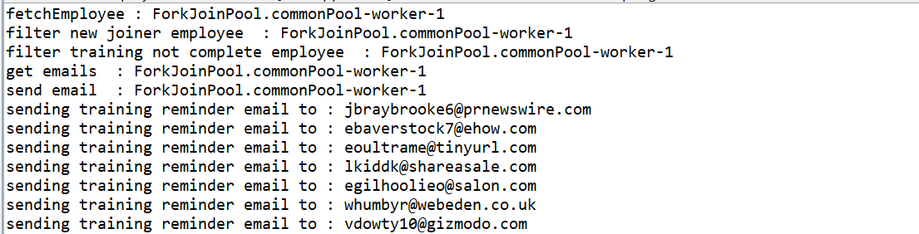

If u see fetch Employee executed by ForkJoinPool-commonPool-worker-1… so all are executing in a single thread. Because even though we are executing concurrently, and we are not specifying our own executor, so it is getting it from fork join common thread pool. If u observed fetch employee, filter new joiner …everything running using a single thread. Even though we have one thousand records.
Now what is the multithreading concept here because everything is running in a single thread there is no use of using these thenApply() or thenAccept() method.to show you that there is a 2 methods thenApply() and thenApplyAsync(). thenAccept() and thenAcceptAsync() method.
Now if we will go to the source code… u can see this is a overloaded methods.

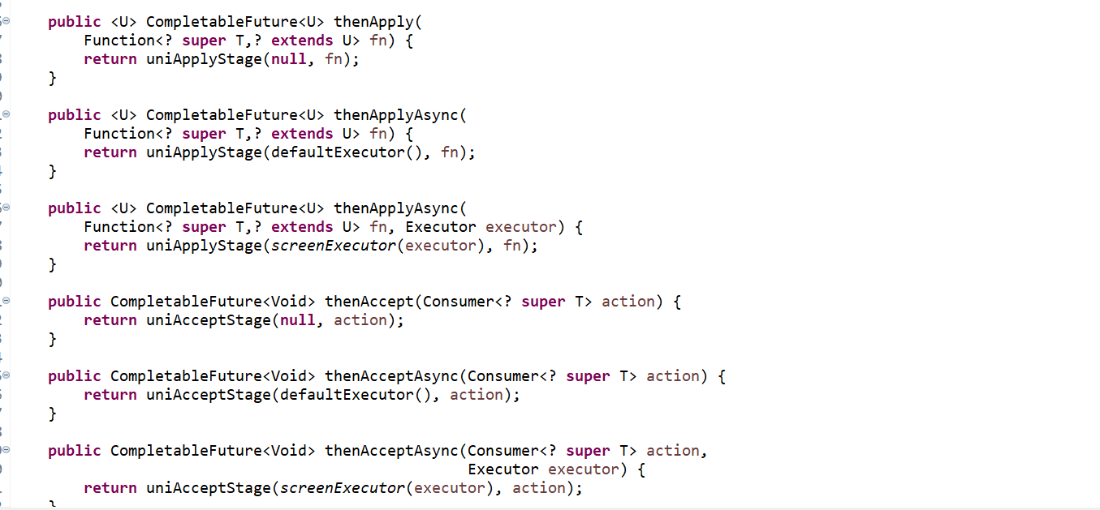

If you want to execute in a separate thread concurrently then you can go for thenApplyAsync() if u don’t specify then it will use thenApply() and it execute in a single flow. There will be no concurrent flow. Then go to code and change it to thenApplyAsync(). If u want to perform asynchronous communication or in a concurrent way u need to go for Async.
Since we have not provided own executor so its taking thread from a fork join pool only.
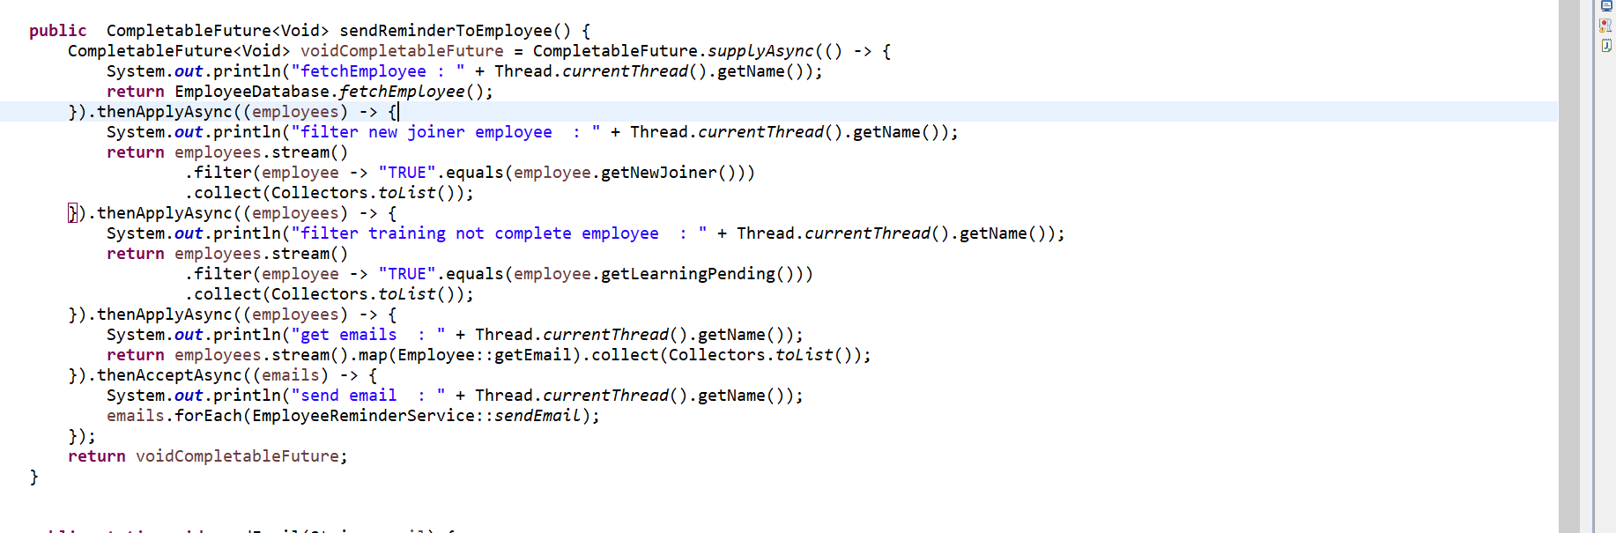

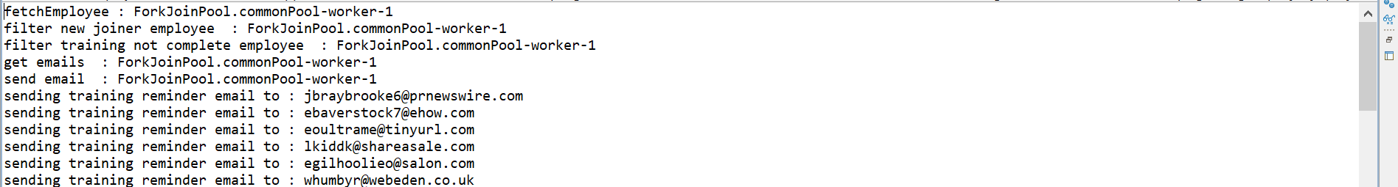

We just need to provide our own executor. Now I just want to provide this executor to my supplyAsync() method.
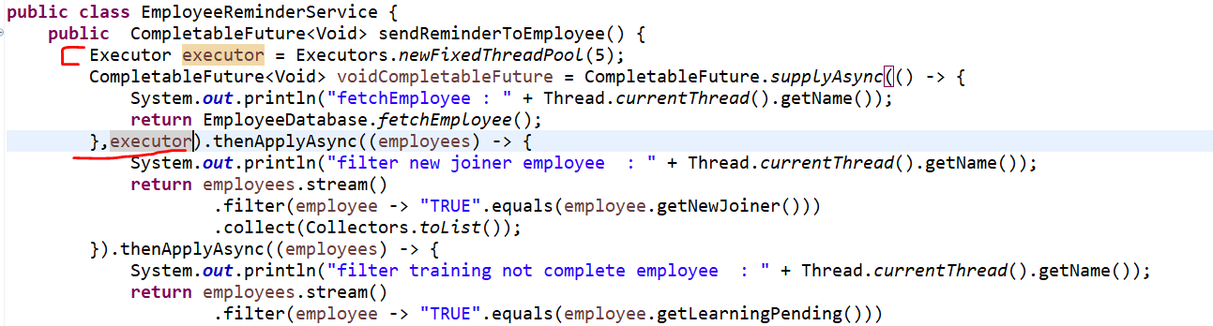
Now this particular this supplyAsync logic up to this executor will execute with my own executor or it will take my own custom thread pool. But the rest other method like thenApplyAsync()….will take threads from the fork join global pool because I am not specifying executor there.
Now let me run this piece of code and see.
Fetch employee run from the pool-1-thread-1 this is my own pool and others are executing from the fork join pool global pool.
Now I will pass this executor to all async method. So, all tasks I am giving this executor. If I will run this every task will execute in a different thread.
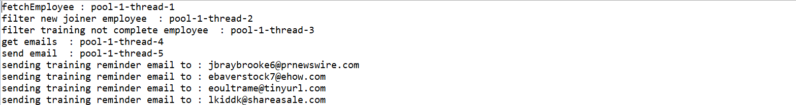
If u can observe here, we have just chained multiple future. This is what 5 futures with chained together.
This is what the disadvantages of Future object which we can achieve using CompletableFuture.
Now I just want to provide Separate Executor to each thread. That also u can do that.
I am not going to do that its not recommended its based on Ur CPU core.

